**LESSON PLAN AND NOTE 1 FOR WEEK 5 ENDING 2/6/2023**

**Term 3rd term**

**Week 5th week**

**Date 2/6/2023**

**Class Nursery One**

**Subject Letter Work**

**Topic Two letter words.**

**Sub-topic Fill in the missing two letter words.**

**Period 4th period**

**Time 10:40 am**

**Duration 35 minutes**

**No in class 18**

**Average Age 3 years**

**Sex Mixed**

**Specific Objectives: By the end of the lesson, the pupils should be able to:**

1. **Fill in the missing two letter words.**
2. **Re-arrange the two letter words.**

**Rationale: To ensure the pupils re-arrange & fill in the missing two letter words.**

**Previous Knowledge: The pupils can write and match two letter words.**

**Instructional Resources: Two letter words chart, Online research.**

**Reference Material: Online research, chart.**

**LESSON PRESENTATION**

|  |  |  |  |
| --- | --- | --- | --- |
| **Steps** | **Teacher’s Activities** | **Pupils’ Activities** | **Learning Points** |
| **Introduction** | **The teacher introduces the lesson by reading two letter words from two letter words chart.** | **The pupils listen to the teacher.** | **To arouse the interest of the pupils.** |
| **Step 1** | **The teacher guides the pupils to fill in the missing two letter words it, up, as, on inside their notebook.**    **i ___ u ___**  **a ___ o __** | **The pupils fill in the missing two letter words it, up, as, on inside their notebook**  **i t u p**  **a s o n** | **For proper understanding of the pupils.** |
| **Step 2** | **The teacher leads the pupils to re-arrange words and write them e.g**  **ti --------**  **ta --------**  **fo --------**  **si ---------** | **The pupils re-arrange the words and write them out**  **ti -------- it**  **ta -------- at**  **fo -------- of**  **si --------- is** | **For better understanding.** |
| **Summary** | **The teacher summarizes the lesson by asking the pupils to spell random two letter words.** | **The pupils respond to the teacher actively.** | **For onward study.** |
| **Evaluation** | **Question:**  **Fill in the missing two letter words**  **i ___ u ___**  **Re-arrange words and write them e.g**  **fi --------**  **na --------** | **The pupils answer the question correctly.** | **To ascertain the pupils’ understanding.** |
| **Conclusion** | **The teacher reacts & summarizes the lesson to the pupils.** | **The pupils gives answer to the teacher’s question.** | **To consolidate the lesson.** |
| **Assignment** | **Question:**  **Re-arrange words and write them e.g**  **ni --------**  **sa --------** | **The pupils copy and do their homework at home.** | **To encourage learning while at home.** |

**LESSON PLAN AND NOTE 2 FOR WEEK 5 ENDING 2/6/2023**

**Term 3rd term**

**Week 5th week**

**Date 2/6/2023**

**Class Nursery One**

**Subject Letter Work**

**Topic Two letter words.**

**Sub-topic Find and underline two letter words.**

**Period 4th period**

**Time 10:40 am**

**Duration 35 minutes**

**No in class 18**

**Average Age 3 years**

**Sex Mixed**

**Specific Objectives: By the end of the lesson, the pupils should be able to:**

1. **Find and underline two letter words.**
2. **Pick from a box and identify two letter words.**

**Rationale: To ensure the pupils find and underline & pick and identify two letter words from a box**

**Previous Knowledge: The pupils can re-arrange & fill in the missing two letter words.**

**Instructional Resources: Two letter words chart, Online research.**

**Reference Material: Online research, chart.**

**LESSON PRESENTATION**

|  |  |  |  |
| --- | --- | --- | --- |
| **Steps** | **Teacher’s Activities** | **Pupils’ Activities** | **Learning Points** |
| **Introduction** | **The teacher introduces the lesson by reading two letter words from two letter words chart.** | **The pupils listen to the teacher.** | **To arouse the interest of the pupils.** |
| **Step 1** | **The teacher guides the pupils to find and underline the two letter hidden words and writes them e.g**    **Scitf --------**  **Bbupth --------** | **The pupils find and underline the two letter hidden words and writes them.**  **Scitf -------- it**  **Bbupth -------- up** | **For proper understanding of the pupils.** |
| **Step 2** | **The teacher guides the pupils to pick from a box and identify the two letter words they see.** | **The pupilspick from a box and identify the two letter words they see.** | **For better understanding.** |
| **Summary** | **The teacher summarizes the lesson by asking the pupils to identify random two letter words.** | **The pupils respond to the teacher actively.** | **For onward study.** |
| **Evaluation** | **Question:**  **Identify (3) two letter words you know?**  **on it**  **as at**  **Find and underline the two letter hidden words and write them**  **Subasjm --------** | **The pupils answer the question correctly.** | **To ascertain the pupils’ understanding.** |
| **Conclusion** | **The teacher reacts & summarizes the lesson to the pupils.** | **The pupils gives answer to the teacher’s question.** | **To consolidate the lesson.** |
| **Assignment** | **Question:**  **Identify (3) two letter words you know?**  **of if**  **an in** | **The pupils copy and do their home-work at home.** | **To encourage learning while at home.** |

**LESSON PLAN AND NOTE 3 FOR WEEK 5 ENDING 2/6/2023**

**Term 3rd term**

**Week 5th week**

**Date 2/6/2023**

**Class Nursery One**

**Subject Letter Work**

**Topic Two letter words.**

**Sub-topic Make sentences with two letter words.**

**Period 4th period**

**Time 10:40 am**

**Duration 35 minutes**

**No in class 18**

**Average Age 3 years**

**Sex Mixed**

**Specific Objectives: By the end of the lesson, the pupils should be able to:**

1. **Make sentences with two letter words.**
2. **Read sentences with two letter words.**

**Rationale: To ensure the pupils make & read sentences with two letter words.**

**Previous Knowledge: The pupils can find,underline & pick from a box two letter words.**

**Instructional Resources: Two letter words chart, Online research.**

**Reference Material: Online research, chart.**

**LESSON PRESENTATION**

|  |  |  |  |
| --- | --- | --- | --- |
| **Steps** | **Teacher’s Activities** | **Pupils’ Activities** | **Learning Points** |
| **Introduction** | **The teacher introduces the lesson by reading two letter words from two letter words chart.** | **The pupils listen to the teacher.** | **To arouse the interest of the pupils.** |
| **Step 1** | **The teacher makes sentences with two letter words for the pupils to understand e.g**  **It is to go on**  **I am in**  **I go up** | **The pupils pays attention to the pupils.** | **For proper understanding of the pupils.** |
| **Step 2** | **The teacher guides the pupils to read sentences with two letter words.** | **The pupils reads sentences with two letter words.** | **For better understanding.** |
| **Summary** | **The teacher summarizes the lesson by naming random two letter words to the pupils.** | **The pupils understand the lesson actively.** | **For onward study.** |
| **Evaluation** | **Question:**  **Make sentences with two letter words?**  **Read the following sentences with two letter words**  **I go up**  **Up I go**  **Is it to go up**  **Is it to go up** | **The pupils answer the question correctly.** | **To ascertain the pupils’ understanding.** |
| **Conclusion** | **The teacher reacts & summarizes the lesson to the pupils.** | **The pupils gives answer to the teacher’s question.** | **To consolidate the lesson.** |
| **Assignment** | **Question:**  **Read the following sentences with two letter words**  **I go up**  **Up I go** | **The pupils copy and do their home-work at home.** | **To encourage learning while at home.** |

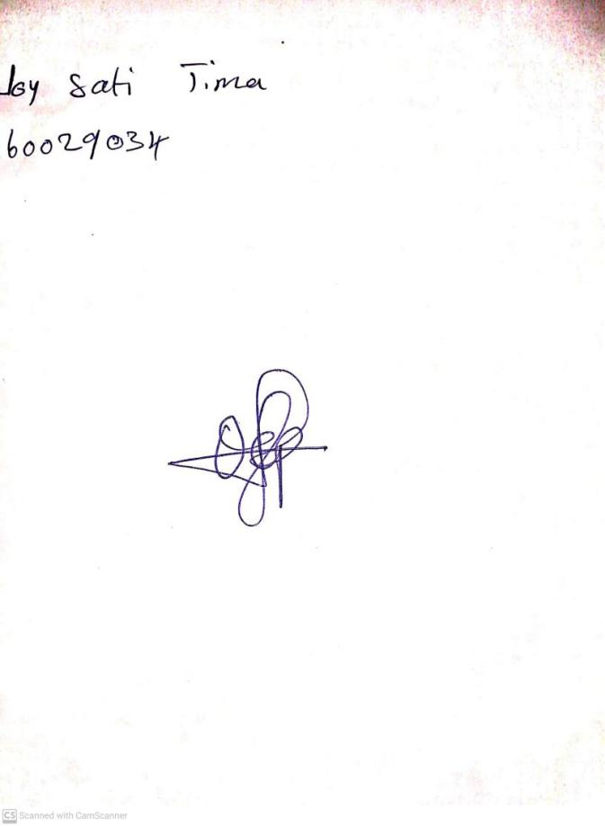

10th May, 2023

Perpetual Ojoma

Stream Head Nursery