**LESSON PLAN FOR WEEK 1 ENDING 13TH JANUARY, 2023**

|  |  |
| --- | --- |
| TERM | 2ND |
| WEEK | 1 |
| DATE | 9th-13th January,2023 |
| SUBJECT | Government |
| TOPIC | Constitution |
| SUB-TOPIC | Features of Constitution |
| PERIOD | 5th |
| TIME | 11:10-11:50AM |
| DURATION | 35 Minutes |
| CLASS | SS1 |
| NO IN CLASS | 7 |
| AVERAGE AGE | 13-15 Years |
| SEX | Mixed |
| LEARNING OBJECTIVES | By the end of the lesson, students should be able to:  i.State the features of constitution  ii.List and explain the types of constitution |
| RATIONALE | To acquaint students with the features and types of constitution. |
| PREVIOUS KNOWLDEGE | The students have been exposed to the meaning and sources of constitution. |
| INSTRUCTIONAL RESOURCES | Essential Government for Senior Secondary schools.  Debie.C.Chris (2017) |

**LESSON DEVELOPMENT**

|  |  |  |  |
| --- | --- | --- | --- |
| STEPS | TEACHER’S ACTIVITIES | STUDENTS ACTIVITIES | LEARNING POINTS |
| Introduction | The teacher introduces the lesson by asking the students to mention two sources of constitution. | The students mention two sources of constitution as:  i.History of the people  ii.Acts of parliament. | To trigger their interest towards the topic. |
| Step 1 | The teacher states the features of constitution. | The students pay attention. | To enhance proper understanding of the topic. |
| Step 2 | The teacher list and explains the types of constitution. | The students listen and asks questions on the topic. | To make room for logical reasoning on the topic. |
| Board Summary | The teacher summarises the lesson thus:  Features of a Constitution:  1.The preamble: A constitution contains a preamble which declares it’s aspirations.  2.The political structure: It states the structure of government, whether unitary of federal and at the same time defines the division of powers among the component units in the state.  3.Political institutions: The constitution defines the powers and functions of these institutions such as the executive, legislative and judicial arms of government.  4.Types of Relationship: It states the type of relationship that would exist among the institutions of government.  5.The Party System: The constitution also reveals the type of party system to adopt-one party, two-party or multi-party systems.  6.Type of administrative structure: The constitution states the administrative structure that would be operated.  7.Fundamental Human Rights: It defines the rights of citizens, their duties and obligations to the state.  8.Citizenship: It defines the qualification for citizenship. It states who the citizens of a country are and how citizenship can be acquired.  8.Tenure of office of government: It states how long a government can stay in office.  **Types of constitution**  **A.Written Constitution**: A written constitution is defined as a document or set of documents establishing the selection of rules embodied in a document in which the fundamental principles concerning the organization of a political system, powers of its various agencies are written down and codified.  **2.Unwritten constitutions**: It is defined as one in which the fundamental principles of the organization of government are not codified in one document. It is usually a combination of statutes, judicial principles, customs and conventions.  **3.Rigid constitutions**: This is defined as one that is very difficult to amend or change. It requires special process or a complicated method before it can be amended or changed.  **4.Flexible Constitution:**: It is defined as the type of constitution that is easy to amend. If the method of amending the constitution is the same as in the passing of ordinary laws, the constitution can be said to be flexible. | The scholars copy notes into their notebooks. | For reference purposes. |
| Evaluation | The teacher evaluates the students thus:  i.Mention five features of constitution.  ii.State and explain the types of constitution. | The scholars attempt the questions | To ascertain their understanding of the topic. |
| Conclusion | The teacher check students notes and make corrections. | The students take the corrections made by the teacher. | For better understanding of the lesson. |
| Assignment | The teacher give the scholars home work:  -State the merits and demerits of both written and unwritten constitution. | The scholars copy their home work to do it at home. | To encourage students to learn and study while at home. |

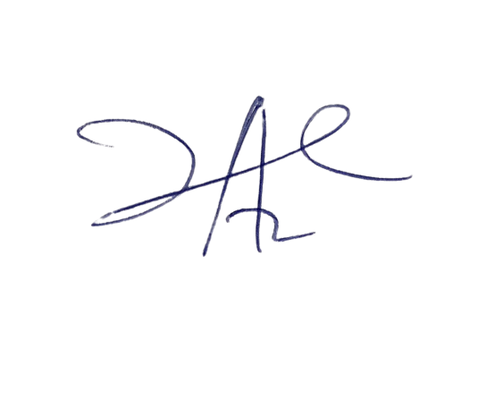

Perpetua Iheme

Head Instructor