**EMERALD ROYAL INTERNATIONAL SCHOOL MPAPE, ABUJA.**

**LESSONS PLAN AND NOTE FOR WEEK 3 ENDING 10TH MAY 2024**

**TERM: 3rd**

**WEEK: 3**

**DATE: 06/05/2024**

**CLASS: Nursery 2**

**SUBJECT: Nature studies**

**TOPIC: Water: uses.**

**SUB—TOPIC: Meaning of water and it's uses.**

**PERIOD: 4th**

**TIME: 10:40—11:20am**

**DURATION: 40 minutes**

**NUMBER IN CLASS: 13**

**AVERAGE AGE: 5 years**

**SEX: Mixed**

**LEARNING OBJECTIVES: By the end of the lesson, the pupils should be able to:**

**1. Define water.**

**2. Mention the uses of water .**

**RATIONALE: For Pupils to know what water is used for.**

**PREVIOUS KNOWLEDGE: Pupils have using for different purposes.**

**INSTRUCTIONAL MATERIALS: Pictures in Pupils textbooks.**

**REFERENCE MATERIALS: Basic science and technology for Nursery schools book 3 by OPEMIPO DADA.**

**LESSON DEVELOPMENT**

|  |  |  |  |
| --- | --- | --- | --- |
| **Steps** | **Teacher's activities** | **Pupils' activities** | **Learning point** |
| **Introduction** | **Teacher introduces the lesson by asking pupils the following questions:**  **1. How many of you bath before coming to school today?**  **2. If you know you brush your teeth this morning hands up.** | **Pupils answer the question asked by the teacher.** | **To prepare pupils minds for the lesson ahead.** |
| **Presentation step 1** | **Teacher defines water and asks Pupils to repeat after her.** | **Pupils listen to the teacher and repeat after her.** | **For proper understanding.** |
| **Step 2** | **Teacher mentions the uses of water to pupils and also asks them to repeat after her.** | **Pupils pay attention to the teacher and repeat after her.** | **For better understanding.** |
| **Board summary** | **Teacher writes the whole note of lesson on the board for pupils to copy into their books.**  **WATER**  **Water is a liquid substance that is colourless, odourless and tasteless.**  **Water has many uses.**  **The most important use of water is for drinking.**  **Human beings, plants and animals needs water to stay alive.**  **USES OF WATER**  **1. Drinking**  **2. Brushing of teeth**  **3. Washing dirty plates**  **4. Cooking**  **5. Cleaning**  **6. Washing dirty clothes**  **7. Watering plants**  **8. Washing fruits and vegetables**  **9. Building houses**  **10. Bathing**  **11. Animals need water to drink** | **Pupils copy the note into their exercise books.** | **For onward study.** |
| **Evaluation** | **Teacher evaluates the lesson by asking pupils the following questions;**  **1. Water is water?**  **2. Mention the uses of water.** | **Pupils answer the questions ask by the teacher.** | **To assess pupils level of understanding.** |
| **Conclusion** | **Teacher concludes the lesson by marking pupils books.** | **Pupils submit their books for marking.** | **For endorsement.** |
| **Assignment** | **Activity 17 page 60. Basic science textbook.** | **Pupils do their assignment at home.** | **To encourage learning at home.** |

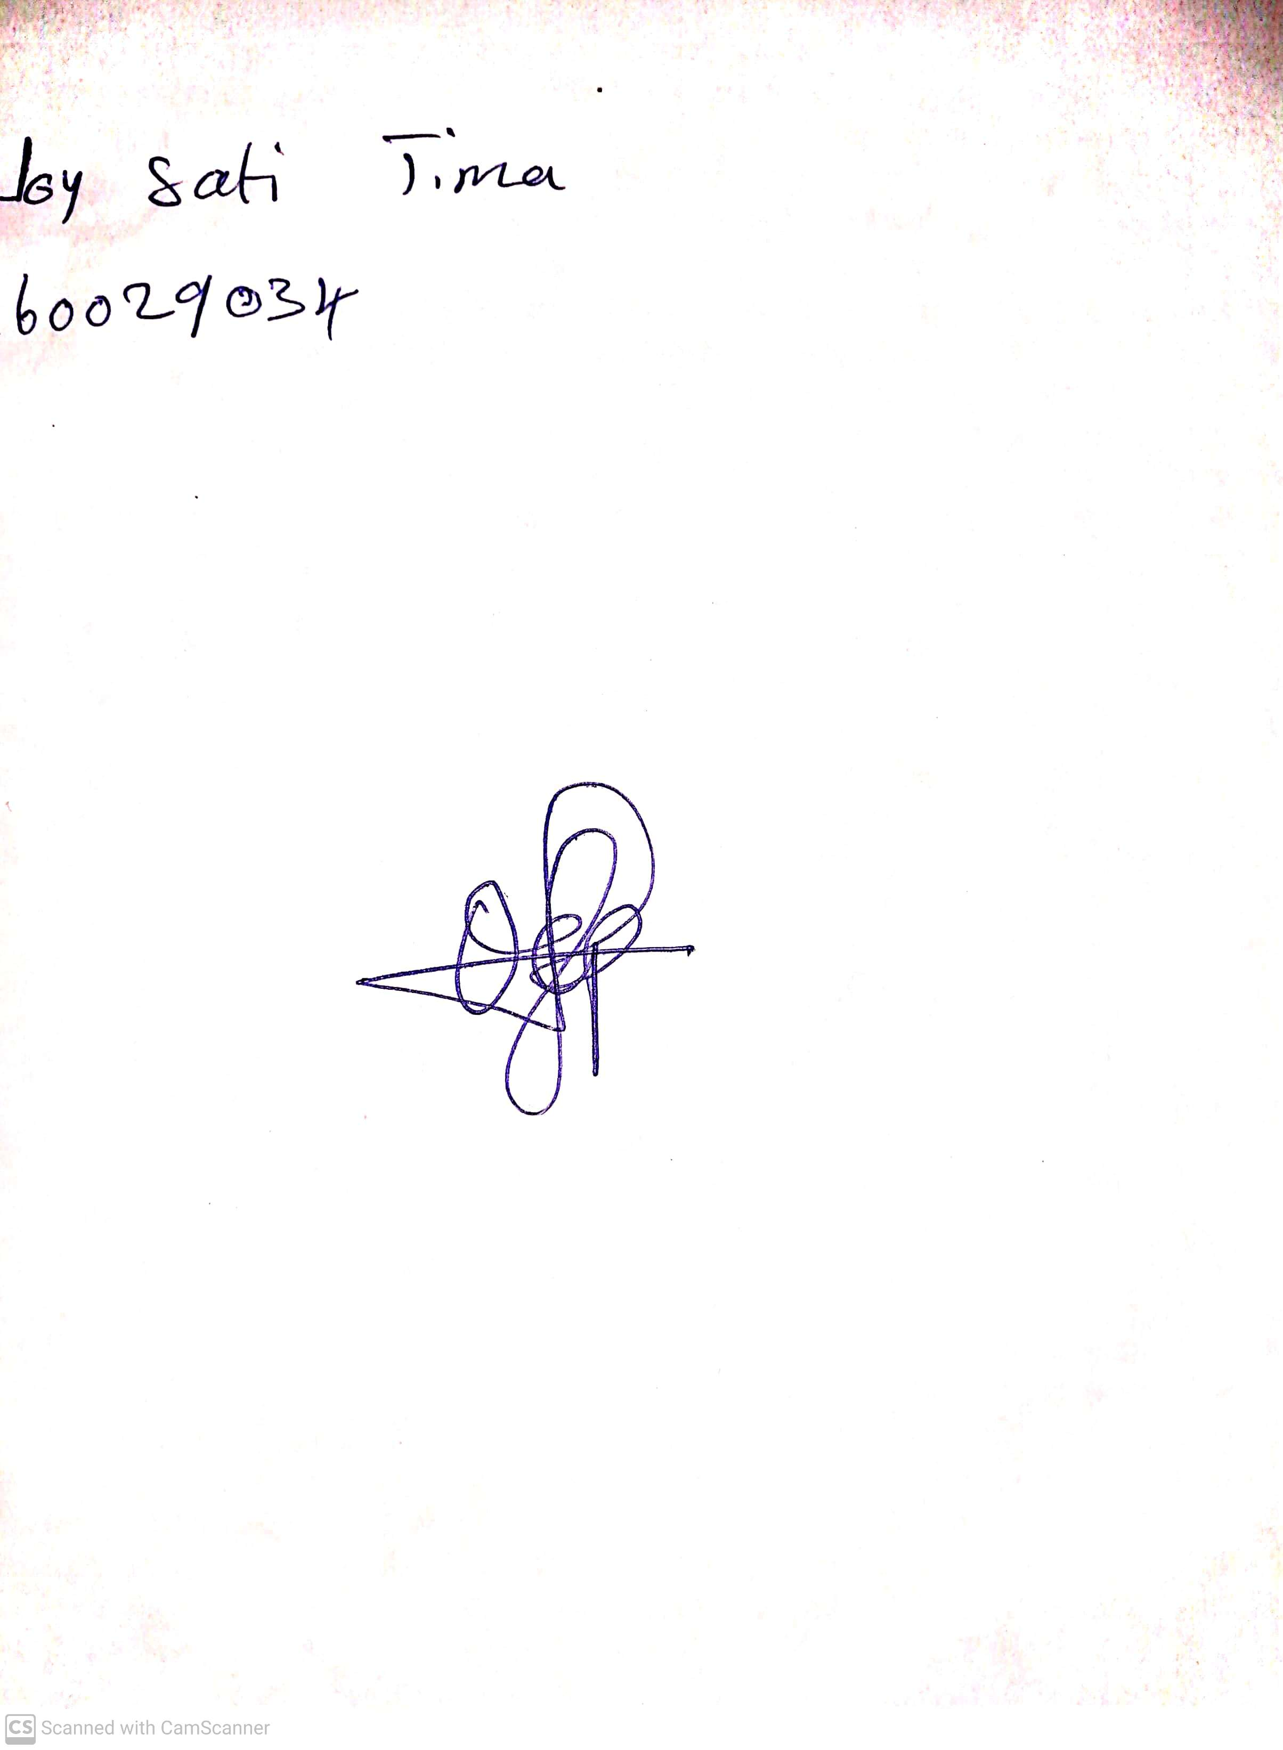

**26TH APRIL, 2024**

**Perpetual Ojoma Ocheja**

**Stream Head Nursery**