**LESSON PLAN/NOTE FOR WEEK 7 ENDING 16/06/2023.**

**Term**: 3rd

**Week**: 7

**Date**: 12/06/2023

**Class**: SS 1

**Subject**: Civic Education

**Topic**: Orderliness

**Sub-Topic:** Roles of orderliness in the society.

**Period**: 3rd

**Time**: 9:30-10:10

**Duration**: 40 Minutes

**Number** **in** **class**: 8 students

**Average** **Age**: 14 Years

**Sex**: mixed

**Specific objectives:** By the end of the lesson, the students should be able to:

(1) state the roles of orderliness in the society.

(11) Explain the roles of orderliness in the society.

**Rationale**: For the students to be able to identify the roles of orderliness in the society.

**Previous** **knowledge**: The students have been paying attention in the classroom.

**Instructional** **material**: A chart showing people obeying traffic 🚦 and queuing to withdraw money.

**Reference material**: Gbenga Babalola (2017), Essential civic Education for senior secondary schools.

**LESSON DEVELOPMENT**

|  |  |  |  |
| --- | --- | --- | --- |
| **Stages/Steps** | **Teacher's Activities** | **Students' Activities** | **Learning points.** |
| **Introduction** | Review the previous lesson | Participate actively in the class discussion | To arouse the students interest to learn. |
| **Step 1** | States the roles of orderliness in the society as: (1) Time saving (2) reduction of frustration etc. | Listen carefully to the teacher. | For better understanding of the lesson. |
| **Step 11** | Guides the students to explain the roles of orderliness in the society. | Respond to the class activity | To encourage critical thinking. |
| **Board summary** | Summarizes the lesson as:  **Roles of orderliness in the society**  (1) Time saving: much time will not be wasted where there is orderliness.  (2) Reduction of frustration: There exist several cases of disorderliness like in time of queuing at the Banks, fuel station etc. This leads to frustration of several kinds. Orderliness helps reduce frustration when things are done accurately.  (3) promotion of good national image: if everyone keeps to orderliness in our daily activities, it will help promote peace, unity and progress which will thereby improve and foster good national name and image.  (4) It promote peace in the society: maintained orderliness in the society mostly in the public place like church, schools markets etc will promote and foster peace in the society.  (5) It brings about national growth: Orderliness beings about national growth due to the fact that the time which would have been wasted will thereby be put into productivity and effectiveness to the nation growth. | Copy and submit the note book for marking. | For future reference. |
| **Evaluation** | Evaluates the students as:  (1) State 5 roles of orderliness in the society.  (2) Explain 4 roles of orderliness in the society | Respond to the questions | Ascertaining the attainment of the stated objectives. |
| **Conclusion** | Rounds up the lesson by marking and correcting students work | Check and do their correction | Consolidation of the lesson. |
| **Assignment** | Gives home work as:  (1) Briefly explain the roles of orderliness in the society | Respond by doing the home work at home. | To ensure continuity of learning. |

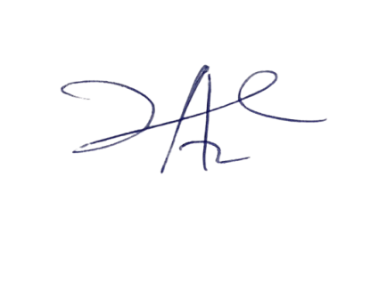

2/6/2023

Principal Head Instuctor