**EMERALD ROYAL INT’L SCHOOL**

**LESSON PLAN/NOTE FOR WEEK 4 ENDING: 26TH MAY, 2023**

|  |  |
| --- | --- |
| **Term** | 3rd |
| **Week** | 4 |
| **Date** | 22/05/2023 |
| **Class** | SSS 2 |
| **Subject** | Physics |
| **Topic** | Electric field 2 |
| **Sub-topic** | Coulomb’s law |
| **Period** | 1 and 2 |
| **Time** | 10:30-11:50 |
| **Duration** | 80minutes |
| **Number in class** | 2 |
| **Average age** | 14years |
| **Sex** | Mixed |
| **Specific objectives** | By the end of the lesson, the students should be able to:   1. State coulomb’s law 2. Solve simple examples on electric forces using coulomb’s law. |
| **Rationale** | To enable the students understand the concepts of electric forces. |
| **Previous knowledge** | Students should have been taught on electric charges, law of charges and electric lines of force. |
| **Instructional aid** | One guide sheet for each student, a cell, an ammeter, a voltmeter, a science notebook and a science textbook. |
| **Reference** | * M.W. Anyakoha. New school physics for secondary schools. Africana first publishers PLC. page 383-392 * P.N. Okeke. Macmillan Senior Secondary Physics. Pearson. Page 233-241 |

**LESSON DEVELOPMENT**

|  |  |  |  |
| --- | --- | --- | --- |
| **STEPS** | **TEACHER’S ACTIVITIES** | **STUDENTS’ ACTIVITIES** | **LEARNING POINTS** |
| **Introduction** | The teacher introduces the lesson by explaining that there is an electric force between two point charges. The french physicist Charles Coulomb (1736-1806) investigated the nature and magnitude of this force. He showed that if the bodies were small compared with the distance between them, then the force between two such bodies was inversely proportional to the square of the distance, r, between them. | The students use electric lines of force to describe the forces of attraction or repulsion experienced by charges | To give the students a rudimentary understanding of electric forces. |
| **Step I** | *Coulomb’s law*  Coulomb’s law states that the electric force between two point charges, q1 and q2 separated by a distance r is directly proportional to the product of the charges and inversely proportional to the square of the distance between the charges.  Mathematically, coulomb’s law is stated as F $∝$ $\frac{{ q_{1}q}_{2}}{r^{2}}$----------- (1)  Removing the proportionality sign, we have that  F = $\frac{{ K q_{1}q}_{2}}{r^{2}}$-----------(2) | Begin to develop an idea of what electric charges. | To ensure proper understanding of the lesson. |
| **Step II** | *Examples*  Find the force of repulsion between two protons of 1.6 × 10-19  C each if the distance between them is 5.3 × 10-11 m.  (take = 9.0x109 NM2C).  *Solution*  Using, F = $\frac{{ K q_{1}q}_{2}}{r^{2}}$ F = $\frac{9 × {10}^{9} × (1.6 × {10}^{−19})^{2}}{(5.3 × {10}^{−11})^{2}}$ F = 8.2 $×$ ${10}^{−8}$ N | The students listen attentively the teacher’s explanation. | To ensure that all the students are carried along. |
| **Summary** | Electric field is an area around a charge, q1 , in which another charge q2 can be experience a force.  Coulomb’s law states that the electric force between two point charges, q1 and q2 separated by a distance r is directly proportional to the product of the charges and inversely proportional to the square of the distance between the charges. | The students listen attentively to the teacher’s explanation. | For reference purpose. |
| **Evaluation** | The teacher evaluates the students by giving the students the following classwork.  Three charges $+$ 10 C, $−20$ C and 16 C are distributed as shown below. Find the resultant force on the $+10 C charge.$ | The students answer the question in their science notebook. | To ascertain the students level of understanding of the lesson. |
| **Conclusion** | The teacher makes correction of the classwork. | The students copy the correction in their exercise books. | For reference purpose |
| **Assignment (Homework)** | The teacher gives the students the following assignment.  Find the force of attraction between two equal but opposite charges, of 2 10-6 C if the distance between them is 25 cm. | The students copy the questions into their exercise books. | To facilitate logical thinking of students at home. |

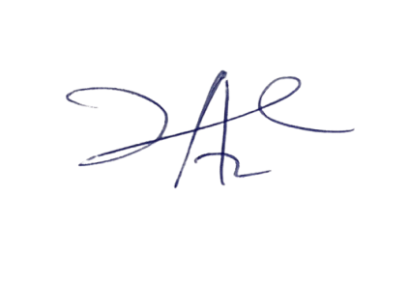

20/7/2023

Principal Head Instuctor