EMERALD ROYAL INTERNATIONAL SCHOOL

MPAPE, ABUJA.

LESSON PLAN AND NOTE 1 FOR WEEK 2 ENDING 3RD MAY, 2024.

SUBJECT: Letter work

TOPIC: Matching letter Aa-Ee with picture word,two letter words and copying

letters Aa and Bb.

SUB-TOPIC: identification of letters Aa-Ee.

DATE: 29/4/2024

DURATION: 40 minutes.

TIME: 08:50--09:30.

PERIOD: 2nd

CLASS: Pre-nursery

NUMBER OF PUPILS: 11

AVERAGE AGE: 2 YEARS

SEX: Mixed.

SPECIFIC OBJECTIVES: By the end of the lesson, the pupils should be able to:-

1. Identify letter Aa-Ee.
2. Match the upper case with the lower case.

RATIONALE: For pupils to know letters and their sounds.

PREVIOUS KNOWLEDGE: Pupils have been learning the lower case.

INSTRUCTIONAL MATERIALS: Flash cards, board, and phonics song.

REFERENCE:Mastering English for nursery schools book 1 by J.M.Omogbai.

LESSON DEVELOPMENT

|  |  |  |  |
| --- | --- | --- | --- |
| STAGES/STEPS | TEACHER’S ACTIVITIES | PUPILS’ ACTIVITIES | LEARNING POINTS |
| INTRODUCTION | Teacher introduces the lesson by singing a jolly phonics song for the pupils. | Pupils sing along with the teacher. | To arouse the interest of the pupils for the lesson. |
| PRESENTATION  STEP 1 | Teacher scattered the flash cards of upper and lower case on the table and asks the pupils the upper case and the lower case of each letters. | Pupils identify the upper and lower case of each letters on the table. | For better understanding of the lesson . |
| STEP2 | Teacher prepares the pupils books for them to match the upper case with lower case.  A e  B d  C b  D c  E a | Pupils match the upper case with the lower case.  A e    B d    C b  D c    E a . | To improve pupils locomotive skills. |
| SUMMARY | Teacher summarizes the lesson by going over the lesson again for more understanding | Pupils listen very attentively to the teacher | For more understanding of the lesson. |
| EVALUATION | Teacher calls out the pupils one after another to identify the upper and the lower case of letter Aa-Ee. | Pupils answer the teacher’s questions. | To assess the level of pupils understanding of the lesson. |
| CONCLUSION | Teacher marks the pupils books and make corrections where necessary. | Pupils submit their books for marking and corrections . | For onwards study. |
| ASSIGNMENT | Read and match upper case and lower case of letter Aa-Ee | Pupils do their Home work at home. | To ensure learning takes place at home. |

LESSON PLAN AND NOTE 2 FOR WEEK 2 ENDING 3RD MAY, 2024.

SUBJECT: Letter work

TOPIC: Matching letter Aa-Ee with picture word,two letter words and copying

letters Aa and Bb.

SUB-TOPIC: identification of letters Aa-Ee and matching letters with the pictures.

DATE: 1/4/2024.

DURATION: 40 minutes.

TIME: 08:50--09:30.

PERIOD: 2nd

CLASS: Pre-nursery

NUMBER OF PUPILS: 11

AVERAGE AGE: 2 YEARS

SEX: Mixed.

SPECIFIC OBJECTIVES: By the end of the lesson, the pupils should be able to:-

1. Identify letter Aa-Ee.
2. Match the letters with the pictures words.

RATIONALE: For pupils to know letters and their sounds.

PREVIOUS KNOWLEDGE: Pupils have been learning the lower case.

INSTRUCTIONAL MATERIALS: Flash cards, board, and phonics song.

REFERENCE:Mastering English for nursery schools book 1 by J.M.Omogbai.

LESSON DEVELOPMENT

|  |  |  |  |
| --- | --- | --- | --- |
| STAGES/STEPS | TEACHER’S ACTIVITIES | PUPILS’ ACTIVITIES | LEARNING POINTS |
| INTRODUCTION | Teacher introduces the lesson by singing a jolly phonics song for the pupils. | Pupils sing along with the teacher. | To arouse the interest of the pupils for the lesson. |
| PRESENTATION  STEP 1 | Teacher writes the upper and lower case of letter Aa-Ee on the board and asks the pupils to identify the upper case and the lower case of each letters. | Pupils identify the upper and lower case of each letters on the table. | For better understanding of the lesson . |
| STEP2 | Teacher prepares the pupils books for them to match the upper case with the picture words. | Pupils match the upper case with the picture words.  .  A as in download (4)  B as in download (8)  C as in download (2)  D as in download (6)  E as in download (3) | To improve pupils locomotive skills. |
| SUMMARY | Teacher summarizes the lesson by going over the lesson again for more understanding | Pupils listen very attentively to the teacher | For more understanding of the lesson. |
| EVALUATION | Teacher calls out the pupils one after another to:-  1. identify the upper and the lower case of letter Aa -Ee.   1. match the letters with the word   A as in cup  B as in egg  C as in apple  D as in dog  E as in banana | Pupils answer the teacher’s questions. | To assess the level of pupils understanding of the lesson. |
| CONCLUSION | Teacher marks the pupils books and make corrections where necessary. | Pupils submit their books for marking and corrections . | For onwards study. |
| ASSIGNMENT | Read and match upper case with the picture words in the text books. | Pupils do their Home work at home. | To ensure learning takes place at home. |

LESSON PLAN AND NOTE 3 FOR WEEK 2 ENDING 3RD MAY, 2024.

SUBJECT: Letter work

TOPIC: Matching letter Aa-Ee with picture word ,two letter words and copying

letters Aa and Bb.

SUB-TOPIC: Two letter words and copy letter Aa and Bb.

DATE: 3/5/2024.

DURATION: 40 minutes.

TIME: 08:50--09:30.

PERIOD: 2nd

CLASS: Pre-nursery

NUMBER OF PUPILS: 11

AVERAGE AGE: 2 YEARS

SEX: Mixed.

SPECIFIC OBJECTIVES: By the end of the lesson, the pupils should be able to:-

1. Pronounce two letter words
2. Copy letter Aa and Bb.

RATIONALE: For pupils to know letters and their sounds.

PREVIOUS KNOWLEDGE: Pupils have been learning the lower case.

INSTRUCTIONAL MATERIALS: Flash cards, board, and phonics song.

REFERENCE:Mastering English for nursery schools book 1 by J.M.Omogbai.

LESSON DEVELOPMENT

|  |  |  |  |
| --- | --- | --- | --- |
| STAGES/STEPS | TEACHER’S ACTIVITIES | PUPILS’ ACTIVITIES | LEARNING POINTS |
| INTRODUCTION | Teacher introduces the lesson by singing a nursery rhyme for the pupils. | Pupils sing along with the teacher. | To arouse the interest of the pupils for the lesson. |
| PRESENTATION  STEP 1 | Teacher guides the pupils to pronounce two letter words. Words. | Pupils listen and pronounce the two letter words according to the teacher.  A + S = AS  A + T = AT  S + O = SO  W + E =WE  U + P = UP  I + T= IT | For proper understanding of the lesson. |
| STEP2 | Teacher prepares the pupils books for them to copy letter Aa and Bb | Pupils copy letter Aa and Bb in the book.  Aa Bb    Aa Bb  Aa Bb | To improve pupils locomotive skills. |
| SUMMARY | Teacher summarizes the lesson by asking the pupils to sing the phonics song for letters Aa-Ee with the teacher. | Pupils sing the phonics song for letters Cc-Ff with the teacher. | For more understanding of the lesson. |
| EVALUATION | Teacher calls out the pupils one after another to:-  1. identify the upper and lower case on the flash card.  2.Re-write letter Aa and Bb. | Pupils answer the teacher’s questions. | To assess the level of pupils understanding of the lesson. |
| CONCLUSION | Teacher marks the pupils books and make corrections where necessary. | Pupils submit their books for marking and corrections . | For onwards study. |
| ASSIGNMENT | Teacher asks the pupils to read and match upper case with the picture words in the text books. | Pupils do their Home work at home. | To ensure learning takes place at home. |

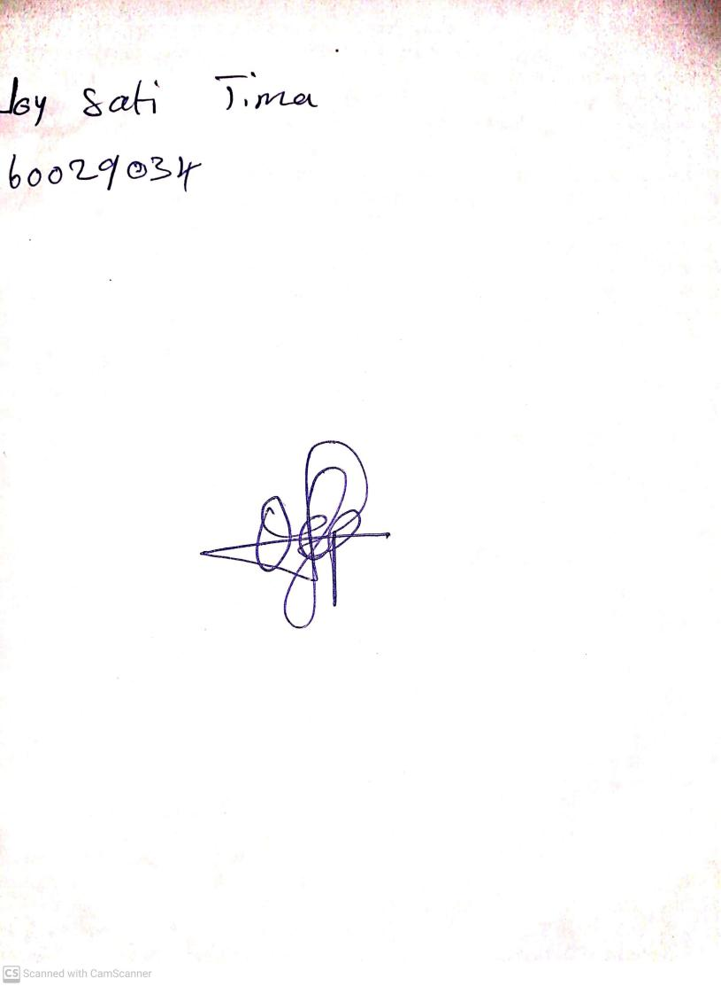

**26TH April, 2024**

**Perpetual Ojoma Ocheja**

**Stream Head Nursery**