**EMERALD ROYAL INTERNATIONAL SCHOOL MPAPE, ABUJA**

**LESSON NOTE/NOTE FOR WEEK 9 PERIOD 1 ENDING 10/03/2023**

**TERM: 2nd**

**WEEK: 09**

**DATE: 06/03/2023**

**CLASS: Nursery 2**

**SUBJECT: Number work**

**TOPIC: Number 36—40**

**SUB—TOPIC: Counting and identification of numbers 36—40**

**PERIOD::1st**

**TIME: 08:50—09:30**

**DURATION: 40 minutes**

**NUMBER IN CLASS: 14**

**AVERAGE AGE: 5 years**

**SEX:Mixed**

**LEARNING OBJECTIVES: By the end of the lesson, the Pupils should be able to:**

**1. Count number 1—40 orally**

**2. Identify number 1—40 on a chart.**

**RATIONALE: For Pupils to be able to count sequentially and identify numbers 1—40.9**

**PREVIOUS KNOWLEDGE: Pupils have learnt counting of numbers 1—35 in previous lesson.**

**INSTRUCTIONAL MATERIALS: Number chart.**

**REFERENCE MATERIALS: Mastering Mathematics for Nursery schools book 3 by Henry Z. Idogun**

**LESSON DEVELOPMENT**

|  |  |  |  |
| --- | --- | --- | --- |
| **STAGES/ STEPS** | **TEACHER'S ACTIVITIES** | **PUPILS' ACTIVITIES** | **LEARNING POINT** |
| **Introduction** | **Teacher introduces the lesson by singing nursery number rhymes.** | **Pupils sing the rhymes along with the teacher.** | **To arouse pupils interest for the lesson.** |
| **Presentation step 1** | **Teacher claps and count number 1—40 and ask Pupils to repeat after her.** | **Pupils listen to the teacher and repeat after her.** | **To improve play way method of learning.** |
| **Step 2** | **Teacher display number chart from 1—40 for the Pupils to count and identify repeatedly.** | **Pupils take turns and count number 1–40 on the chart.** | **For pupils to be familiar with the numbers.** |
| **Board summary** | **Teacher summarizes the lesson by writing numbers 1—40 on the board for pupils to copy into their books. That is;**  **1 2 3 4 5 6 7 8 9 10 11 12 13 14 15 16 17 18 19 20 21 22 23 24 25 26 27 28 29 30 31 32 33 34 35 36 37 38 39 40** | **Pupils copy the note into their exercise books** | **For onward study.** |
| **Evaluation** | **Teacher calls out the Pupils one after another to count number 1—40** | **Pupils count number 1—40 on their own.** | **To ascertain if Pupils can count number 1—40 on their own.** |
| **Conclusion** | **Teacher concludes the lesson by singing nursery rhymes for the Pupils.** | **Pupils sing the rhymes along with the teacher.** | **To make learning fun.** |
| **Assignment** | **Count, identify and write numbers 1—40.** | **Pupils do their assignment at home.** | **To encourage learning at home.** |

**LESSON NOTE/ PLAN FOR WEEK 9 PERIOD 2 ENDING 10/03/2023**

**TERM: 2ND**

**WEEK: 9**

**DATE: 08/03/2023**

**CLASS: Nursery 2**

**SUBJECT: Number work**

**TOPIC: Number 36—40**

**SUB—TOPIC: Counting of Numbers 36—40**

**PERIOD: 2nd period**

**TIME: 08:50—09:30am**

**DURATION: 40 minutes**

**NUMBER IN N CLASS: 14**

**AVERAGE AGE: 5 years**

**SEX: Mixed**

**LEARNING OBJECTIVES: By the end of the lesson, the Pupils should be able to:**

**1. Count number 36—40**

**2. Colour number 36—40**

**RATIONALE: For Pupils to know counting of numbers 36—40**

**PREVIOUS KNOWLEDGE: Pupils have learnt counting of numbers 1—40 in previous lesson.**

**INSTRUCTIONAL MATERIALS: Flash cards.**

**REFERENCE MATERIALS: Mastering Mathematics for Nursery schools book 3 by Henry Z. Idogun.**

**. LESSON DEVELOPMENT**

|  |  |  |  |
| --- | --- | --- | --- |
| **Steps** | **Teacher's activities** | **Pupils' activities** | **Learning 08054768333 Simon** |
| **Introduction** | **Teacher introduces the lesson by singing nursery rhyme** | **Pupils sing the rhyme along with the teacher.** | **To arouse pupils interest for the lesson.** |
| **Presentation step 1** | **Teacher writes number 36—40 on the board, count, and ask Pupils to repeat after her. As;**  **36 37 38 39 40** | **Pupils pay attention and repeat after her.** | **For proper understanding.** |
| **Step 2** | **Teacher prepares pupils books for them to identify and colour number 36—40.** | **Pupils identify and colour number 36—40 in their books.** | **To enhance Pupils participation in class.** |
| **Board summary** | **Teacher summarizes the lesson by writing numbers 36—40 on the board for pupils to copy into their books. That is;**  **NUMBER 36—40**  **36 37 38 39 40** | **Pupils copy the numbers on the board into their exercise books.** | **For onward study.** |
| **Evaluation** | **Teacher evaluates the lesson by calling out the Pupils one after the other to identify the numbers on the board.** | **Pupils identify the numbers 36—40 on the board.** | **To assess Pupils level of understanding.** |
| **Conclusion** | **Teacher concludes the lesson by marking pupils books.** | **Pupils submit their books for marking.** | **For endorsement.** |
| **Assignment** | **Count and write numbers 36—40.** | **Pupils do their assignment at home.** | **To encourage learning at home.** |

**LESSON PLAN / NOTE FOR WEEK 9 PERIOD 3 ENDING 10/03/2023**

**TERM: 2nd**

**WEEK: 9**

**DATE: 10/03/2023**

**CLASS: Nursery 2**

**SUBJECT: Number work**

**TOPIC: Number 36—40**

**SUB—TOPIC: Tracing of numbers**

**PERIOD: 3rd**

**TIME: 08:10—08:50am**

**DURATION: 40 minutes**

**NUMBER IN CLASS: 14**

**AVERAGE AGE: 5 years**

**SEX:Mixed**

**LEARNING OBJECTIVES: By the end of the lesson, the Pupils should be able to:**

**1. Count number 36—40**

**2. Trace numbers at least 31—40**

**RATIONALE: For Pupils to be conversant with the numbers.**

**PREVIOUS KNOWLEDGE: Pupils have learnt colouring of numbers 36—40 in previous lesson.**

**INSTRUCTIONAL MATERIALS: Number flash cards.**

**REFERENCE MATERIALS: Mastering Mathematics for Nursery schools book 3 by Henry Z. Idogun.**

**LESSON DEVELOPMENT**

|  |  |  |  |
| --- | --- | --- | --- |
| **Steps** | **Teacher's activities** | **Pupils' activities** | **Learning point** |
| **Introduction** | **Teacher introduces the lesson by asking pupils to count number 1–30.** | **Pupils count number 1—30.** | **To prepare pupils minds for the lesson ahead.** |
| **Presentation step 1** | **Teacher presents the lesson by writing numbers 1—40 on the board, count and ask Pupils to repeat after her. As;**  **1 2 3 4 5 6 7 8 9**  **10 11 12 13 14 15 16**  **17 18 19 20 21 22**  **23 24 25 26 27 28**  **29 30 31 32 33 34**  **35 36 37 38 39 40** | **Pupils listen to the teacher and repeat after her.** | **For proper understanding.** |
| **Step 2** | **Teacher writes dotted numbers in Pupils books for them to trace numbers from 31—40. As;** | **Pupils trace the numbers in their books.** | **For better understanding.** |
| **Board summary** | **Teacher summarizes the lesson by preparing pupils books for them to copy the numbers on the board.** | **Pupils copy the numbers on the board into their exercise books.** | **For onward study.** |
| **Evaluation** | **Teacher evaluates the lesson by displaying flash cards of numbers 1—40 on the desk and called out any number amongst the numbers on the desk for pupils to identify.** | **Pupils identify the numbers called out by the teacher.** | **To determine if Pupils can identify the numbers 1—40.** |
| **Conclusion** | **Teacher concludes the lesson by marking pupils books.** | **Pupils submit their books for marking.** | **For endorsement.** |
| **Assignment** | **Count,identify and write numbers from 1—40.** | **Pupils do their assignment at home.** | **To encourage learning at home.** |

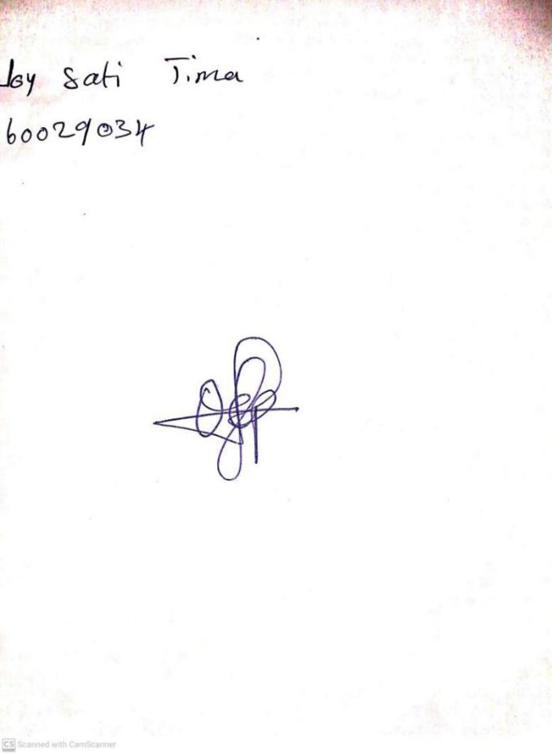

**1ST MARCH, 2024**

**Perpetual Ojoma Ocheja**

**Stream Head Nursery**