**LESSON PLAN FOR WEEK 5 ENDING 13/10/2023**

**Term 1st term**

**Week 5th  week**

**Date 11th October,2023**

**Class Nursery One**

**Subject Nature studies**

**Topic Objects in the home.**

**Sub-topic Definition of objects in the home.**

**Period 4th period**

**Time 10:40 am**

**Duration 35 minutes**

**No in class 15**

**Average Age 3 years**

**Sex Mixed**

**Specific Objectives: By the end of the lesson, the pupils should be able to:**

1. **Define the objects in the home.**
2. **Mention the objects found in the home.**

**Rationale: To ensure the pupils know the objects in the home.**

**Previous Knowledge: The pupils can identify objects found in the classroom.**

**Instructional Resources: Objects in the home chart.**

**Reference Material: Elementary science by Showers kiddies nursery 1**

**LESSON PRESENTATION**

|  |  |  |  |
| --- | --- | --- | --- |
| **Steps** | **Teacher’s Activities** | **Pupils’ Activities** | **Learning Points** |
| **Introduction** | **The teacher introduces the lesson by showing the pupils chart that contains the “objects in the home”.** | **The pupils listens attentively to identify objects found in the home.** | **To arose the pupils’ interest.** |
| **Step 1** | **The teacher defines objects in the home as the “different kinds of school objects found in the home”.** | **The pupils defines with the teacher “objects in the home”.** | **For proper understanding.** |
| **Step 2** | **The teacher lists the objects found in the home which includes:**  **PLATES**  **SPOONS**  **CUP**  **POT**  **KNIFE**  **TABLE**  **CHAIRS**  **KITCHEN CABINET**  **GAS COOKER**  **BLENDER**  **TELEVISION**  **WARDROBE etc.** | **The pupils mention with the teacher the objects found in the home.** | **For better understanding.** |
| **Summary** | **The teacher summarizes the lesson by showing the pupils some objects found in the home.** | **The pupils can identify the objects found in the home.** | **For onward study.** |
| **Evaluation** | 1. **Define objects in the home?** 2. **Mention five objects you can find in a home?** | **The pupils answer the question correctly.** | **To ascertain the pupils’ understanding.** |
| **Conclusion** | **The teacher summarizes, reacts, and corrects the pupils.** | **The pupils gives answer to the teacher’s questions** | **To consolidate the lesson.** |
| **Assignment** | 1. **Objects in the home are those objects we can find in the __________?** 2. **Can we find a rake inside a home?** | **The pupils copy and do their homework at home.** | **To encourage learning while at home.** |

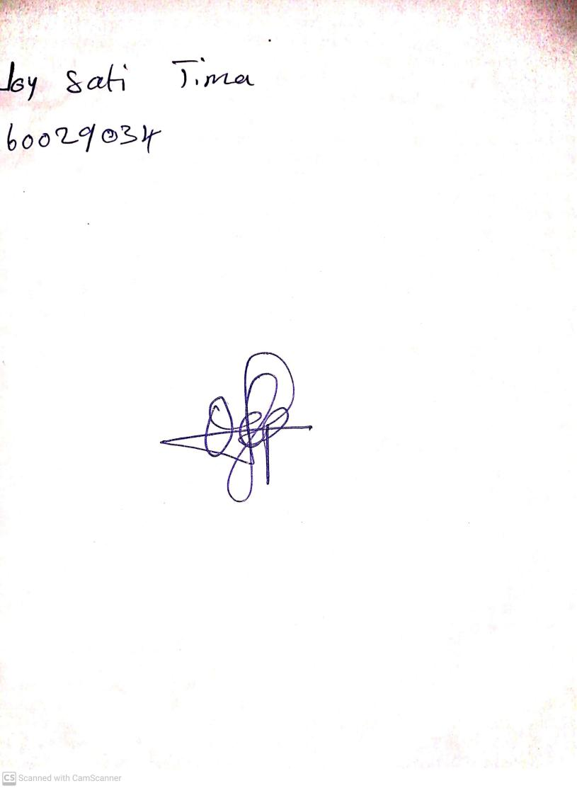

15th August, 2023

Perpetual Ojoma Ocheja

Stream Head Nursery