**EMERALD ROYAL INTERNATIONAL SCHOOL**

**MPAPE, ABUJA.**

**LESSON PLAN AND NOTE 1 FOR WEEK 5 ENDING 2ND JUNE,2023.**

TERM: 3RD TERM

WEEK: 5TH WEEK

SUBJECT: Number Work

TOPIC: Counting numbers 1 - 35.

SUB-TOPIC: Identification of numbers 1 - 35.

DATE: 29th May, 2023.

DURATION: 40 minutes.

TIME: 08:50--09:30.

PERIOD: 1st

CLASS: Pre-nursery

NUMBER OF PUPILS: 11

AVERAGE AGE: 2 years

SEX: Mixed.

SPECIFIC OBJECTIVES: By the end of the lesson, the pupils should be able to:-

1. Count Numbers 1-35
2. Identify numbers 1 - 35

RATIONALE: For pupils to be able to count numbers.

PREVIOUS KNOWLEDGE: Pupils have been counting numbers.

INSTRUCTIONAL MATERIALS: Number chart, flash cards, building blocks etc

REFERENCE MATERIALS: Mastering mathematics for nursery schools book 1 by Henry Idogun.

**LESSON DEVELOPMENT**

|  |  |  |  |
| --- | --- | --- | --- |
| STAGES/STEPS | TEACHER’S ACTIVITIES | PUPILS’ ACTIVITIES | LEARNING POINTS |
| INTRODUCTION | Teacher asks pupils to count numbers 1- 30. | Pupils count numbers 1 - 30 | To encourage pupils to participate in the lesson. |
| PRESENTATION  STEP 1 | Teacher counts numbers 1 - 35 for the pupils to repeat after her. | Pupils count numbers 1 - 35 after the teacher. I.e 1 2 3 4 5 6 7 8 9 10 11 12 13 14 15 16 17 18 19 20 21 22 23 24 252627 28 29 30 31 32 33 34 35. | For better understanding of the lesson . |
| STEP 2 | Teacher guides pupils to identify numbers numbers 1 - 35 | Pupils point at numbers 1 - 35. ie  1 2 3 4 5 6 7 8 9 10 11 12 13 14 15 16 17 18 19 20 21 22 23 24 25 2627 28 29 30 31 32 33 34 35. | For proper understanding of the lesson. |
| SUMMARY | Teacher identifies each number 1 - 35 for the pupils. | Pupils point at the numbers. | For more understanding of the lesson. |
| EVALUATION | Teacher asks Pupils to count numbers 1 - 35 | Pupils count numbers 1 - 35. | To assess pupils understanding of the lesson. |
| CONCLUSION | Teacher sings a number rhyme for the pupils. | Pupils sing the rhyme along with the teacher. | To improve pupils speaking ability. |
| ASSIGNMENT (HOME WORK) | Count and circle numbers 1 - 35  1 2 3 4 5 6 7 8 9 10 11 12 13 14 15 16 19 20 21 22 23 24 25 26 27 28 29 30 31 32 33 34 35 . | Pupils do their assignment at home. | To encourage pupils to learn at home. |

**LESSON PLAN AND NOTE 2 FOR WEEK 5 ENDING 2ND JUNE,2023.**

TERM: 3RD TERM

WEEK: 5TH WEEK

SUBJECT: Number Work

TOPIC: Counting numbers 1 - 35.

SUB-TOPIC: Tracing number 7

DATE: 31st May, 2023.

DURATION: 40 minutes.

TIME: 10 : 40 - 11:20

PERIOD: 2nd

CLASS: Pre-nursery

NUMBER OF PUPILS: 11

AVERAGE AGE: 2 years

SEX: Mixed.

SPECIFIC OBJECTIVES: By the end of the lesson, the pupils should be able to:-

1.Count Numbers 1-35

2.Trace number 7

RATIONALE: For pupils to be able to count numbers.

PREVIOUS KNOWLEDGE: Pupils have been counting numbers.

INSTRUCTIONAL MATERIALS: Number chart, flash cards, building blocks etc

REFERENCE MATERIALS: Mastering mathematics for nursery schools book 1 by Henry Idogun.

**LESSON DEVELOPMENT**

|  |  |  |  |
| --- | --- | --- | --- |
| STAGES/STEPS | TEACHER’S ACTIVITIES | PUPILS’ ACTIVITIES | LEARNING POINTS |
| INTRODUCTION | Teacher introduces the lesson by singing a number rhyme for the pupils. | Pupils sing the rhyme along with the teacher. | To arouse pupils interest in the lesson. |
| PRESENTATION  STEP 1 | Teacher counts numbers 1 - 35 for the pupils to repeat after her. | Pupils count numbers 1 - 35 after the teacher. I.e 1 2 3 4 5 6 7 8 9 10 11 12 13 14 15 16 17 18 19 20 21 22 23 24 252627 28 29 30 31 32 33 34 35. | For better understanding of the lesson . |
| STEP 2 | Teacher guides pupils to tracing number 7 | Pupils copy number 7  Dotted numbersDotted numbersDotted numbersDotted numbersDotted numbersDotted numbers | For proper understanding of the lesson. |
| SUMMARY | Teacher writes number 7 boldly on the board for the pupils to see. | Pupils point at the number at number 7 on the board. | For more understanding of the lesson. |
| EVALUATION | Teacher asks Pupils to count numbers 1 - 35from the number chart. | Pupils count numbers 1 - 35. | To assess pupils understanding of the lesson. |
| CONCLUSION | Teacher sings a number rhyme for the pupils. | Pupils sing the rhyme along with the teacher. | To improve pupils speaking ability. |
| ASSIGNMENT (HOME WORK) | Copy number 5  Dotted numbersDotted numbersDotted numbersDotted numbersDotted numbersDotted numbers | Pupils do their assignment at home. | To encourage pupils to study at home. |

**LESSON PLAN AND NOTE 3 FOR WEEK 5 ENDING 2ND JUNE,2023.**

TERM: 3RD TERM

WEEK: 5TH WEEK

SUBJECT: Number Work

TOPIC: Counting numbers 1 - 35.

SUB-TOPIC: Tracing number 8

DATE: 1st May, 2023.

DURATION: 40 minutes.

TIME: 08 : 10 - 08:50

PERIOD: 3rd

CLASS: Pre-nursery

NUMBER OF PUPILS: 11

AVERAGE AGE: 2 years

SEX: Mixed.

SPECIFIC OBJECTIVES: By the end of the lesson, the pupils should be able to:-

1.Count Numbers 1-35

2.Trace number 8

RATIONALE: For pupils to be able to count numbers.

PREVIOUS KNOWLEDGE: Pupils have been counting numbers.

INSTRUCTIONAL MATERIALS: Number chart, flash cards, building blocks pencils etc.

REFERENCE MATERIALS: Mastering mathematics for nursery schools book 1 by Henry Idogun.

**LESSON DEVELOPMENT**

|  |  |  |  |
| --- | --- | --- | --- |
| STAGES/STEPS | TEACHER’S ACTIVITIES | PUPILS’ ACTIVITIES | LEARNING POINTS |
| INTRODUCTION | Teacher introduces the lesson by singing a number rhyme for the pupils. | Pupils sing the rhyme along with the teacher. | To arouse pupils interest in the lesson. |
| PRESENTATION  STEP 1 | Teacher counts numbers 1 - 35 for the pupils to repeat after her. | Pupils count numbers 1 - 35 after the teacher. I.e 1 2 3 4 5 6 7 8 9 10 11 12 13 14 15 16 17 18 19 20 21 22 23 24 25 26 27 28 29 30 31 32 33 34 35. | For better understanding of the lesson . |
| STEP 2 | Teacher guides pupils to trace number 8 | Pupils trace number 8  Dotted numbersDotted numbersDotted numbersDotted numbersDotted numbersDotted numbers | For proper understanding of the lesson. |
| SUMMARY | Teacher writes number 8 boldly on the board for the pupils to see. | Pupils point at the number  numbers 1-   20 | For more understanding of the lesson. |
| EVALUATION | Teacher asks Pupils to identify number 8 | Pupils point at number 8 | To assess pupils understanding of the lesson. |
| CONCLUSION | Teacher counts numbers 1 - 35 for the pupils. | Pupils count numbers 1 - 35 along with the teacher. | For proper under standing of the lesson. |
| ASSIGNMENT (HOME WORK) | Circle number 8 amongst other numbers  2 8 6 8 8 10 3  8 5 3 8 9 8 8 | Pupils do their assignment at home. | To encourage pupils to learn at home. |

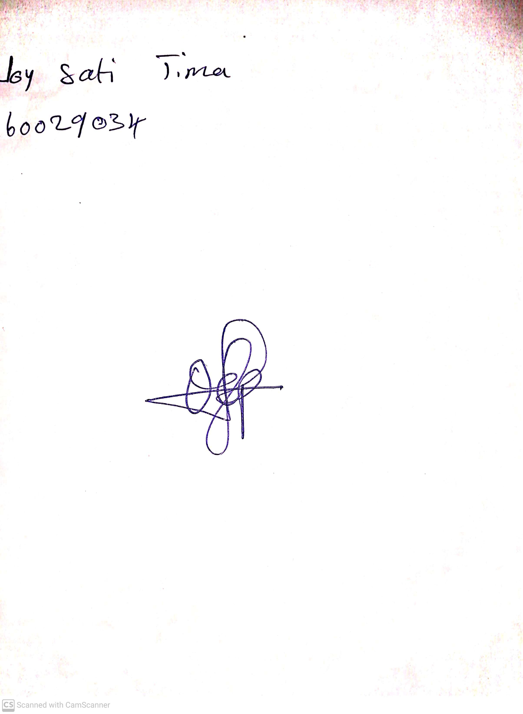

20th May, 2023

Perpetual Ojoma

Stream Head Nursery