**EMERALD ROYAL INTERNATIONAL SCHOOL**

**MPAPE, ABUJA.**

**LESSON PLAN AND NOTE FOR WEEK 2 ENDING 22/09/2023**

TERM: FIRST

WEEK: 2ND

DATE: 18/09/2023

CLASS: NURSERY 2

SUBJECT: SOCIAL NORMS

TOPIC: CHILD ABUSE .

SUB-TOPIC: MEANING AND EXAMPLES OF CHILD ABUSE

PERIOD: 2ND PERIOD AFTER LONG BREAK

TIME: 11: 20- 12: 00PM

DURATION: 40 MINUTES.

NUMBER IN CLASS: 14

AVERAGE AGE: 5 YEARS.

SEX: MIXED.

SPECIFIC OBJECTIVES: BY THE END OF THE LESSON,THE PUPILS SHOULD BE ABLE TO:

1. EXPLAIN THE MEANING OF CHILD ABUSE
2. STATE THE EXAMPLES OF CHILD ABUSE

RATIONALE: FOR PUPILS TO KNOW THE MEANING AND EXAMPLES OF CHILD ABUSE

PREVIOU KNOWLEDGE: PUPILS HAVE LEARNT THE MEANING AND EXAMPLES OF HUMAN RIGHT IN PREVIOUS LESSON.

INSTRUCTIONAL MATERIALS: A VIDEO CLIP OF CHILDREN BEEING MALTREATED BY THEIR STEP MOTHER IN TEACHERS PHONE.

REFERENCE MATERIALS: GOOGLE.COM

**LESSON DEVELOPMENT**

|  |  |  |  |
| --- | --- | --- | --- |
| STAGES/STEPS | TEACHER’S ACTIVITIES | PUPILS’ ACTIVITIES | LEARNING POINTS |
| INTRODUCTION | Teacher introduces the lesson by asking pupils the following questions:   1. What is right? 2. Mention the examples of human rights. | Pupils answer the questionsasked by the teacher. | To arouse pupils interest for the lesson ahead. |
| PRESENTATION  STEP 1 | Teacher explains the meaning of child abuse to pupils and then asks them to repeat after her. | Pupils listen attentively to the teacher and repeat after her. | For proper understanding . |
| STEP 2 | Teacher states the examples of child abuse to pupils and also asks them to repeat after her. | Pupils pay attention to the teacher and repeat after her. | For better understanding of the lesson. |
| BOARD SUMMARY | Teacher summarizes the lesson by writing the whole note of lesson on the board for pupils to copy into their books. Ie,  CHILD ABUSE  Child abuse is any form of maltreatment by an adult, which is violent or threatening for the child.  Examples of child abuse are:   1. Hitting and beating a child. 2. Hitting a child with an object, such as belt or a stick. 3. Kicking achild 4. Burning a child with hot water,a cigarette,or an iron. 5. Holding a child under water. 6. Tying up achild 7. Severely shaking ababy. | Pupils copy the note into their exercise books. | For onward study. |
| EVALUATION | Teacher evaluates the lesson by asking the following questions;   1. What is child abuse? 2. State the examples of child abuse. | Pupils answer the questions ask by the teacher. | To assess pupils level of understanding. |
| CONCLUSION | Teacher concludes the lesson by marking pupils books. | Pupils submit their books for marking. | For endorsement. |
| ASSIGNMENT | 1. Mention 3 forms of child abuse? 2. Explain the forms of child abuse mentioned. | Pupils do their assignment at home. | To encourage learning at home. |

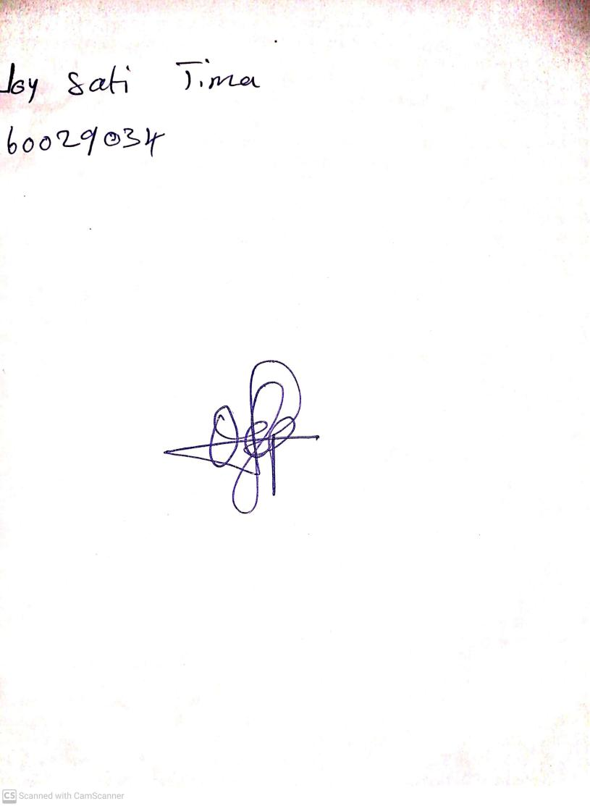

18th September, 2023

Perpetual Ojoma Ocheja

Stream Head Nursery