**EMERALD ROYAL INTERNATIONAL SCHOOL**

**MPAPE, ABUJA.**

**LESSON PLAN AND NOTE FOR WEEK 2 PERIOD 1 ENDING 22/09/2023**

TERM: FIRST

WEEK: 2

DATE: 18/09/2023

CLASS: NURSERY 2

SUBJECT: NUMBER WORK

TOPIC: COUNTING NUMBER 21-25 .

SUB-TOPIC: COUNTING AND IDENTIFICATION OF NUMBERS 1-25

PERIOD: 1ST.

TIME: O8:50-09:30.

DURATION: 40 MINUTES.

NUMBER IN CLASS: 14

AVERAGE AGE: 5 YEARS.

SEX: MIXED.

SPECIFIC OBJECTIVES: BY THE END OF THE LESSON,THE PUPILS SHOULD BE ABLE TO:

1. COUNT NUMBER 1-25 ORALLY.
2. IDENTIFY NUMBER 1-25 ON A CHART.

RATIONALE: FOR PUPILS TO BE ABLE TO COUNT SEQUENTIALLY AND IDENTIFY NUMBER 1-25.

PREVIOU KNOWLEDGE: PUPILS HAVE LEARNT COUNTING OF NUMBERS 1-20 IN PREVIOUS LESSON.

INSTRUCTIONAL MATERIALS: NUMBER CHART FROM 1-25.

REFERENCE MATERIALS: THE NEW MASTERING MATHEMATICS FOR NURSERY SCHOOLS BOOK 3 BY HENRY.Z.IDOGUN.

**LESSON DEVELOPMENT**

|  |  |  |  |
| --- | --- | --- | --- |
| STAGES/STEPS | TEACHER’S ACTIVITIES | PUPILS’ ACTIVITIES | LEARNING POINTS |
| INTRODUCTION | Teacher introduces the lesson by singing a number rhyme for the pupils. | Pupils sing the rhyme along with the teacher. | To arouse pupils interest in the lesson. |
| PRESENTATION  STEP 1 | Teacher claps and count number 1-25 and then asks pupils to repeat after her. | Pupils repeat after the teacher by counting number 1-25 while clapping their hands. That is; 1 2 3 4 5 6 7 8 9 10 11 12 13 14 15 16 17 18 19 20 21 22 23 24 25 | To enhance play way method of learning . |
| STEP 2 | Teacher displays number chart from 1-25 and then identify and asks pupils to repeat after her | Pupils identify the numbers after the teacher repeatedly. | For better understanding of the lesson. |
| BOARD SUMMARY | Teacher summarizes the lesson by counting the numbers 1-25 on the chart over and over again. | Pupils pay attention to the teacher. | For more understanding of the lesson. |
| EVALUATION | Teacher asks Pupils to:   1. count numbers 1 - 25 on the chart one after the other. 2. Identify umber 1–25. | Pupils count and identify the numbers 1 - 25 on the board one after another. | To ascertain if pupils can count and identify numbers 1-25 on their own. |
| CONCLUSION | Teacher ends the lesson by singing a nursery rhyme. | Pupils sing the rhyme along with the teacher. | To improve pupils speaking ability. |
| ASSIGNMENT (HOME WORK) | Identify, count and write numbers 1 -25 | Pupils do their assignment at home. | To encourage learning at home. |

**LESSON PLAN AND NOTE FOR WEEK 2 PERIOD 2 ENDING 22/09/2023**

TERM: FIRST

WEEK: 2

DATE: 19/09/2023

CLASS: NURSERY 2

SUBJECT: NUMBER WORK

TOPIC: COUNTING NUMBER 21-25 .

SUB-TOPIC: BACKWARD COUNTING OF NUMBERS 25- 1

PERIOD: 2ND.

TIME: O8:50-09:30.

DURATION: 40 MINUTES.

NUMBER IN CLASS: 14

AVERAGE AGE: 5 YEARS.

SEX: MIXED.

SPECIFIC OBJECTIVES: BY THE END OF THE LESSON,THE PUPILS SHOULD BE ABLE TO:

1. COUNT NUMBER 25-1 BACKWARDLY
2. WRITE NUMBER 25-1

RATIONALE: FOR PUPILS TO KNOW BACKWARD COUNTING OF NUMBERS 25-1

PREVIOU KNOWLEDGE: PUPILS HAVE LEARNT COUNTING OF NUMBERS 1-25 IN PREVIOUS LESSON.

INSTRUCTIONAL MATERIALS: NUMBER FLASH CARDS.

REFERENCE MATERIALS: THE NEW MASTERING MATHEMATICS FOR NURSERY SCHOOLS BOOK 3 BY HENRY.Z.IDOGUN.

**LESSON DEVELOPMENT**

|  |  |  |  |
| --- | --- | --- | --- |
| STAGES/STEPS | TEACHER’S ACTIVITIES | PUPILS’ ACTIVITIES | LEARNING POINTS |
| INTRODUCTION | Teacher introduces the lesson by reviewing the previous lesson. | Pupil listen to the teacher. | To arouse pupils interest for the lesson ahead. |
| PRESENTATION  STEP 1 | Teacher displays numbers flash cards on the pupils table from 25-1 counts and then asks pupils to repeat after her. I.e, 25 24 23 22 21 20 19 18 17 16 15 14 13 12 11 10 9 8 7 6 5 4 3 2 1. | Pupils identify and count numbers 25-1 after the teacher. | For proper understanding of the lesson . |
| STEP 2 | Teacher then writes numbers 25-1 on the board for pupils to copy into their exercise books. | Pupils count and copy the numbers into their exercise books. I.e,  25 24 23 22 21 20 19 18 17 16 15 14 13 12 11 10 9 8 7 6 5 4 3 2 1. | For better understanding of the lesson. |
| BOARD SUMMARY | Teacher summarizes the lesson by going through the lesson on the board over and over again. | Pupils pay attention to the teacher. | For more understanding of the lesson. |
| EVALUATION | Teacher asks Pupils to:   1. count numbers 25 - 1 on the board one after the other. 2. Identify number 25–1 on the flash cards. | Pupils count numbers 25 - 1 on the board one after another. | To assess pupils understanding of the lesson. |
| CONCLUSION | Teacher marks pupils books. | Pupils submit their books for marking. | For endorsement. |
| ASSIGNMENT | Identify, count and write numbers 25- 1. | Pupils do their assignment at home. | To encourage learning at home. |

**LESSON PLAN AND NOTE FOR WEEK 2 PERIOD 3 ENDING 22/09/2023**

TERM: FIRST

WEEK: 2

DATE: 22/09/2023

CLASS: NURSERY 2

SUBJECT: NUMBER WORK

TOPIC: COUNTING NUMBER 21-25 .

SUB-TOPIC: COUNTING OF NUMBERS 21- 25

PERIOD: 3RD.

TIME: O8:1O- 08:50.

DURATION: 40 MINUTES.

NUMBER IN CLASS: 14

AVERAGE AGE: 5 YEARS.

SEX: MIXED.

SPECIFIC OBJECTIVES: BY THE END OF THE LESSON,THE PUPILS SHOULD BE ABLE TO:

1.COUNT NUMBER 21 - 25

2. WRITE NUMBER 21 - 25

RATIONALE: FOR PUPILS TO BE ABLE TO COUNT AND WRITE NUMBER 21 - 25.

PREVIOU KNOWLEDGE: PUPILS HAVE LEARNT BACKWARD COUNTING OF NUMBERS 25-1 IN PREVIOUS LESSON.

INSTRUCTIONAL MATERIALS: NUMBER CHART FROM 21 - 25.

REFERENCE MATERIALS: THE NEW MASTERING MATHEMATICS FOR NURSERY SCHOOLSBOOK 3 BY HENRY.Z.IDOGUN.

**LESSON DEVELOPMENT**

|  |  |  |  |
| --- | --- | --- | --- |
| STAGES/STEPS | TEACHER’S ACTIVITIES | PUPILS’ ACTIVITIES | LEARNING POINTS |
| INTRODUCTION | Teacher introduces the lesson by reviewing the previous lesson. | Pupil listen to the teacher. | To arouse pupils interest for the lesson ahead. |
| PRESENTATION  STEP 1 | Teacher writes numbers 21-25 on the board, counts and then asks pupils to repeat after her. I.e, 21 22 23 24 25. | Pupils count numbers 21-25 after the teacher. | For proper understanding of the lesson . |
| STEP 2 | Teacher prepares pupils books for them to count and copy the numbers on the board into their exercise books. | Pupils count and copy the numbers into their exercise books. I.e,  21 22 23 24 25. | For better understanding of the lesson. |
| BOARD SUMMARY | Teacher summarizes the lesson by going through the lesson on the board over and over again. | Pupils pay attention to the teacher. | For more understanding of the lesson. |
| EVALUATION | Teacher asks Pupils to:   1. count numbers 21 - 25 on the board one after the other. 2. Identify umber 21–25 one after another. | Pupils count numbers 21- 25 on the board one after another. | To assess pupils understanding of the lesson. |
| CONCLUSION | Teacher marks pupils books. | Pupils submit their books for marking. | For endorsement. |
| ASSIGNMENT | Identify, and circle number 21-25 amongst others. 4 6 21 7 2 14 24 8 23 6 9 32 17 15 12 18 19 25 22 33 | Pupils do their assignment at home. | To encourage learning at home. |

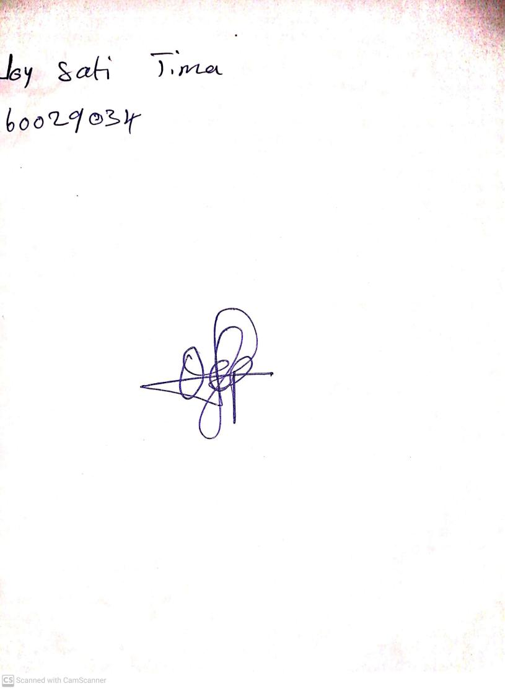

18th September, 2023

Perpetual Ojoma Ocheja

Stream Head Nursery