**EMERALD ROYAL INT’L SCHOOL**

**LESSON PLAN/NOTE FOR WEEK 6 ENDING: 9th JUNE, 2023**

|  |  |
| --- | --- |
| **Term** | 3rd |
| **Week** | 6 |
| **Date** | 05/06/2023 |
| **Class** | SSS 1 |
| **Subject** | Physics |
| **Topic** | Equilibrium of bodies in liquids |
| **Sub-topic** | Archimedes principles |
| **Period** | 1 and 2 |
| **Time** | 11:50-1:00 |
| **Duration** | 80minutes |
| **Number in class** | 8 |
| **Average age** | 13years |
| **Sex** | Mixed |
| **Specific objectives** | By the end of the lesson, the students should be able to:   1. Explain the concept of equilibrium of bodies in liquids 2. Explain the Archimedes principle 3. Solve simple question involving Archimedes principles |
| **Rationale** | To enable the students understand the concept of equilibrium of bodies in liquids |
| **Previous knowledge** | Students should have been taught on resultant forces |
| **Instructional aid** | One guide sheet for each student, science notebook and a science textbook. |
| **Reference** | * M.W. Anyakoha. New school physics for secondary schools. Africana first publishers PLC. page 155-169 * P.N. Okeke. Macmillan Senior Secondary Physics. Pearson. Page 89-99 |

**LESSON DEVELOPMENT**

|  |  |  |  |
| --- | --- | --- | --- |
| **STEPS** | **TEACHER’S ACTIVITIES** | **STUDENTS’ ACTIVITIES** | **LEARNING POINTS** |
| **Introduction** | The teacher introduces the lesson by stating that it is our common experience that objects appear to become lighter when partially or completely immersed in a liquid such as water. For example, if one draws a bucket full of water out from a stream, the bucket appears heavier and heavier as it leaves the stream. It appears heaviest when completely out of the stream. This experience suggests that there is some upward force exerted by the liquid on anything immersed partially or completely in it. | The students listen attentively. | To give the students a proper understanding of equilibrium of forces in liquids. |
| **Step I** | *Archimedes principle*  Archimedes principle states that when a body is totally or partially immersed in a fluid (liquid or gas), it experiences an upthrust which is equal to the weight of fluid displaced. | The students engage in the practical application of Archimedes principle. | To ensure proper understanding of the lesson. |
| **Step II** | *Example*  An object of density 15 gcm-3 weighs 100g when suspended with a string from a spring balance. It is then lowered it is then lowered into a liquid of density 0.9gcm-3 until two-thirds of its volume is immersed in the liquid. Calculate the tension in the string in Newtons.  *Solution*  Mass of liquid displaced = volume × density  = 4.45 × 10=6 × 0.9 × 103 kg  = 4.005 × 10-3 = 0.004 kg  Weight of liquid displaced = 0.004 × 10 = 0.04 N  Upthrust = Weight of liquid displaced = 0.04N  Tension in string = Weight of Object - Upthrust  = 1 - 0.04 = 0.96 N | The students listen attentively to the teacher’s explanation. | To ensure that all the students are carried along. |
| **Summary** | Archimedes principle states that when a body is partially or totally immersed in a fluid, it experiences an upthrust which is equal to the weight of fluid displaced. | The students listen attentively to the teacher’s explanation. | For reference purpose. |
| **Evaluation** | The teacher evaluates the students by giving the students the following class work.  State Archimedes principle and describe an experiment to verify the principle. | The students answer the question in their science notebook. | To ascertain the students level of understanding of the lesson. |
| **Conclusion** | The teacher makes correction of the classwork. | The students copy the correction in their exercise books. | For reference purpose |
| **Assignment**  **(Homework)** | The teacher gives the students the following assignment.  What is the upthrust on a body which displaces 0.6 m3 of water, 0.5 m3 of methylated spirit?  (density of water = 103 kgm-3, density of methylated spirit = 0.8 × 103 kgm=3 and g = 10 ms-2) | The students copy the questions into their exercise books and take home for solving. | To encourage logical thinking of the students at home. |

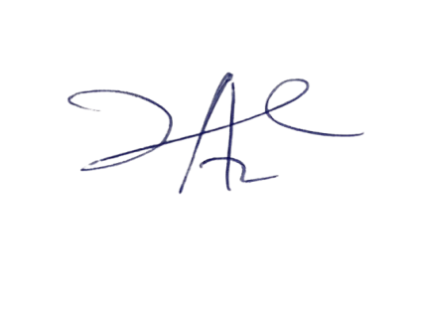

20/7/2023

Principal Head Instuctor