**EMERALD ROYAL INTERNATIONAL SCHOOL MPAPE, ABUJA.**

**LESSON PLAN AND NOTE FOR WEEK 9 PERIOD 1 ENDING 21/06/2024**

**TERM: THIRD**

**WEEK: 9TH**

**DATE: 17/06/2024**

**CLASS: NURSERY 2**

**SUBJECT: LETTER WORK**

**TOPIC: PEOPLE I KNOW**

**SUB-TOPIC: NAMES OF PEOPLE I KNOW AT HOME**

**PERIOD: 1ST PERIOD**

**TIME: 09: 30 - 10:10am**

**DURATION: 40 MINUTES.**

**NUMBER IN CLASS: 13**

**AVERAGE AGE: 5 YEARS.**

**SEX: MIXED.**

**SPECIFIC OBJECTIVES: BY THE END OF THE LESSON,THE PUPILS SHOULD BE**

**ABLE TO:**

**1. MENTION NAMES OF PEOPLE WE KNOW AT HOME**

**2. SPELL AND PRONOUNCE NAMES OF PEOPLE WE**

**KNOW AT HOME**

**RATIONALE: FOR PUPILS TO KNOW HOW TO SPELL AND**

**PRONOUNCE NAMES OF PEOPLE THEY KNOW AT**

**HOME.**

**PREVIOU KNOWLEDGE: PUPILS HAVE BEEN MAKING FRIENDS AT HOME.**

**INSTRUCTIONAL MATERIALS: PICTURES OF PEOPLE IN THEIR HOME**

**REFERENCE MATERIALS: THE NEW MASTERING ENGLISH FOR NURSERY**

**SCHOOLS BOOK 3 BY J .M OMOGBAI**

**LESSON DEVELOPMENT**

|  |  |  |  |
| --- | --- | --- | --- |
| **STAGES/STEPS** | **TEACHER’S ACTIVITIES** | **PUPILS’ ACTIVITIES** | **LEARNING POINTS** |
| **INTRODUCTION** | **Teacher reviews the previous lesson on common things in the classroom and school environment to pupils.** | **Pupil listen attentively to the teacher.** | **To prepare pupils minds for the lesson ahead.** |
| **PRESENTATION**  **STEP 1** | **Teacher guides pupils to mention the names of people they know at home.** | **Pupils listen attentively to the teacher and mention.** | **For proper understanding .** |
| **STEP 2** | **Teacher writes the names of people mentioned by the Pupils on the board, spell and pronounce and asks pupils to repeat after her.** | **Pupils pay attention to the teacher and repeat after her.** | **For better understanding of the lesson.** |
| **BOARD SUMMARY** | **Teacher writes the whole not of lesson on the board for pupils to copy.ie,**  **PEOPLE I KNOW**  **Names of people I know at home are:**  **1. Janet**  **2. Daniel**  **3. Tamilore**  **4. Ono**  **5. Okiki**  **6. David**  **7. Adebo**  **8. Emmanuel**  **9. Mary**  **10. Richard**  **11. Peace**  **12. Chisom**  **13. Monica**  **14. Solomon**  **15. James**  **16. John**  **17. Alisha**  **18. Aisha etc.** | **Pupils copy the note into their exercise books.** | **For onward study.** |
| **EVALUATION** | **Teacher evaluates the lesson by asking asking the following questions:**  **1. Mention the names of pupils you know at home.**  **2. Spell and pronounce the names of people you at home on the board one after another** | **Pupils listen to the teacher and answer the questions asked by her..** | **To assess pupils reading skills.** |
| **CONCLUTION** | **Teacher concludes the lesson by marking pupils books.** | **Pupils submit their books for marking.** | **For endorsement.** |
| **ASSIGNMENT** | **Answer the following questions:**  **1. The number of people you know in school are ____.**  **2. Spell and write the names of people you know in school.** | **Pupils do their assignment at home.** | **To encourage learning at home.** |

**LESSON PLAN AND NOTE FOR WEEK 9 PERIOD 2 ENDING 21/06/2024**

**TERM: THIRD**

**WEEK: 9TH**

**DATE: 18/06/2024**

**CLASS: NURSERY 2**

**SUBJECT: LETTER WORK**

**TOPIC: PEOPLE I KNOW**

**SUB-TOPIC: NAMES OF PEOPLE I KNOW IN SCHOOL**

**PERIOD: 2ND PERIOD**

**TIME: 08: 50 - 09:30am**

**DURATION: 40 MINUTES.**

**NUMBER IN CLASS: 13**

**AVERAGE AGE: 5 YEARS.**

**SEX: MIXED.**

**SPECIFIC OBJECTIVES: BY THE END OF THE LESSON,THE PUPILS SHOULD BE**

**ABLE TO:**

**1. MENTION NAMES OF PEOPLE YOU KNOW IN SCHOOL**

**2. SPELL AND PRONOUNCE NAMES OF PEOPLE YOU**

**KNOW IN SCHOOL.**

**RATIONALE: FOR PUPILS TO KNOW HOW TO SPELL AND**

**AND PRONOUNCE THE NAMES OF PEOPLE THEY**

**KNOW IN SCHOOL.**

**PREVIOU KNOWLEDGE: PUPILS HAVE LEARNT NAMES OF PEOPLE AT HOME**

**INSTRUCTIONAL MATERIALS: A CHART OF SCHOLARS NAMES IN CLASS.**

**REFERENCE MATERIALS: MASTERING ENGLISH FOR NURSERY SCHOOL BOOK 3 BY**

**J.M OMOGBAI**

**LESSON DEVELOPMENT**

|  |  |  |  |
| --- | --- | --- | --- |
| **STAGES/STEPS** | **TEACHER’S ACTIVITIES** | **PUPILS’ ACTIVITIES** | **LEARNING POINTS** |
| **INTRODUCTION** | **Teacher introduces the lesson by asking pupils to mention the names of people THEY know in school.** | **Pupil mention the names of people that they know in school.** | **To prepare pupils minds for the lesson ahead.** |
| **PRESENTATION**  **STEP 1** | **Teacher mention the names of people in the school for pupils and asks them to repeat after her.** | **Pupils listen attentively to the teacher and repeat after her.** | **For proper understanding .** |
| **STEP 2** | **Teacher writes the names of people in school on the board, spell and pronounce and also asks pupils to repeat after her.** | **Pupils pay attention to the teacher and repeat after her.** | **For better understanding of the lesson.** |
| **BOARD SUMMARY** | **Teacher writes the whole not of lesson on the board for pupils to copy.ie,**  **PEOPLE I KNOW**  **The names of people I know in school are:**  **1. Araceli**  **2. Best**  **3. Treasure**  **4. Oluwakorede**  **5. Mahmud**  **6. Zara**  **7. Precious**  **8. Diamond**  **9. Oyebola**  **10. Adriel**  **11. Gabriella**  **12. Edouard**  **13. Elliana etc** | **Pupils copy the note into their exercise books.** | **For onward study.** |
| **EVALUATION** | **Teacher evaluates the lesson by asking pupils the following questions:**  **1. Mention the names of people they know in the school.**  **2. Spell and pronounce the names of people in school on the board one after the other.** | **Pupils listen to the teacher and answer the questions asked by her.** | **To assess pupils reading skills.** |
| **CONCLUTION** | **Teacher concludes the lesson by marking pupils books.** | **Pupils submit their books for marking.** | **For endorsement.** |
| **ASSIGNMENT** | **Write 10 names of staff in emerald royal international school.** | **Pupils do their assignment at home.** | **To encourage learning at home.** |

**LESSON PLAN AND NOTE FOR WEEK 9 PERIOD 3 ENDING 21/06/2024**

**TERM: THIRD**

**WEEK: 9TH**

**DATE: 21/06/2024**

**CLASS: NURSERY 2**

**SUBJECT: LETTER WORK**

**TOPIC: PEOPLE I KNOW**

**SUB-TOPIC: NAMES OF STAFF IN MY SCHOOL**

**PERIOD: 3RD PERIOD**

**TIME: 09: 30 - 10:10am**

**DURATION: 40 MINUTES.**

**NUMBER IN CLASS: 13**

**AVERAGE AGE: 5 YEARS.**

**SEX: MIXED.**

**SPECIFIC OBJECTIVES: BY THE END OF THE LESSON,THE PUPILS SHOULD BE ABLE TO:**

**1. MENTION NAMES OF STAFFS IN SCHOOL**

**2. SPELL AND PRONOUNCE NAMES OF STAFFS IN**

**SCHOOL.**

**RATIONALE: FOR PUPILS TO KNOW THE NAMES OF THEIR STAFFS**

**PREVIOU KNOWLEDGE: PUPILS HAVE LEARNT NAMES OF PEOPLE IN THE SCHOOL. ENVIROMENT.**

**INSTRUCTIONAL MATERIALS: A CHART OF STAFFS NAMES**

**REFERENCE MATERIALS: NEW MASTERING ENGLISH FOR NURSERY**

**SCHOOLS BOOK 3 BY J. M OMOGBAI**

**LESSON DEVELOPMENT**

|  |  |  |  |
| --- | --- | --- | --- |
| **STAGES/STEPS** | **TEACHER’S ACTIVITIES** | **PUPILS’ ACTIVITIES** | **LEARNING POINTS** |
| **INTRODUCTION** | **Teacher reviews the previous lesson on to pupils.** | **Pupil listen attentively to the teacher.** | **To prepare pupils minds for the lesson ahead.** |
| **PRESENTATION**  **STEP 1** | **Teacher mentions the names of staffs in our school and then asks pupils to repeat after her.** | **Pupils listen attentively to the teacher and repeat after her.** | **For proper understanding** |
| **STEP 2** | **Teacher writes the names of staffs on the board, spell and pronounce, and also asks pupils to repeat after her.** | **Pupils listen to the teacher and also repeat after her.** | **For better understanding of the lesson.** |
| **BOARD SUMMARY** | **Teacher writes the whole not of lesson on the board for pupils to copy and match. As;**  **PEOPLE I KNOW**  **Names of staffs in our school are:**  **1. Mrs Vivian**  **2. Mrs mary**  **3. Miss perpetual**  **4. Mrs Gloria**  **5. Miss Mercy**  **6. Miss Favour**  **7. Mrs Joy**  **8. Mrs Juliet**  **9. Miss perpetua**  **10. Mr Dickson**  **11. Mr Charles etc.** | **Pupils copy the note into their exercise books.** | **For onward study.** |
| **EVALUATION** | **Teacher evaluates the lesson by asking pupils the following questions:**  **1. Mention the names of staffs that you know**  **2. Spell and pronounce the names of staffs on the board one after another.** | **Pupils read the note on the board one after another.** | **To assess pupils reading skills.** |
| **CONCLUTION** | **Teacher concludes the lesson by marking pupils books.** | **Pupils submit their books for marking.** | **For endorsement.** |
| **ASSIGNMENT** | **Spell and write 20 names of people you know.** | **Pupils do their assignment at home.** | **To encourage learning at home.** |

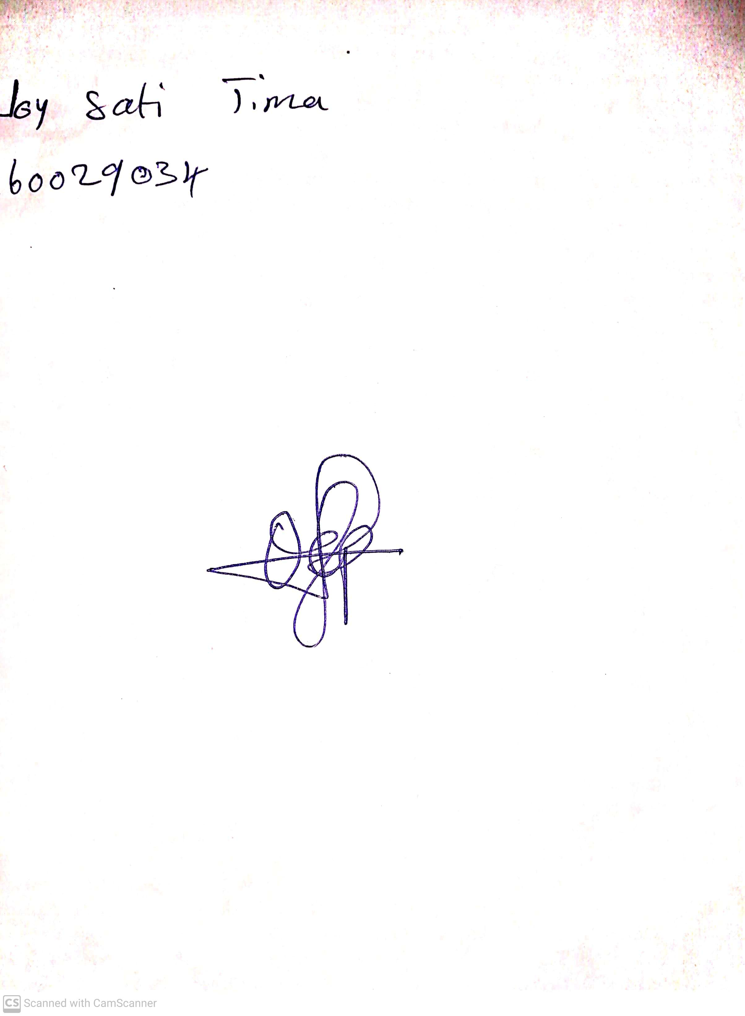

**14th June, 2024**

**Perpetual Ojoma Ocheja**

**Stream Head Nursery**