LESSON PLAN FOR WEEK 5 ENDING 10TH FEBRUARY, 2023

|  |  |
| --- | --- |
| TERM | 2ND |
| WEEK | 5 |
| DATE | 6TH- 10TH February, 2023 |
| CLASS | SS 1 |
| SUBJECT | Government |
| TOPIC | Basic Principles of Government |
| SUB-TOPIC | Political Liberty |
| PERIOD | 4th |
| TIME | 10:30-11:10 |
| DURATION | 40 Minutes |
| NO IN CLASS | 2 |
| AVERAGE AGE | 15years |
| SEX | Mixed |
| SPECIFIC OBJECTIVES | By the end of the lesson, scholars should be able to:  i.Explain the meaning of political liberty.  ii.Outline the factors that can safeguard the liberty of individuals. |
| RATIONALE | To acquaint the scholars with the meaning and factors that ensure the political liberty of individuals. |
| PREVIOUS KNOWLEDGE | The scholars can mention the examples of fundamental human rights. |
| INSTRUCTIONAL RESOURCES | Charts from textbook explaining the topic. |
| REFERENCE MATERIAL | Essential Government for Senior Secondary Schools.  Debbie C. Chris(2017) |

LESSON DEVELOPMENT

|  |  |  |  |
| --- | --- | --- | --- |
| STEPS | TEACHER’S ACTIVITIES | SCHOLARS’ ACTIVITIES | LEARNING POINTS |
| Introduction | The teacher introduces the lesson by asking the scholars to mention two examples of fundamental human rights. | The scholars mention them as:   1. Right to life. 2. Right to press. | To arouse scholar’s interest towards the topic. |
| Step 1 | The teacher explains the meaning of political liberty. | The scholars listen carefully. | To ensure proper understanding of the topic. |
| Step 2 | The teacher states the factors that can ensure the political liberty of individuals. | The scholars ask questions on the topic. | To make room for logical reasoning on the topic. |
| Board summary | The teacher summarizes the lesson thus:  **Political Liberty**  This nis the right of an individual to share in the government of his country. The state recognizes political right, especially as most of these rights are entrenched in the constitution.  Political Liberty involves the following:  i.The right to vote: Where political leadership is operational, all adults have a right to vote.  ii.The right to stand as a candidate in an election: Age limit differs in different countries e.g in Nigeria. It is 18 years for a voter.  iii.Periodic elections: Powers are not given to given to elected bodies permanently. Elections are done periodically, after either four years in Nigeria.  **Factors that can Safeguard the Liberty of Individuals**  1.Law: This is an important condition to the liberty of an individual.  2.Independence of the judiciary: The essential of this to freedom of the individual cannot be underestimated. The judiciary and the judges should be free from the interference of the executive and legislature.  3.Democracy: Under democracy, political power is with the masses and so freedom is guaranteed.  4.Power distribution: When powers are decentralized, more likely, men will be zealous for power.  5.Vigilance: This is a sure safeguard to freedom. This means that citizens are alert and ready to fight any unreasonable interference with their rights. | The scholars copy notes into their notebooks. | For reference purposes. |
| Evaluation | The teacher evaluates the scholars thus:  i.Define political liberty.  ii.List three factors that can safeguard the political liberty of individuals. | The scholars attempt the questions. | To asacertain their level of understanding of the lesson. |
| Conclusion | The teacher check scholars notes and make corrections. | The scholars take corrections made by the teacher. | For better understanding of the lesson. |
| Assignment | The teacher gives the scholars assignment:  State three merits and demerits of political liberty of an individual. | The scholars copy their assignment to do at home. | To encourage scholars to study and learn at home. |

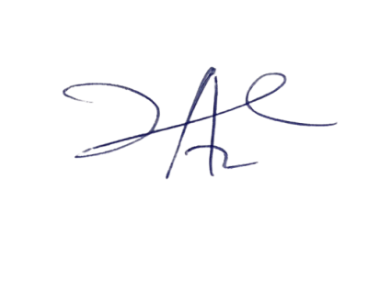

29/3/2023

Principal Head Instuctor