**LESSON PLAN/NOTE FOR WEEK 5 ENDING 02/06/2023**

**Term**: 3rd

**Week**: 5

**Date**: 31/05/2023

**Class**: SS 1

**Subject**: Civic Education

**Topic**: Orderliness

**Sub-Topic:** Meaning of Orderliness

**Period**: 5th

**Time**: 11:10-11:50

**Duration**: 40 Minutes

**Number in class**: 8 students

**Average Age**: 14 years

**Sex**: mixed

**Specific objectives:** By the end of the lesson, the students should be able to:

(1) Define orderliness.

(11) Explain orderliness

(111) State the areas orderliness occurs

**Rationale:** For the students to be able to follow due process in handling issues and obeying rules and regulations in school and in the society.

**Previous knowledge:** The students have been following issues accordingly.

**Instructional material**: A chart showing people queue in the bank to withdraw money.

**Reference material:** Gbenga Babalola (2017) Essential civic Education for senior secondary schools.

**LESSON DEVELOPMENT**

|  |  |  |  |
| --- | --- | --- | --- |
| **Stages/Steps** | **Teacher's Activities** | **Students' Activities** | **Learning points** |
| **Introduction** | Review the previous lesson | Participate actively in the class discussion | To arouse the students interest to learn. |
| **Step 1** | Defines orderliness as: orderliness is the act of doing things in a peaceful and orderly fashion. | Listen carefully to the teacher | For better understanding of the lesson. |
| **Step 11** | Guides the students to explain orderliness | Respond to the class activity | To encourage critical thinking. |
| **Step 111** | Asks the students to state the areas orderliness occur | State the areas as: (1) Cleanliness (2) cooperation etc. | To enable the students to reason logically. |
| **Board summary** | Summarizes the lesson as:  **Meaning of Orderliness**  Orderliness is the act of doing things in a peaceful and orderly fashion. It is the act by which things are arranged in a proper, neat and systematic manner. Orderliness also entails people taking time to become aware of everything that is going on in the their lives which they choose to handle in a certain order. Orderliness is also a situation where laws are obeyed and authority is respected.  The truth is that without orderliness, everything will be in chaos, driving on the road, flying in the air, navigating on the high seas, all involve orderliness. Law is the blood without which order is bound to collapse. Or comes alive and becomes entrenched when there is law to back it up.  **Areas orderliness occur**  Orderliness should be used by everybody, every day. The areas are: Cleanliness , cooperation, family and Life are all reasons for keeping things in order. Getting up in the morning, arriving at school on time, keeping the desk at work clean etc are starting points of orderliness. | Copy and submit the note book for marking. | For future reference |
| **Evaluation** | Evaluates the students as:  (1) Define orderliness  (2) Explain orderliness  (3) state 3 areas orderliness occur. | Respond to the questions | Ascertaining the attainment of the stated objectives. |
| **Conclusion** | Rounds up the lesson by marking and correcting students work. | Check and do their correction | Consolidation of the lesson. |
| **Assignment** | Gives home work as:  (1) In your own words, what did you understand by orderliness. | Respond by doing the home work at home. | To ensure continuity of learning. |

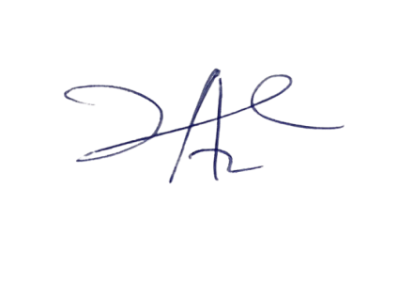

2/6/2023

Principal Head Instuctor