EMERALD ROYAL INTERNATIONAL SCHOOL MPAPE, ABUJA. LESSON NOTE FOR WEEK 9 ENDING 10th MARCH, 2023.

SUBJECT: Letter work

TOPIC: Identification of letter l and it's sound.

SUB-TOPIC: Recognition and sounding letter l .

DATE: 6/3/2023.

DURATION: 40 minutes.

TIME: 08:50---09:30

PERIOD: 2nd

CLASS: Pre-nursery

NUMBER OF PUPILS: 11

AVERAGE AGE: 2 years

SEX: Mixed.

SPECIFIC OBJECTIVES: By the end of the lesson, the pupils should be able to:-

I. Point and Identify letter l .

2. Sing a phonics song for letter l.

RATIONALE: For Pupils to know letters and their sounds.

PREVIOUS KNOWLEDGE: Pupils have been learning how to identify and say the sounds of the letter .

INSTRUCTIONAL MATERIAL: flash cards, board and phonics song.

REFERENCE: Mastering English for Nursery schools book 1 by J.M.Omogbai

LESSON DEVELOPMENT

|  |  |  |  |
| --- | --- | --- | --- |
| Stages/steps | Teacher's activities | Pupils' activities | Learning points. |
| Introduction | Teacher introduces the lesson by singing the A,B,C, D'S song for the pupils. | Pupils sing the rhyme along with the teacher. | To arouse interest of the pupils for the lesson. |
| Presentation  Step 1 | Teacher shows the pupils letter l on a flash card. Teacher asks the pupils to point at the flash card and say " letter l". | Pupils point at letter l on the flash card and say " letter l "repeatedly. | For proper recognition of letter l. |
| Step 2 | Teacher sings and teaches the pupils jolly phonics song for letter l . | Pupils pay attention to the teacher and repeat after her. | For better understanding of the lesson. |
| Summary | Teacher summarizes the lesson by asking the pupils to point at letter j on the flash card and say it's sound. | Pupils point at letter j on the and say it's sound. | To improve pupils understanding of the lesson. |
| Evaluation | Teacher puts flash cards of different letters on the table including letter j and asks the pupils to:-  1. Identify letter j amongst other letters.  2.Say the sound for letter j. | Pupils answer the questions asked by the teacher. | To assess the level of pupils understanding of the lesson. |
| Conclusion | Teacher marks the pupils books and makes necessary corrections. | Pupils submit their books for marking and corrections. | For onwards learning. |
| Assignment | Teacher asks the pupils to trace letter j. | Pupils trace letter j | To encourage Learning at home. |

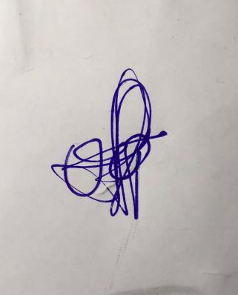

**29th March, 2023**

**Perpetual Ojoma Ocheja**

**Stream Head Nursery**