**LESSON PLAN AND NOTE FOR WEEK 4 ENDING 17/5/2024**

**Term 3rd term**

**Week 4th week**

**Date 14th May, 2024**

**Class Nursery One**

**Subject Social Norms**

**Topic My Environment.**

**Sub-topic Define Environment.**

**Period 4th period**

**Time 10:40 am**

**Duration 35 minutes**

**No in class 14**

**Average Age 3 years**

**Sex Mixed**

**Specific Objectives: By the end of the lesson, the pupils should be able to:**

1. **Define Environment.**
2. **Identify & mention the things found in your environment.**

**Rationale: To ensure the pupils to understand what environment is all about.**

**Previous Knowledge: The pupils can mention kinds of good table manners.**

**Instructional Resources: Online research.**

**Reference Material: Smart Smart Civic Education by A.M Solu & T.Y Alabi, nursery 2**

**LESSON PRESENTATION**

|  |  |  |  |
| --- | --- | --- | --- |
| **Steps** | **Teacher’s Activities** | **Pupils’ Activities** | **Learning Points** |
| **Introduction** | **The teacher introduces the lesson by showing the pupils round the school’s premises.** | **The pupils participates with the teacher.** | **To arouse the pupils’ interest.** |
| **Step 1** | **The teacher explains environment as “ the things around us”.** | **The pupils pay attention and repeats the definition of table manners with the teacher.** | **For proper understanding.** |
| **Step 2** | **The teacher guides the pupils to walk around the school environment to identify & mention objects in the environment such as:**  **Rocks**  **Birds**  **Cars**  **Hospital**  **School**  **Stones**  **Houses**  **Flowers**  **Grass etc.** | **The pupils identify & mention tshe objects in the environment along with the teacher.** | **For better understanding.** |
| **Summary** | **The teacher summarizes the lesson by explaining things found in our environment such as:**  **Tree**  **Car**  **Grass, etc.** | **The pupils listen and understands the lesson.** | **For onward study.** |
| **Evaluation** | **Question:**  **What is Environment?.**  **Mention two objects you can see around?.** | **The pupils answer the question correctly.** | **To ascertain the pupils’ understanding.** |
| **Conclusion** | **The teacher summarizes the lesson to the pupils.** | **The pupils gives answers to the teacher.** | **To consolidate the lesson.** |
| **Assignment** | **Question:**  **What is Environment?.**  **Mention two objects you can see around?.** | **The pupils copy and do their homework .** | **To encourage learning while at home.** |

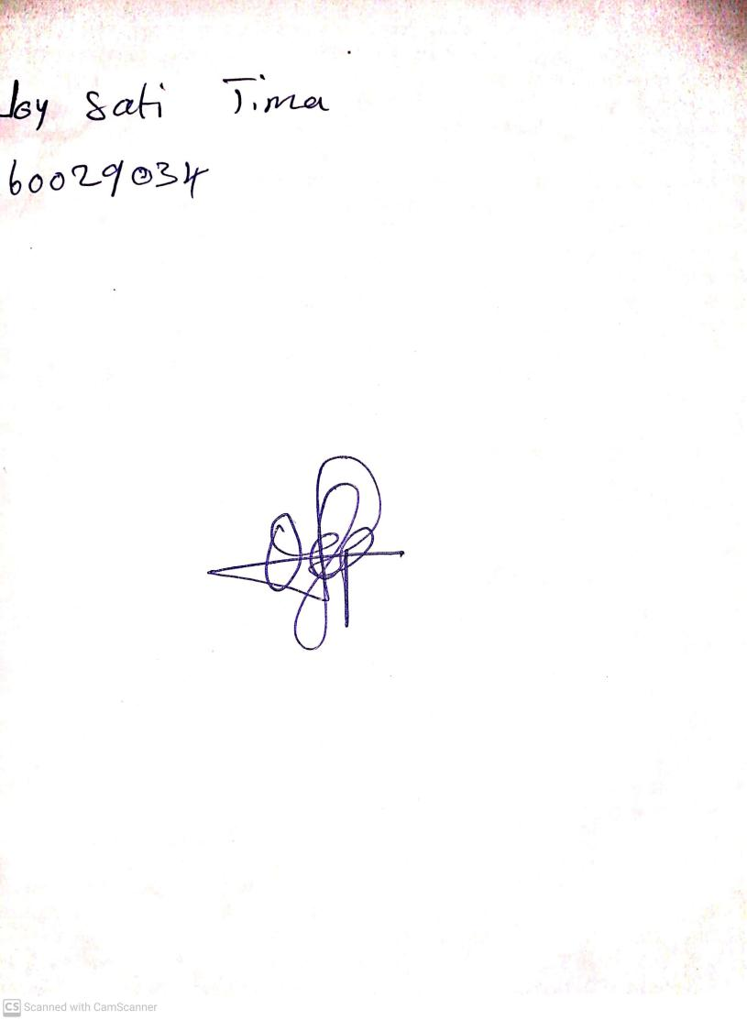

10th May, 2024

Perpetual Ojoma Ocheja

Stream Head Nursery