**EMERALD ROYAL INTERNATIONAL SCHOOL**

**MPAPE, ABUJA.**

**LESSON PLAN AND NOTE FOR WEEK 4 ENDING 26/05/2023**

TERM: THIRD

WEEK: 4TH

DATE: 22/05/2023

CLASS: NURSERY 2

SUBJECT: SOCIAL NORMS

TOPIC: VIOLENCE (MENTAL) .

SUB-TOPIC: DEFINITION OF VIOLENCE, HARMFUL EFFECT AND

EXAMPLES.

PERIOD: 2ND PERIOD AFTER LONG BREAK

TIME: 11: 20- 12: 00PM

DURATION: 40 MINUTES.

NUMBER IN CLASS: 17

AVERAGE AGE: 5 YEARS.

SEX: MIXED.

SPECIFIC OBJECTIVES: BY THE END OF THE LESSON,THE PUPILS SHOULD BE

ABLE TO:

1. DEFINE MENTAL VIOLENCE
2. STATE THE HARMFUL EFFECT OF MENTAL VIOLENCE
3. MENTION EXAMPLES OF MENTAL VIOLENCE.

RATIONALE: FOR PUPILS TO KNOW WHAT MENTAL VIOLENCE IS ALL

ABOUT.

PREVIOU KNOWLEDGE: PUPILS HAVE LEARNT ABOUT PHYSICAL VIOLENCE

INSTRUCTIONAL MATERIALS: BELT AND STICK.

REFERENCE MATERIALS: GOOGLE.COM

**LESSON DEVELOPMENT**

|  |  |  |  |
| --- | --- | --- | --- |
| STAGES/STEPS | TEACHER’S ACTIVITIES | PUPILS’ ACTIVITIES | LEARNING POINTS |
| INTRODUCTION | Teacher reviews the previous lesson to pupils. | Pupils pay attention to the teacher. | To arouse pupils interest for the lesson ahead. |
| PRESENTATION  STEP 1 | Teacher defines the meaning of mental violence to pupils and then asks them to repeat after her. | Pupils listen attentively to the teacher and repeat after her. | For proper understanding . |
| STEP 2 | Teacher states the harmful effect of mental violence to pupils and also asks them to repeat after her. | Pupils pay attention to the teacher and repeat after her. | For better understanding of the lesson. |
| STEP 3 | Teacher mentions the examples of mental violence to pupils and also asks them to repeat after her. | Pupils listen to the teacher and repeat after her. | To enhance pupils participation in class. |
| BOARD SUMMARY | Teacher summarizes the lesson by writing the whole note of lesson on the board for pupils to copy into their books. Ie,  MENTAL VIOLENCE  Mental violence is when a child is repeatedly made to feel worthless, unloved, alone or scared.  HARMFUL EFFECT OF MENTAL VIOLENCE   1. Depression 2. Anxiety 3. Poor self-esteem 4. Heart disease etc.   EXAMPLES OF MENTAL VIOLENCE   1. Yelling 2. Bullying 3. Blaming and scapegoat 4. Making the child the subject of jokes 5. Threatening,shouting at a child or calling them names 6. Humiliating or constantly criticizing a child etc. | Pupils copy the note into their exercise books. | For onward study. |
| EVALUATION | Teacher evaluates the lesson by asking the following questions;   1. What is mental violence? 2. State the harmful effect of mental violence . 3. Mention the examples of mental violence. | Pupils answer the questions ask by the teacher. | To assess pupils level of understanding. |
| CONCLUTION | Teacher concludes the lesson by marking pupils books. | Pupils submit their books for marking. | For endorsement. |
| ASSIGNMENT | 1. Explain the meaning of children with special needs 2. Mention 3 ways we can care for children with special needs. | Pupils do their assignment at home. | To encourage learning at home. |

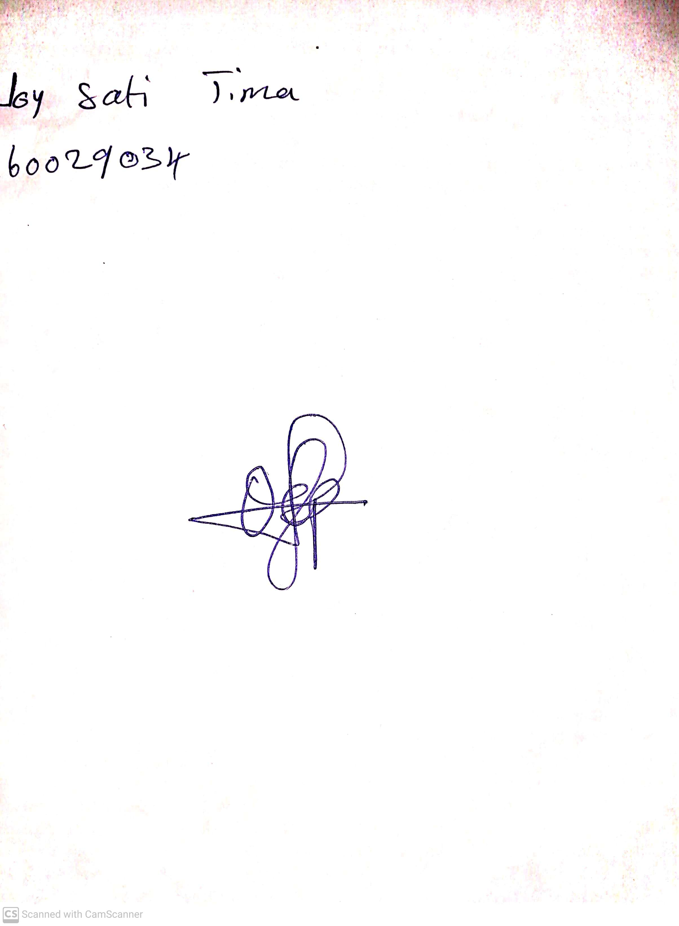

14th May, 2023

Perpetual Ojoma

Stream Head Nursery