**LESSON PLAN FOR WEEK 8 ENDING 3/11/2023**

**Term 1st term**

**Week 8th  week**

**Date 3rd November,2023**

**Class Nursery One**

**Subject Nature studies**

**Topic Things in the sky.**

**Sub-topic Colour things in the sky.**

**Period 2nd period**

**Time 8:50 am**

**Duration 35 minutes**

**No in class 15**

**Average Age 3 years**

**Sex Mixed**

**Specific Objectives: By the end of the lesson, the pupils should be able to:**

1. **Define things in the sky.**
2. **Colour things in the sky .**

**Rationale: To ensure the pupils define and colour things in the sky.**

**Previous Knowledge: The pupils can identify rocks in different sizes.**

**Instructional Resources: Things in the sky chart, crayons.**

**Reference Material: Elementary science by Showers kiddies nursery 1**

**LESSON PRESENTATION**

|  |  |  |  |
| --- | --- | --- | --- |
| **Steps** | **Teacher’s Activities** | **Pupils’ Activities** | **Learning Points** |
| **Introduction** | **The teacher introduces the lesson (Things in the sky) to the pupils.** | **The pupils listens attentively to their teacher.** | **To arose the pupils’ interest.** |
| **Step 1** | **The teacher defines things in the sky as “those things found in the sky either during the day or during the night”.** | **The pupils together with the teacher define things in the sky.** | **For proper understanding.** |
| **Step 2** | **The teacher guides the pupils to colour those things found in the sky.**  **plain sun plain rain**  **plain rainbow plain cresent** | **The pupils participates in colouring those things found in the sky.** | **For better understanding.** |
| **Summary** | **The teacher summarizes the lesson by defining things in the sky for the pupils.** | **The pupils can define things in the sky.** | **For onward study.** |
| **Evaluation** | 1. **Define things in the sky?** 2. **Mention 2 things found in the sky?** 3. **Colour the following things in the sky below**   **plain star plain sun** | **The pupils answer the question correctly.** | **To ascertain the pupils’ understanding.** |
| **Conclusion** | **The teacher summarizes, reacts, and corrects the pupils.** | **The pupils gives answer to the teacher’s questions** | **To consolidate the lesson.** |
| **Assignment** | 1. **Define things in the sky?** 2. **Mention 2 things found in the sky?** 3. **Colour the following things in the sky below**   **plain star plain sun**  **plain rain plain rain**  **plain rainbow plain cresent** | **The pupils copy and do their homework at home.** | **To encourage learning while at home.** |

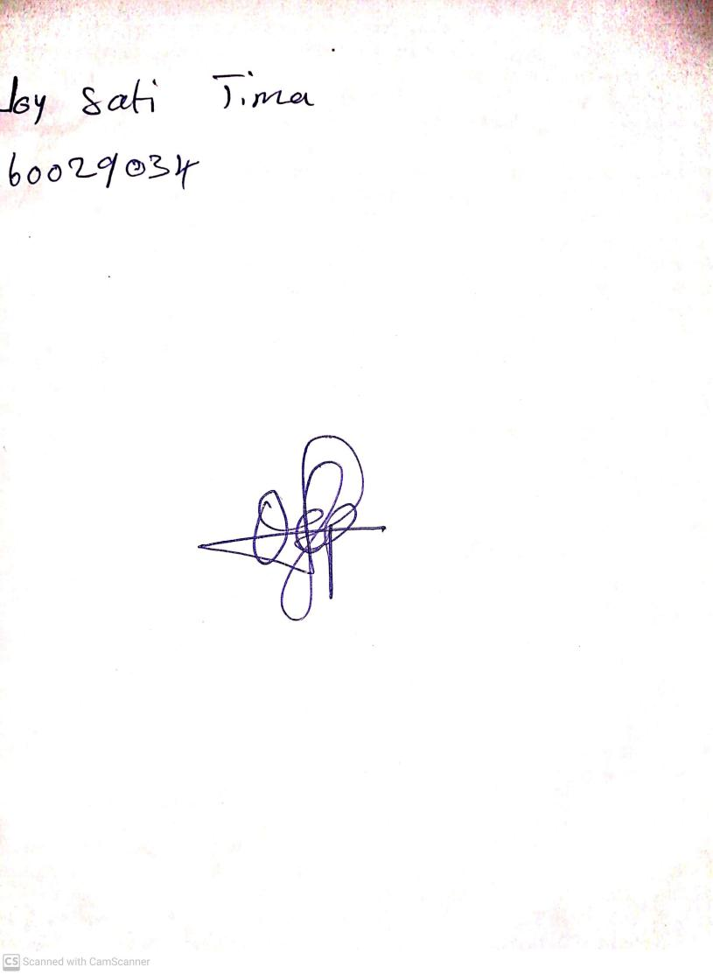

15th August, 2023

Perpetual Ojoma Ocheja

Stream Head Nursery