LESSON PLAN AND NOTE FOR WEEK 8 ENDING 03/11/2023

TERM: 1st

WEEK: 8th

DATE: 30/10/2023

CLASS: Nursery 2

SUBJECT: Nature studies

TOPIC: Body care on sickness

SUB—TOPIC: Meaning and types of sickness

PERIOD: 4th

TIME: 10:40—11:20am

DURATION: 40 minutes

NUMBER IN CLASS: 14

AVERAGE AGE: 5 years

SEX: Mixed

LEARNING OBJECTIVES: By the end of the lesson, the pupils should be able to:

1. Explain the meaning of sickness.

2. Mention the examples of sickness.

3. State the things to do when you are sick.

RATIONALE: For pupils to know the meaning of sickness and kind of sickness.

PREVIOUS KNOWLEDGE: Pupils have been falling sick

INSTRUCTIONAL MATERIALS: picture of a sick person at the hospital in Pupils text books.

REFERENCE MATERIALS: Basic science and technology for Nursery schools book 3 by OPEMIPO DADA.

LESSON DEVELOPMENT

|  |  |  |  |
| --- | --- | --- | --- |
| Steps | Teacher's activities | Pupils' activities | Learning point |
| Introduction | Teacher introduces the lesson by reviewing the previous lesson. | Pupils pay attention to the teacher. | To prepare pupils minds for the lesson ahead. |
| Presentation step 1 | Teacher explains the meaning of sickness to pupils and then asks them to repeat after her. | Pupils listen to the teacher and repeat after her. | To improve pupils listening and speaking ability. |
| Step 2 | Teacher mentions the examples of sickness to pupils and also asks them to repeat after her. | Pupils pay attention to the teacher and repeat her. | To enhance pupils participation in the class. |
| Step 3 | Teacher state the things to do when one is sick to pupils and also asks them to repeat after her. | Pupils listen very attentively to the teacher and repeat after her. | To improve pupils speaking ability. |
| Board summary | Teacher writes the whole note of lesson on the board for pupils to copy into their books. That is;  Body care on sickness:  A sick person is a person who is not healthy.  Sickness is the condition of being sick or unwell.  Examples of sickness are:   1. Malaria 2. Stomach upset 3. Headaches 4. Diarrhoea 5. Conjunctivitis 6. Fever 7. Catarrh 8. Measles 9. Kwashiorkor 10. Cough etc.   What to do when you are sick:   1. Tell your parents or teachers when you feel sick. 2. Ask for your mum or dad to take you to a hospital. 3. Take your drugs. 4. Rest at home. 5. Eat lots of fruits and vegetables. 6. Eat some food to keep you strong. 7. Drink lots of water. | Pupils copy the note into their exercise books. | For onward study. |
| Evaluation | Teacher evaluates the lesson by asking pupils the following questions;   1. What is sickness? 2. Mention the examples of sickness. | Pupils answer the questions asked by the teacher. | To assess pupils level of understanding. |
| Conclusion | Teacher concludes the lesson by marking pupils books. | Pupils submit their books for marking. | For endorsement. |
| Assignment | Answer the following questions:   1. What is food? 2. Mention 5 types of food 3. List 5 reason why we eat food. | Pupils do their assignment at home. | To encourage learning at home. |

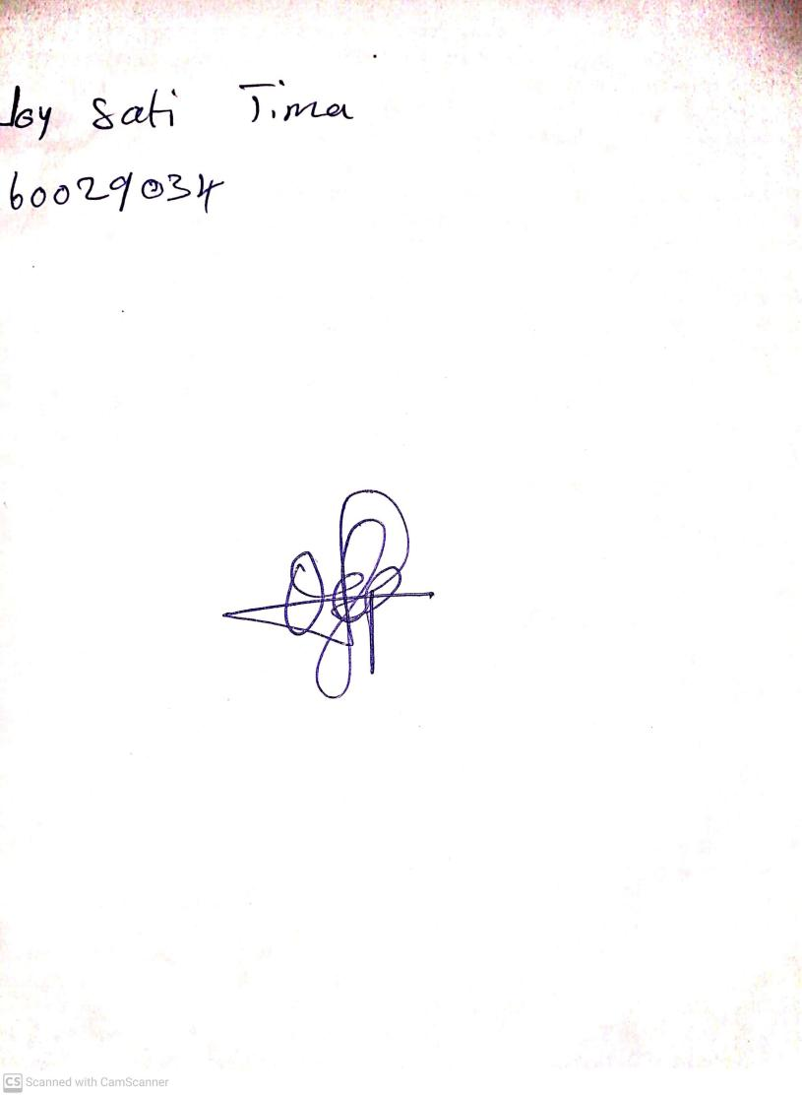

27th August, 2023

Perpetual Ojoma Ocheja

Stream Head Nursery