EMERALD ROYAL INTERNATIONAL SCHOOL

MPAPE, ABUJA.

LESSON PLAN AND NOTE FOR WEEK 5 ENDING 24TH MAY,2024.

TERM: Third term.

WEEK: 5

SUBJECT: Nature studies.

TOPIC: Weather

SUB-TOPIC: Definition of weather and differences in weather.

DATE: 23/5/2024

DURATION: 40 minutes

TIME: 08:50-09:30

PERIOD: 3rd

CLASS: Pre-nursery

NUMBER OF PUPILS: 19

AVERAGE AGE: 2 years

SEX: Mixed

SPECIFIC OBJECTIVES: By the end of the lesson, the pupils should be able to:-

I Define weather.

2. Explain the differences in weather.

RATIONALE: For Pupils to know the condition of their place.

PREVIOUS KNOWLEDGE: Pupils have been experiencing raining weather.

INSTRUCTIONAL MATERIALS: chart of rainfall and cloud.

REFERENCE: Showers kiddies books Elementary science book nursery 1 by showers kiddies books.

LESSON DEVELOPMENT

|  |  |  |  |
| --- | --- | --- | --- |
| Stages/steps | Teacher's activities | Pupils' activities | Learning points |
| Introduction | Teacher introduces the lesson by singing a nursery rhyme as:-  Rain rain go away  Come again another day  Little children want to play. | Pupils listen to teacher and sing along with the teacher. | To arouse the interest of the pupils. |
| Presentation  Step 1 | Teacher defines weather to the pupils as:  "Weather is the condition of the atmosphere at a particular place and time."  "Teacher asks the pupils to repeat after the teacher. | Pupils listen to the teacher and repeat after the teacher. | For better understanding of the lesson. |
| Step 2 | Teacher explains to the pupils the differences in weather.   1. Sunny hot day:- The sun is very important. We can see it in the day when the sun is out. The sun keeps us warm and helps our plants grow. 2. Rainy day:- When clouds can hold no more water, water comes down in the form of rain. 3. Windy cold day:- Moving air is called wind. Sometimes when it is windy it is cold and we keep warm   Teacher asks the pupils to repeat after the teacher. | Pupils listen to the teacher as she is explaining the differences in weather. | For proper understanding of the lesson. |
| Summary | Teacher summarizes the lesson by going over the lesson again for more understanding. | Pupils listen attentively to the teacher as she is going over the lesson. | To ensure better understanding. |
| Evaluation | Teacher asks the Pupils to :-   1. Define weather 2. State the differences in weather. | Pupils answer the teacher's questions correctly. | To ascertain the level of pupils understanding of the lesson. |
| Conclusion | Teacher concludes the lesson by taking the pupils out to experience the sunny hot day. | Pupils follow the  Teacher's instruction to experience the sunny hot day. | For better understanding of the lesson. |
| Assignment | Teacher asks the pupils to experience how they feel during windy cool day orally | Pupils do the assignment at home. | To encourage Learning at home. |

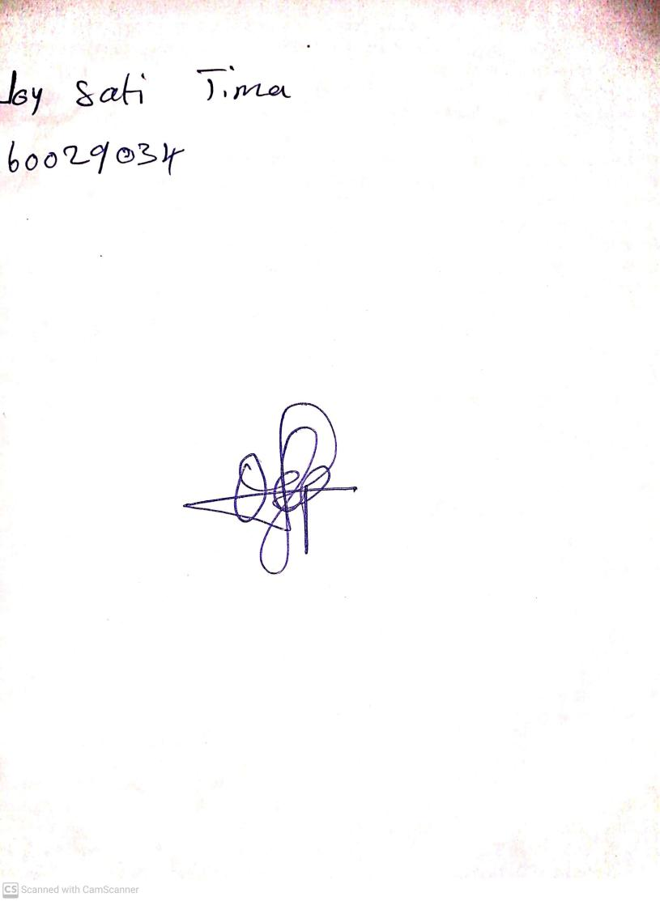

**17th May, 2024**

**Perpetual Ojoma Ocheja**

**Stream Head Nursery**