**LESSON PLAN AND NOTE 1 FOR WEEK 4 ENDING 26/5/2023**

**Term 3rd term**

**Week 4th week**

**Date 26th May,2023**

**Class Nursery One**

**Subject Number Work**

**Topic Reciting months of the year.**

**Sub-topic Rhyming January, February, March,**

**April**

**Period 2ND period**

**Time 9:05 am**

**Duration 35 minutes**

**No in class 18**

**Average Age 3 years**

**Sex Mixed**

**Specific Objectives: By the end of the lesson ,the pupils should**

**be able to:**

1. **Know how many months we have in a year.**
2. **Rhyme January, February.**
3. **Rhyme March and April.**

**Rationale: To make sure the pupils know and rhyme January,**

**February,March, and April.**

**Previous Knowledge: The pupils have write numbers before and after.**

**Instructional Resources: Months of the year chart, board, marker, etc.**

**Reference Material: Online Research.**

**LESSON PRESENTATION**

|  |  |  |  |
| --- | --- | --- | --- |
| **Steps** | **Teacher’s Activities** | **Pupils’ Activities** | **Learning Points** |
| **Introduction** | **The teacher introduces the topic (Reciting months of the year) by rhyming.** | **The pupils together with the teacher rhyme the months of the year.** | **To arouse the pupils’ interest.** |
| **Step 1** | **The teacher teaches the pupils that there are twelve months in a year.** | **The pupils knows how many months there are in a year.** | **For proper understanding.** |
| **Step 2** | **The teacher start by rhyming**  **January**  **February for the pupils.** | **The pupils participate with the teacher in rhyming**  **January**  **February** | **For better understanding.** |
| **Step 3** | **The teacher rhyme**  **March and April for the pupils.** | **The pupils participate with the teacher in rhyming March and April.** | **For further understanding.** |
| **Summary** | **The teacher summarizes the lesson by rhyming the first four months of the year (January, February, March and April.)** | **The pupils have master and rhyme the first four months of the year.** | **For onward study.** |
| **Evaluation** | **Question:**  **How many month of the year do we have?**  **Rhyme January and February?**  **Rhyme March and April?** | **The pupils answer the question correctly.** | **To ascertain the pupils’ understanding.** |
| **Conclusion** | **The teacher summarizes, reacts and corrects the pupils.** | **The pupils gives answers to the teacher's question.** | **To consolidate the lesson.** |
| **Assignment** | **How many months do we have?**  **Rhyme January, February, March, April?** | **The pupils copy and do their homework at home.** | **To encourage learning while at home.** |

**LESSON PLAN AND NOTE 2 FOR WEEK 4 ENDING 26/5/2023**

**Term 3rdterm**

**Week 4th week**

**Date 26th May,2023**

**Class Nursery One**

**Subject Number Work**

**Topic Reciting months of the year.**

**Sub-topic Rhyming May, June,July, August.**

**Period 2ND period**

**Time 9:05 am**

**Duration 35 minutes**

**No in class 18**

**Average Age 3 years**

**Sex Mixed**

**Specific Objectives: By the end of the lesson ,the pupils should**

**be able to:**

1. **Rhyme May, June.**
2. **Rhyme July, August.**

**Rationale: To make sure the pupils rhyme May, June, July, August.**

**Previous Knowledge: The pupils have rhyme January, February, March, April.**

**Instructional Resources: Months of the year chart, board, marker, etc.**

**Reference Material: Online Research.**

**LESSON PRESENTATION**

|  |  |  |  |
| --- | --- | --- | --- |
| **Steps** | **Teacher’s Activities** | **Pupils’ Activities** | **Learning Points** |
| **Introduction** | **The teacher introduces the topic (Reciting months of the year) by rhyming.** | **The pupils together with the teacher rhyme the months of the year.** | **To arouse the pupils’ interest.** |
| **Step 1** | **The teacher rhyme**  **May**  **June** | **The pupils together with the teacher rhyme months of the year**  **May**  **June**  **July**  **August** | **For proper understanding.** |
| **Step 2** | **The teacher rhyme**  **July**  **August for the pupils.** | **The pupils participate in rhyming July and August.** | **For better understanding.** |
| **Summary** | **The teacher summarizes the lesson by rhyming the months of the year**  **May**  **June**  **July**  **August** | **The pupils have master month**  **May**  **June**  **July**  **August** | **For onward study.** |
| **Evaluation** | **Question:**  **Rhyme May and June**  **Rhyme July and August?.** | **The pupils answer the question correctly.** | **To ascertain the pupils’ understanding.** |
| **Conclusion** | **The teacher summarizes, reacts and corrects the pupils.** | **The pupils gives answers to the teacher's question.** | **To consolidate the lesson.** |
| **Assignment** | **Question :**  **Rhyme May, June, July, August?** | **The pupils copy and do their homework at home.** | **To encourage learning while at home.** |

**LESSON PLAN AND NOTE 3 FOR WEEK 4 ENDING 26/5/2023**

**Term 3rd term**

**Week 4th week**

**Date 26th May,2023**

**Class Nursery One**

**Subject Number Work**

**Topic Reciting days of the week.**

**Sub-topic Rhyming September, October, November,**

**December.**

**Period 2nd period**

**Time 9:50 am**

**Duration 35 minutes**

**No in class 18**

**Average Age 3 years**

**Sex Mixed**

**Specific Objectives: By the end of the lesson ,the pupils**

**should be able to:**

1. **Rhyme September, October.**
2. **Rhyme November, December.**

**Rationale: To make sure the pupils rhyme September, October,**

**December.**

**Previous Knowledge: The pupils have rhyme May, June, July, August.**

**Instructional Resources: Board, Marker, Months of the year chart.**

**Reference Material: Online research, Chart, Board.**

**LESSON PRESENTATION**

|  |  |  |  |
| --- | --- | --- | --- |
| **Steps** | **Teacher’s Activities** | **Pupils’ Activities** | **Learning Points** |
| **Introduction** | **The teacher introduces the topic (Reciting months of the year) by rhyming.** | **The pupils together with the teacher rhyme the months of the year.** | **To arouse the pupils’ interest.** |
| **Step 1** | **The teacher rhyme**  **September**  **October** | **The pupils rhyme**  **September**  **October** | **For proper understanding.** |
| **Step 2** | **The teacher rhyme**  **November**  **December.** | **The pupils participate in rhyming**  **November**  **December.** |  |
| **Summary** | **The teacher summarizes the lesson by rhyming the months of the year**  **January**  **February**  **March**  **April**  **May**  **June**  **July**  **August**  **September**  **October**  **November**  **December** | **The pupils have master and rhyme the months of the year.** | **For onward study.** |
| **Evaluation** | **Question:**  **Rhyme September and October**  **Rhyme November and December.** | **The pupils answer the question correctly.** | **To ascertain the pupils’ understanding.** |
| **Conclusion** | **The teacher summarizes, reacts and corrects the pupils.** | **The pupils gives answers to the teacher's question.** | **To consolidate the lesson.** |
| **Assignment** | **Question :**  **Rhyme the twelve months of the year?** | **The pupils copy and do their home-work at home.** | **To encourage learning while at home.** |

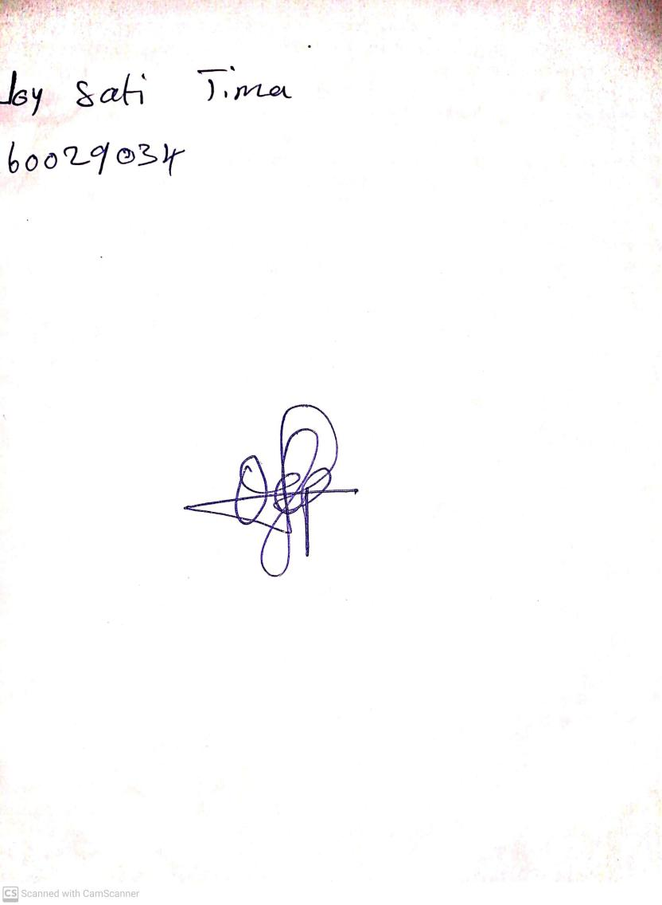

30th April, 2023

Perpetual Ojoma

Stream Head Nursery