**EMERALD ROYAL INTERNATIONAL SCHOOL**

**MPAPE, ABUJA.**

**LESSON PLAN AND NOTE FOR WEEK 9 PERIOD 1 ENDING 21/06/2024**

**TERM: 3RD**

**WEEK: 9TH**

**DATE: 17/06/2024**

**CLASS: NURSERY 2**

**SUBJECT: NUMBER WORK**

**TOPIC: SIMPLE ADDITION( NUMBER 1-9) .**

**SUB-TOPIC: MEANING AND ITS SIGN(+) AND EXAMPLES**

**PERIOD: 1ST**

**TIME: O8:50-09:30.**

**DURATION: 40 MINUTES.**

**NUMBER IN CLASS: 13**

**AVERAGE AGE: 5 YEARS.**

**SEX: MIXED.**

**SPECIFIC OBJECTIVES: BY THE END OF THE LESSON,THE PUPILS SHOULD BE**

**ABLE TO:**

1. **EXPLAIN THE MEANING OF ADDITION AND ITS SIGN**
2. **ADD NUMBERS 1-3**

**RATIONALE: FOR PUPILS TO KNOW ADDITION OF NUMBERS**

**PREVIOU KNOWLEDGE: PUPILS HAVE LEARNT NUMBERS IN WORDS 1-20 PREVIOUS LESS0N.**

**INSTRUCTIONAL MATERIALS: NOTE BOOKS, PENCILS AND CHAIRS FOR COUNTING**

**REFERENCE MATERIALS: THE NEW MASTERING MATHEMATICS FOR NURSERY SCHOOLS BOOK 3 BY HENRY.Z.IDOGUN.**

**LESSON DEVELOPMENT**

|  |  |  |  |
| --- | --- | --- | --- |
| **STAGES/STEPS** | **TEACHER’S ACTIVITIES** | **PUPILS’ ACTIVITIES** | **LEARNING POINTS** |
| **INTRODUCTION** | **Teacher introduces the lesson by reviewing the previous lesson.** | **Pupil listen to the teacher.** | **To arouse pupils interest for the lesson ahead.** |
| **PRESENTATION**  **STEP 1** | **Teacher explains the meaning of addition and it's sign to pupils and then asks them to repeat after her.** | **Pupils listen attentively to the teacher and repeat after her.** | **For proper understanding of the lesson .** |
| **STEP 2** | **Teacher solves some questions on the board from 1-3.** | **Pupils pay attention to the teacher.** | **For better understanding of the lesson.** |
| **BOARD SUMMARY** | **Teacher summarizes the lesson by writing the whole note of lesson on the board for pupils to copy into their books.that is,**  **ADDITION OF NUMBERS**  **Addition: is the process of combining two or more numbers.**  **OR**  **The action or process of adding something to something else.**  **Addition sign is(+).**  **Examples**   1. **1+2=3** 2. **2+1=3** 3. **1+1+1=3** 4. **1+1=2** 5. **2+2=4** 6. **3+3=6** 7. **3+2=5 etc.** | **Pupils copy the note into their exercise books.** | **For onward study.** |
| **EVALUATION** | **Teacher displays pencils in group on the desk and then asks pupils to add them one after the other and then say their answers .** | **Pupils go out one after another and then count the pencils and add the pencils according to the instructions.** | **To assess pupils understanding of the lesson.** |
| **CONCLUSION** | **Teacher marks pupils books.** | **Pupils submit their books for marking.** | **For endorsement.** |
| **ASSIGNMENT** | **Add the following numbers**   1. **1+2=** 2. **3+1=** 3. **2+4=** 4. **2+2+2=** 5. **3+3+1=** | **Pupils do their assignment at home.** | **To encourage learning at home.** |

**LESSON PLAN AND NOTE FOR WEEK 9 PERIOD 2 ENDING 21/06/2024**

**TERM: 3RD**

**WEEK: 9TH**

**DATE: 18/06/2024**

**CLASS: NURSERY 2**

**SUBJECT: NUMBER WORK**

**TOPIC: SIMPLE ADDITION (NUMBER 1-9) .**

**SUB-TOPIC: ADDITION OF NUMBERS 4-6**

**PERIOD: 2nd**

**TIME: O8:50-09:30.**

**DURATION: 40 MINUTES.**

**NUMBER IN CLASS: 13**

**AVERAGE AGE: 5 YEARS.**

**SEX: MIXED.**

**SPECIFIC OBJECTIVES: BY THE END OF THE LESSON,THE PUPILS SHOULD BE**

**ABLE TO:**

1. **SOLVE QUESTIONS ON ADDITION OF NUMBERS 4-6**
2. **FIND ANSWERS TO QUESTIONS ON ADDITION OF NUMBERS 4-6**

**RATIONALE: FOR PUPILS TO BE ABLE TO ADD NUMBERS 4–6 .**

**PREVIOU KNOWLEDGE: PUPILS HAVE LEARNT ADDITION OF NUMBERS 1-3 IN PREVIOUS LESS0N.**

**INSTRUCTIONAL MATERIALS: STONES, BOTTLE TOPS AND PENCILS FOR COUNTING.**

**REFERENCE MATERIALS: THE NEW MASTERING MATHEMATICS FOR NURSERY SCHOOLSBOOK 3 BY HENRY.Z.IDOGUN.**

**LESSON DEVELOPMENT**

|  |  |  |  |
| --- | --- | --- | --- |
| **STAGES/STEPS** | **TEACHER’S ACTIVITIES** | **PUPILS’ ACTIVITIES** | **LEARNING POINTS** |
| **INTRODUCTION** | **Teacher introduces the lesson by asking pupils to all stand and count numbers 1-10.** | **Pupil all stand and count numbers 1-10** | **To prepare pupils minds for the lesson ahead.** |
| **PRESENTATION**  **STEP 1** | **Teacher presents the lesson by writing some questions on the board from 4-6 on the board,,solve and asks pupils to repeat after her.** | **Pupils pay attention to the teacher and the repeat after her.** | **For proper understanding of the lesson .** |
| **STEP 2** | **Teacher writes questions from 4-6 on the board and then asks pupils to find the answers.** | **Pupils pay attention to the teacher and find the answers to the questions on the board.** | **For better understanding of the lesson.** |
| **BOARD SUMMARY** | **Teacher summarizes the lesson by writing the whole note of lesson on the board for pupils to copy into their books .That is,**  **ADDITION OF NUMBERS 4-6**   1. **Add the following numbers**   **4+5, 5+4, 6+5, 4+6, 5+6, 4+4, 5+5, 6+6.**  **Solution:**   1. **4+5= 9**   **0000+00000=9**   1. **5+4= 9**   **00000+0000=9**   1. **6+5= 11**   **000000+00000=11**   1. **4+6= 10**   **0000+000000=10**   1. **5+6= 11**   **00000+000000=11**   1. **4+4= 8**   **0000+0000= 8**   1. **5+5= 10**   **00000+00000= 10**   1. **6+6= 12**   **000000+000000=12** | **Pupils copy the note into their exercise books.** | **For onwardstudy.** |
| **EVALUATION** | **Teacher displays stones on the desk and asks pupils random questions for them to add the stones and find their answers.** | **Pupils count and find answers according to the teachers questions.** | **To create platform for slow learners.** |
| **CONCLUSION** | **Teacher marks pupils books.** | **Pupils submit their books for marking.** | **For endorsement.** |
| **ASSIGNMENT** | **Add the following.**   1. **2+3=** 2. **3+2=** 3. **1+4=** 4. **4+5=** 5. **6+2=** 6. **3+5** 7. **1+5=** 8. **3+1=** 9. **5+5=** 10. **6+6=** | **Pupils do their assignment at home.** | **To encourage learning at home.** |

**LESSON PLAN AND NOTE FOR WEEK 9 PERIOD 3 ENDING 21/06/2024**

**TERM: 3RD**

**WEEK: 9TH**

**DATE: 21/06/2024**

**CLASS: NURSERY 2**

**SUBJECT: NUMBER WORK**

**TOPIC: SIMPLE ADDITION (NUMBERS 1-9) .**

**SUB-TOPIC: ADDITION OF NUMBERS 7-9**

**PERIOD: 3RD**

**TIME: 08:10- 08:50am**

**DURATION: 40 MINUTES.**

**NUMBER IN CLASS: 13**

**AVERAGE AGE: 5 YEARS.**

**SEX: MIXED.**

**SPECIFIC OBJECTIVES: BY THE END OF THE LESSON,THE PUPILS SHOULD BE**

**ABLE TO:**

**1. SOLVE QUESTIONS ON ADDITION OF NUMBERS 7-9**

**2. FIND ANSWERS TO QUESTIONS ON ADDITION OF NUMBERS7-9**

**RATIONALE: FOR PUPILS TO KNOW ADDITION OF NUMBERS 7-9**

**PREVIOU KNOWLEDGE: PUPILS HAVE LEARNT ADDITION OF NUMBERS 1-6**

**INSTRUCTIONAL MATERIALS: PENCILS AND BOTTLE TOPS .**

**REFERENCE MATERIALS: THE NEW MASTERING MATHEMATICS FOR NURSERY**

**SCHOOL BOOK 3 BY J.M OMOGBAI.**

**LESSON DEVELOPMENT**

|  |  |  |  |
| --- | --- | --- | --- |
| **STAGES/STEPS** | **TEACHER’S ACTIVITIES** | **PUPILS’ ACTIVITIES** | **LEARNING POINTS** |
| **INTRODUCTION** | **Teacher introduces the lesson by singing nursery numbers rhymes . As;**  **1 little, 2little, 3little fingers**  **4little, 5little,6little figers………** | **Pupils sing the rhymes along with the teacher.** | **To arouse pupils interest for the lesson ahead.** |
| **PRESENTATION STEP 1** | **Teacher presents the lesson by writing some questions from 7-9 on the board,solve and asks pupils to repeat after her.** | **Pupils pay attention to the teacher and then repeat after her.** | **For better understanding.** |
| **STEP 2** | **Teacher writes questions from 7-9 on the board and then asks pupils to find the answers.** | **Pupils find the answers to the questions on the board.** | **To create platform for slow learners.** |
| **BOARD SUMMARY** | **Teacher writes notes on the board for pupils to copy. As,**  **ADDITION OF NUMBERS 7-9**  **Add the following numbers 9+8, 7+9, 8+7, 8+8, 7+7**  **Solution:**   1. **9+8=17 000000000+00000000=17** 2. **7+9= 16**   **0000000+000000000=16**   1. **8+7= 15**   **00000000+0000000=15**   1. **8+8= 16**   **00000000+00000000=16**   1. **7+7= 14**   **0000000+0000000=14** | **Pupils copy the note into their books** | **For onward study** |
| **EVALUATION** | **Teacher evaluates the lesson by asking the following questions:**  **Answer the following questions.**  **1 .1+2=.**  **2 .2+3=**   1. **6+7=** 2. **8+9= etc.** | **Pupils answer the questions ask by the teacher.** | **To assess pupils level of understanding..** |
| **CONCLUTION** | **Teacher concludes the lesson by marking pupils books** | **Pupils submit their books for marking.** | **For endorcement** |
| **ASSIGNMENT** | **Add the following:**   1. **1+6=** 2. **3+7=** 3. **3+8=** 4. **5+4=** 5. **9+3** 6. **6+1=** 7. **6+5** 8. **3+8=** 9. **7+2=** 10. **1+2=** | **Pupils do their assignment at home.** | **To encourage learning at home** |

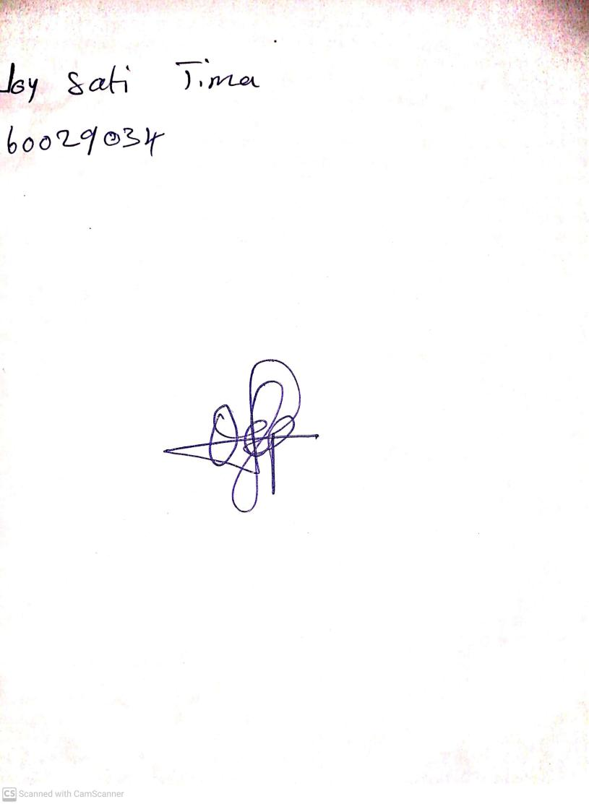

**14th June, 2024**

**Perpetual Ojoma Ocheja**

**Stream Head Nursery**