**EMERALD ROYAL INTERNATIONAL SCHOOL MPAPE, ABUJA**

**LESSON PLAN AND NOTE FOR WEEK 3 PERIOD 1 ENDING 16/01/2024**

**TERM: 2nd**

**WEEK: 3**

**DATE: 22/01/2024**

**CLASS: Nursery 2**

**SUBJECT: Number work**

**TOPIC: Number 31—35**

**SUB—TOPIC: Identification and counting number 31—35**

**PERIOD: 3rd**

**TIME: 08:50—09:30am**

**DURATION: 40 minutes**

**NUMBER IN CLASS: 13**

**AVERAGE AGE: 5 years**

**SEX: Mixed**

**LEARNING OBJECTIVES: By the end of the lesson, the pupils should be able to:**

**1. Count number 31—35**

**2. Write number 31–35**

**RATIONALE: For pupils to know counting of numbers.**

**PREVIOUS KNOWLEDGE: Pupils have been counting number 1–30**

**INSTRUCTIONAL MATERIALS: A chart of numbers.**

**REFERENCE MATERIALS: My choice of Mathematics stage 3.**

**LESSON DEVELOPMENT**

|  |  |  |  |
| --- | --- | --- | --- |
| **Steps** | **Teacher's activities** | **Pupils' activities** | **Learning point** |
| **Introduction** | **Teacher introduces the lesson by singing nursery number rhymes.** | **Pupils sing the rhymes along with the teacher.** | **To arouse pupils interest for the lesson.** |
| **Presentation step 1** | **Teacher presents the lesson by counting number 31–35 and then asks Pupils to repeat after her.** | **Pupils pay attention to the teacher and repeat after her.** | **For proper understanding.** |
| **Step 2** | **Teacher writes the numbers on the board from 31–35 for pupils to identify and count** | **Pupils identify the numbers on the board and count** | **For better understanding.** |
| **Board summary** | **Teacher summarizes the lesson by preparing pupils books for them to copy the note on the board into their books. That is;**  **COUNTING, IDENTIFICATION AND WRITING OF NUMBER 31—35**  **3 and 1 = 31**  **3 and 2 = 32**  **3 and 3 = 33**  **3 and 4 = 34**  **3 and 5 = 35.** | **Pupils copy the note into their exercise books** | **For onward study.** |
| **Evaluation** | **Teacher evaluates the lesson by asking pupils to go to the board one after the other and count. That is,**  **31 32 33 34 35** | **Pupils count the numbers on the board one after another** | **To assess pupils individual counting of numbers** |
| **Conclusion** | **Teacher concludes the lesson by marking pupils books.** | **Pupils submit their books for marking** | **For endorsement** |
| **Home work** | **Count,identify and write number 35–31** | **Pupils do their assignment at home.** | **To encourage learning at home.** |

**LESSON PLAN AND NOTE FOR WEEK 3 PERIOD 2 ENDING 26/01/2024**

**TERM. 2nd**

**WEEK. 3rd**

**DATE. 25/01/2024**

**CLASS. Nursery 2**

**SUBJECT. Number work**

**TOPIC. Number 31–35**

**SUB—TOPIC. Counting, identification and writing number 35—31**

**PERIOD. 2nd**

**TIME. 08:50—09:30am**

**DURATION. 40 minutes**

**NUMBER IN CLASS. 13**

**AVERAGE AGE. 5 years**

**SEX. Mixed**

**LEARNING OBJECTIVES: By the end of the lesson, the pupils should be able to:**

**1. Count number 35—31**

**2. Identify and write number 35_31**

**RATIONALE: For pupils to learn backward counting of numbers**

**PREVIOUS KNOWLEDGE: Pupils learn forward counting of numbers 31—35**

**INSTRUCTIONAL MATERIALS: Number chart**

**REFERENCE MATERIALS: My choice of Mathematics stage 3.**

**LESSON DEVELOPMENT**

|  |  |  |  |
| --- | --- | --- | --- |
| **Stages/ steps** | **Teacher's activities** | **Pupils' activities** | **Learning point** |
| **Introduction** | **Teacher introduces the lesson by asking pupils to count number 31–35** | **Pupils count number 31—35** | **To prepare pupils minds for the lesson ahead** |
| **Presentation step 1** | **Teacher presents the lesson by counting number 35—31 and then asks Pupils to repeat after her.** | **Pupils pay attention to the teacher and repeat after her.** | **For proper understanding.** |
| **Step 2** | **Teacher writes numbers 35—31 on the board and then asks pupils to identify and count. That is;**  **BACKWARD COUNTING, IDENTIFICATION AND WRITING NUMBER 35—31**  **3 and 5 =35**  **3 and 4 = 34**  **3 and 3 =33**  **3 and 2 =32**  **3 and 1 =31**  **Or,**  **35 34 33 32 31.** | **Pupils identify the numbers on the board and count.** | **For better understanding.** |
| **Board summary** | **Teacher summarizes the lesson by preparing pupils books for them to copy the note on the board into their books.** | **Pupils copy the note into their exercise books.** | **For onward study.** |
| **Evaluation** | **Teacher evaluates the lesson by asking pupils to count number 35—31.** | **Pupils all stand and count the numbers on the board** | **To assess the understanding of the lesson.** |
| **Conclusion** | **Teacher concludes the lesson by marking pupils books** | **Pupils submit their books for marking** | **For endorsement** |
| **Home work** | **Count, identify and write number 1—35**  **_______ ______ _______ _______ _______ _______ _______ _______ _______ _______ _______ ________ _______ _______ _______ _______ _______ ________ _______ ________ _______ ________ _______ _______ _______ _______ _______ _______ _______ ________ _______ ________ _______ ________ _______** | **Pupils do their assignment at home** | **To encourage learning at home** |

**LESSON PLAN AND NOTE FOR WEEK 3 PERIOD 3 ENDING 26/01/2024**

**TERM: 2nd**

**WEEK: 3rd**

**DATE: 26/01/2024**

**CLASS: Nursery 2**

**SUBJECT: Number work**

**TOPIC: Number 31—35**

**SUB—TOPIC: Counting and writing number 1–35**

**PERIOD: 3rd**

**TIME: 08:10—08:50am**

**DURATION: 40 minutes**

**NUMBER IN CLASS: 13**

**AVERAGE AGE: 5 years**

**SEX: Mixed**

**LEARNING OBJECTIVES: By the end of the lesson, the pupils should be able to:**

**1. Count number 1–35**

**2. Write number 1–35**

**RATIONALE: For pupils to know counting of numbers 1–35**

**PREVIOUS KNOWLEDGE: pupils have been learning counting of numbers in previous Lesson.**

**INSTRUCTIONAL MATERIALS: A chart of numbers**

**REFERENCE MATERIALS: My choice of Mathematics stage 3.**

**LESSON DEVELOPMENT**

|  |  |  |  |
| --- | --- | --- | --- |
| **Stages/ steps** | **Teacher's activities** | **Pupils' activities** | **Learning point** |
| **Introduction** | **Teacher introduces the lesson by jumping and counting number 1–35** | **Pupils jump and count number 1—35** | **To arouse pupils interest for the lesson** |
| **Presentation step 1** | **Teacher writes number 1—35 on the board, count and then asks Pupils to repeat after her.** | **Pupils listen to the teacher and repeat after her.** | **For proper understanding.** |
| **Step 2** | **Teacher guides pupils to count and identify number 1–35 on the board often and often.** | **Pupils identify and count the numbers on the board** | **For better understanding.** |
| **Board summary** | **Teacher summarizes the lesson by preparing pupils books for them to copy the note on the board. That is;**  **COUNTING AND WRITING OF NUMBERS 1—35**  **1 2 3 4 5**  **6 7 8 9 10**  **11 12 13 14 15**  **16 17 18 19 20**  **21 22 23 24 25**  **26 27 28 29 30**  **31 32 33 34 35** | **Pupils copy the note into their exercise books** | **For onward understanding.** |
| **Evaluation** | **Teacher evaluates the lesson by asking pupils to all stand and count the numbers on the board** | **Pupils stand and count the numbers on the board** | **To create platform for slow learners** |
| **Conclusion** | **Teacher marks pupils books** | **Pupils submit their books for marking** | **For endorsement** |
| **Assignment** | **Fill in the missing numbers**  **1 2 __ 4__ 6 7 __ 9 10 __ 12 __ 14 __ 16 __ 18 __ 20 __ 22 __ 24 __ 26 __ 28 __ 30 __ 32 __ 34 __** | **Pupils do their assignment at home** | **To encourage learning at home** |

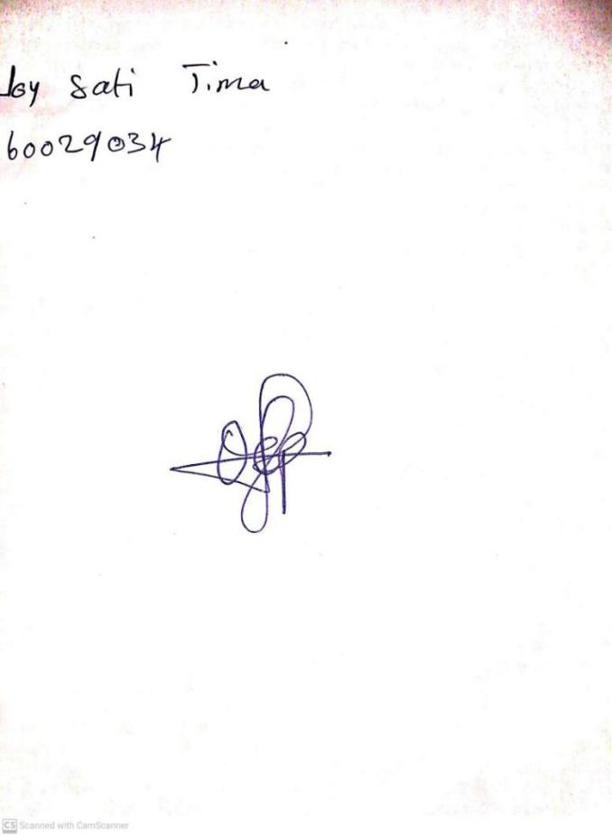

**19TH JANUARY, 2024**

**Perpetual Ojoma Ocheja**

**Stream Head Nursery**