EMERALD ROYAL INTERNATIONAL SCHOOL MPAPE, ABUJA. LESSON NOTE 1 FOR WEEK 9 ENDING 8th MARCH, 2024.

SUBJECT: Letter work

TOPIC: Identification of letter l and it's sound.

SUB-TOPIC: Recognition and sounding letter l .

DATE: 5/3/2024.

DURATION: 40 minutes.

TIME: 08:50---09:30

PERIOD: 2nd

CLASS: Pre-nursery

NUMBER OF PUPILS: 17

AVERAGE AGE: 2 years

SEX: Mixed.

SPECIFIC OBJECTIVES: By the end of the lesson, the pupils should be able to:-

I. Point and Identify letter l .

2. Sing a phonics song for letter l.

RATIONALE: For Pupils to know letters and their sounds.

PREVIOUS KNOWLEDGE: Pupils have been learning how to identify and say the sounds of the letter .

INSTRUCTIONAL MATERIAL: flash cards, board and phonics song.

REFERENCE: Mastering English for Nursery schools book 1 by J.M.Omogbai

LESSON DEVELOPMENT

|  |  |  |  |
| --- | --- | --- | --- |
| Stages/steps | Teacher's activities | Pupils' activities | Learning points. |
| Introduction | Teacher introduces the lesson by singing the A,B,C, D'S song for the pupils. | Pupils sing the rhyme along with the teacher. | To arouse interest of the pupils for the lesson. |
| Presentation  Step 1 | Teacher shows the pupils letter l on a flash card. Teacher asks the pupils to point at the flash card and say " letter l". | Pupils point at letter l on the flash card and say " letter l "repeatedly. | For proper recognition of letter l. |
| Step 2 | Teacher sings and teaches the pupils jolly phonics song for letter l . | Pupils pay attention to the teacher and repeat after her. | For better understanding of the lesson. |
| Summary | Teacher summarizes the lesson by asking the pupils to point at letter j on the flash card and say it's sound. | Pupils point at letter j on the and say it's sound. | To improve pupils understanding of the lesson. |
| Evaluation | Teacher puts flash cards of different letters on the table including letter j and asks the pupils to:-  1. Identify letter j amongst other letters.  2.Say the sound for letter j. | Pupils answer the questions asked by the teacher. | To assess the level of pupils understanding of the lesson. |
| Conclusion | Teacher marks the pupils books and makes necessary corrections. | Pupils submit their books for marking and corrections. | For onwards learning. |
| Assignment | Teacher asks the pupils to trace letter j. | Pupils trace letter j | To encourage Learning at home. |

LESSON NOTE 2 FOR WEEK 9 ENDING 8th MARCH, 2024.

SUBJECT: Letter work

TOPIC: Identification of letter l and it's sound.

SUB-TOPIC: Recognition and tracing letter l .

DATE: 6/3/2024.

DURATION: 40 minutes.

TIME: 08:50---09:30

PERIOD: 2nd

CLASS: Pre-nursery

NUMBER OF PUPILS: 17

AVERAGE AGE: 2 years

SEX: Mixed.

SPECIFIC OBJECTIVES: By the end of the lesson, the pupils should be able to:-

I. Identify letter l on the board.

2. Trace letter l.

RATIONALE: For Pupils to know letters and their sounds.

PREVIOUS KNOWLEDGE: Pupils have been learning how to identify and say the sounds of the letter .

INSTRUCTIONAL MATERIAL: flash cards, board and phonics song.

REFERENCE: Mastering English for Nursery schools book 1 by J.M.Omogbai

LESSON DEVELOPMENT

|  |  |  |  |
| --- | --- | --- | --- |
| Stages/steps | Teacher's activities | Pupils' activities | Learning points. |
| Introduction | Teacher introduces the lesson by asking the pupils the sounds for letter /a/_ /k/. | Pupils say the sounds from letter /a/ -/k/. | To arouse interest of the pupils for the lesson. |
| Presentation  Step 1 | Teacher writes letter l on the board and call the pupils one after another to point at letter" l " and say it's sound repeatedly. | Pupils point at letter l on the board and say it's sound " letter l "repeatedly. | For proper recognition of letter l. |
| Step 2 | Teacher prepares the pupils books for them to trace letter l | Pupils trace letter l in their books . | To improve pupils eye-hand coordination. |
| Summary | Teacher summarizes the lesson by asking the pupils to point at letter l on the flash card and say it's sound. | Pupils point at letter l on the flash card and say it's sound. | To improve pupils understanding of the lesson. |
| Evaluation | Teacher puts flash cards of different letters on the table including letter l and asks the pupils to:-  1. Identify letter l amongst other letters on the flash card.  2.Say the sound for letter l. | Pupils answer the questions asked by the teacher. | To assess the level of pupils understanding of the lesson. |
| Conclusion | Teacher marks the pupils books and makes necessary corrections. | Pupils submit their books for marking and corrections. | For onwards learning. |
| Assignment | Teacher asks the pupils to trace letter l. | Pupils do their homework at home. | To encourage Learning at home. |

LESSON NOTE 3 FOR WEEK 9 ENDING 8th MARCH, 2024.

SUBJECT: Letter work

TOPIC: Identification of letter l and it's sound.

SUB-TOPIC: Recognition and Colouring letter l .

DATE: 8/3/2024.

DURATION: 40 minutes.

TIME: 08:50---09:30

PERIOD: 2nd

CLASS: Pre-nursery

NUMBER OF PUPILS: 17

AVERAGE AGE: 2 years

SEX: Mixed.

SPECIFIC OBJECTIVES: By the end of the lesson, the pupils should be able to:-

I. Colour letter l

2. Say the sound for letter l

RATIONALE: For Pupils to know letters and their sounds.

PREVIOUS KNOWLEDGE: Pupils have been learning how to identify and say the sounds of the letter .

INSTRUCTIONAL MATERIAL: flash cards, board and phonics song.

REFERENCE: Mastering English for Nursery schools book 1 by J.M.Omogbai

LESSON DEVELOPMENT

|  |  |  |  |
| --- | --- | --- | --- |
| Stages/steps | Teacher's activities | Pupils' activities | Learning points. |
| Introduction | Teacher introduces the lesson by singing a nursery rhyme for the pupils. | Pupils sing the rhyme along with the teacher. | To arouse interest of the pupils for the lesson. |
| Presentation  Step 1 | Teacher writes letter l boldly on the pupils exercise books for them to colour.  L | Pupils colour letter l in their books.  L | For proper recognition of letter l. |
| Step 2 | Teacher passes the flash card of letter of from one child to another and encourages the pupils to hold it and say the letter l sound. | Pupils hold the flash card for letter l and practice it sound. | For better understanding of the lesson. |
| Summary | Teacher summarizes the lesson by asking the pupils to sing the phonics song for letter l along with the teacher. | Pupils sing the phonics song for letter I along with the teacher. | To improve pupils understanding of the lesson. |
| Evaluation | Teacher asks the pupils to:-   1. point at letter l on the flash card. 2. Colour letter L. | Pupils answer the questions asked by the teacher. | To assess the level of pupils understanding of the lesson. |
| Conclusion | Teacher marks the pupils books and makes necessary corrections. | Pupils submit their books for marking and corrections. | For onwards learning. |
| Assignment | Teacher asks the pupils to identify letter l amongst other letters.  j k l m  h l o l  l p l l | Pupils do their homework at home. | To encourage Learning at home. |

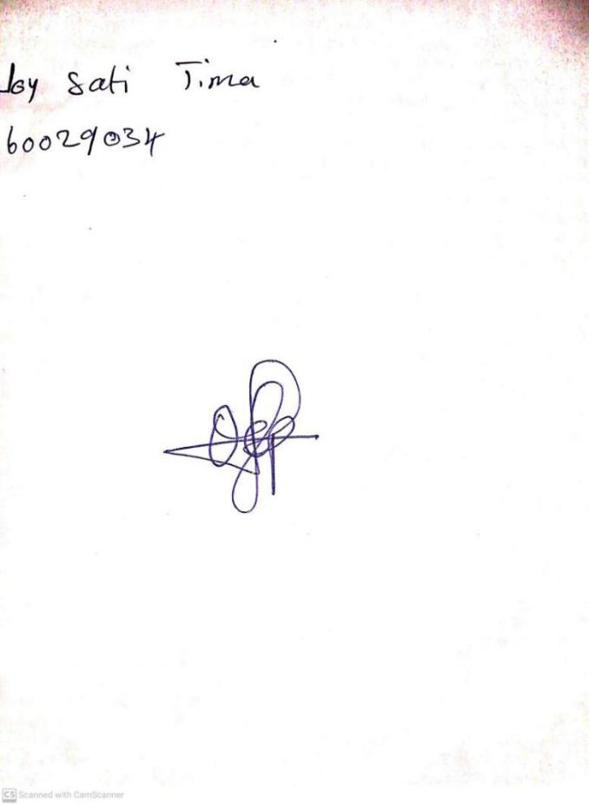

**1ST MARCH, 2024**

**Perpetual Ojoma Ocheja**

**Stream Head Nursery**