**LESSON PLAN AND NOTE FOR WEEK 11 ENDING 5/7/2024**

**Term 3rd term**

**Week 11th week**

**Date 4th July, 2024.**

**Class Nursery One**

**Subject Social Norms**

**Topic Love & Respect for others.**

**Sub-topic Naming the things we must love and respect.**

**Period 4th period**

**Time 10:40 am**

**Duration 35 minutes**

**No in class 14**

**Average Age 3 years**

**Sex Mixed**

**Specific Objectives: By the end of the lesson, the pupils should be able to:**

1. **Name the things to love & respect.**
2. **Know why we must love & respect others.**
3. **Know how to love & respect others.**

**Rationale: To teach & ensure the pupils love & respect others.**

**Previous Knowledge: The pupils can spell the name of their country.**

**Instructional Resources: Online research.**

**Reference Material: Smart Smart Civic Education by A.M Solu & T.Y Alabi, nursery 2**

**LESSON PRESENTATION**

|  |  |  |  |
| --- | --- | --- | --- |
| **Steps** | **Teacher’s Activities** | **Pupils’ Activities** | **Learning Points** |
| **Introduction** | **The teacher introduces the lesson [Love & Respect for others] to the pupils.** | **The pupils pays attention to the teacher.** | **To arouse the pupils’ interest.** |
| **Step 1** | **The teacher mention the things we must love & respect which include**  **OUR PARENTS**  **OUR COUNTRY**  **OUR RELIGION** | **The pupils pay attention and repeats after the teacher the things to love and respect.** | **For proper understanding.** |
| **Step 2** | **The teacher teaches the pupils why we must love and respect**  **OUR PARENTS**  **OUR COUNTRY**  **OUR RELIGION**  **Because GOD, Mummy & Daddy and our country NIGERIA is above us.** | **The pupils listens attentively to the teacher.** | **For better understanding.** |
| **Step 3** | **The teacher teaches the pupils how to love and respect PARENTS,COUNTRY & RELIGION which include**  **We love & respect our parents by obeying them, by helping them.**  **We love & respect our country by knowing all about our country such as reciting the national anthem, saying the national pledge, and the national coat of arm etc.** | **The pupils listen and understands the lesson as the teacher teaches them.** | **For further understanding.** |
| **Summary** | **The teacher summarizes the lesson by explaining love & respect for others to the pupils.** | **The pupils listens and understand the lesson.** | **For onward study.** |
| **Evaluation** | **Question:**  **Mention two things we must love & respect?**  **Why should we obey our country?**  **How do we obey our country?** | **The pupils answer the question correctly.** | **To ascertain the pupils’ understanding.** |
| **Conclusion** | **The teacher summarizes the lesson to the pupils.** | **The pupils gives answers to the teacher.** | **To consolidate the lesson.** |
| **Assignment** | **Question:**  **Mention two things we must love & respect?**  **Why should we obey our country?**  **How do we obey our country?** | **The pupils copy and do their homework** | **To encourage learning while at home.** |

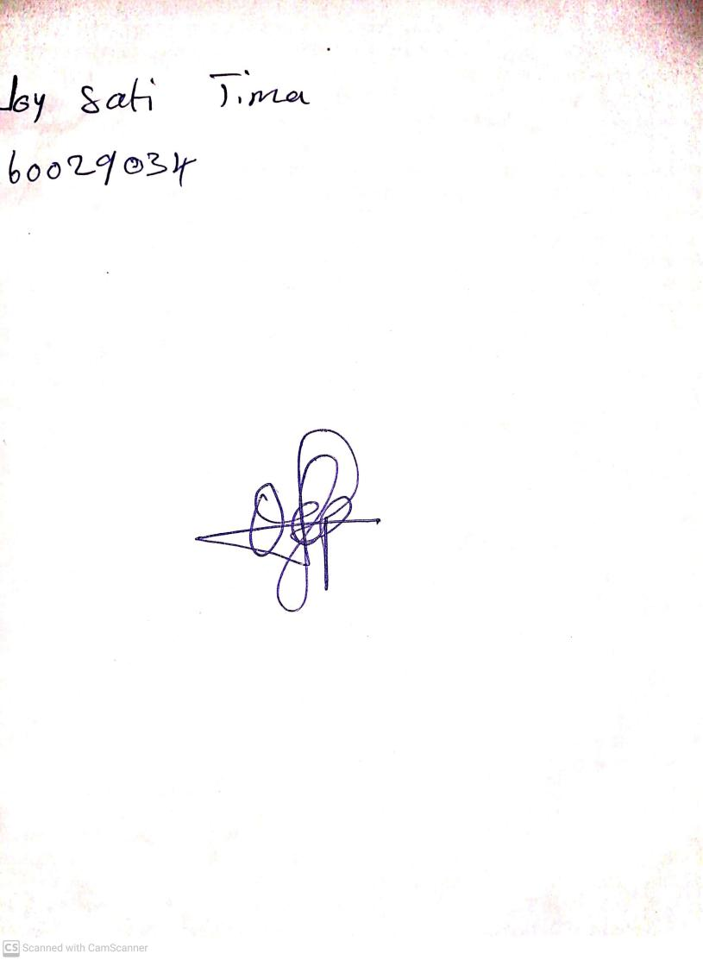

27th June, 2024

Perpetual Ojoma Ocheja

Stream Head Nursery