**LESSON PLAN AND NOTE 1 FOR WEEK 7 ENDING 25/10/2024**

**Term 1st  term**

**Week 7th week**

**Date 21st October,2024**

**Class Nursery one**

**Subject Letter work**

**Topic Tracing letter Aa - Jj.**

**Sub-topic Trace letter Aa, Bb, Cc.**

**Period 2nd period**

**Time 8:50 am**

**Duration 35 minutes**

**No in class 15**

**Average Age 3 years**

**Sex Mixed**

**Specific Objectives: By the end of the lesson the pupils should be able to;**

1. **Sound letter Aa, Bb, Cc.**
2. **Identify letter Aa, Bb, Cc.**
3. **Trace letter Aa, Bb, Cc.**

**Rationale: To make sure the pupils sound trace and identify letter Aa-Jj.**

**Previous knowledge: The pupils can match letter Uu - Zz with picture words.**

**Instructional Resources: Chart, board, marker, exercise books, pencils.**

**Reference Materials: Online Research,chart,board.**

**LESSON PRESENTATION**

|  |  |  |  |
| --- | --- | --- | --- |
| **Steps** | **Teacher’s Activities** | **Pupils’ Activities** | **Learning points** |
| **Introduction** | **The teacher introduces the topic (Tracing of letters Aa - Jj) to the pupils by rhyming it.** | **The pupils listen attentively to the teacher.** | **To arouse the interest of the pupils.** |
| **Step 1** | **The teacher assists the pupils to sound letters Aa, Bb, Cc**  **A a**  **B b**  **C c** | **The pupils individually sound the letters Aa, Bb, Cc .** | **For proper understanding.** |
| **Step 2** | **The teacher leads the pupils to identify letter Aa, Bb, Cc .**  **Aa Bb**  **Cc** | **The pupils identify the letter Aa, Bb, Cc after the teacher.** | **For better understanding.** |
| **Step 3** | **The teacher guides the pupils in tracing letters Aa, Bb, Cc inside their notebooks**  **dotted letter Aa dotted letter Bb** | **The pupils trace the letters Aa, Bb, Cc as the teacher guides them.** | **For further understanding.** |
| **Summary** | **The teacher summarizes the lesson by sounding capital and small letter Aa, Bb, Cc.** | **The pupils can sound capital and small letter Aa, Bb, Cc.** | **For onward study.** |
| **Evaluation** | **The teacher asks the pupils to:**   1. **Sound the letters below?**     **Aa Bb Cc**   1. **Identify these letters below?**   **Aa Bb**  **Cc**   1. **Trace the letters Aa and Bb below?**   **dotted letter Aa dotted letter Bb** | **The pupils answer the question correctly.** | **To ascertain the pupils’ understanding.** |
| **Conclusion** | **The teacher summarizes, reacts & corrects the pupils.** | **The pupils answer to the teacher’s questions.** | **To consolidate the lesson.** |
| **Assignment** | **Sound the letters below?**    **Aa Bb Cc**  **Identify these letters below?**  **Aa Bb**  **Cc**  **Trace capital and small letter Aa?**  **dotted letter Aa dotted letter Bb** | **The pupils copy and do their homework at home.** | **To encourage learning while at home.** |

**LESSON PLAN AND NOTE 2 FOR WEEK 7 ENDING 25/10/2024**

**Term 1st  term**

**Week 7th week**

**Date 23rd October,2024**

**Class Nursery one**

**Subject Letter work**

**Topic Tracing letter Aa - Jj.**

**Sub-topic Trace letter Dd, Ee, Ff.**

**Period 2nd period**

**Time 8:50 am**

**Duration 35 minutes**

**No in class 15**

**Average Age 3 years**

**Sex Mixed**

**Specific Objectives: By the end of the lesson the pupils should be able to;**

1. **Sound letter Dd, Ee, Ff.**
2. **Identify letter Dd, Ee, Ff.**
3. **Trace letter Dd, Ee, Ff.**

**Rationale: To make sure the pupils trace and identify letter Aa-Jj.**

**Previous knowledge: The pupils can trace and identify letter Aa, Bb, Cc.**

**Instructional Resources: Chart, board, marker, exercise books, pencils.**

**Reference Materials: Online Research,chart,board.**

**LESSON PRESENTATION**

|  |  |  |  |
| --- | --- | --- | --- |
| **Steps** | **Teacher’s Activities** | **Pupils’ Activities** | **Learning points** |
| **Introduction** | **The teacher introduces the topic (Tracing letter Aa-Jj) to the pupils by rhyming them.** | **The pupils listen attentively to the teacher.** | **To arouse the interest of the pupils.** |
| **Step 1** | **The teacher assists the pupils to sound letter Dd, Ee, Ff.**  **Dd Ee**  **Ff** | **The pupils individually sound the letters Dd, Ee, Ff** | **For proper understanding.** |
| **Step 2** | **The teacher leads the pupils to identify letter Dd, Ee, Ff.**    **Dd Ee**  **Ff** | **The pupils identify the letter Dd, Ee, Ff after the teacher.** | **For better understanding.** |
| **Step 3** | **The teacher guides the pupils in tracing letters Dd, Ee, Ff**  **untraced letter Dd untraced letter Ee**  **untraced letter Ff** | **The pupils trace the letters Dd, Ee, Ff as the teacher guides them.** | **For further understanding.** |
| **Summary** | **The teacher summarizes the lesson by sounding letters Dd, Ee, Ff to the pupils.** | **The pupils can sound letters Dd, Ee, Ff.** | **For onward study.** |
| **Evaluation** | **The teacher asks the pupils to:**   1. **Sound the letters below?**   **Dd Ee Ff**   1. **Identify these letters below?**   **Dd Ee**  **Ff**   1. **Trace the letters below?**   **untraced letter Dd untraced letter Ee**  **untraced letter Ff** | **The pupils answer the question correctly.** | **To ascertain the pupils’ understanding.** |
| **Conclusion** | **The teacher summarizes, reacts & corrects the pupils.** | **The pupils answer to the teacher’s questions.** | **To consolidate the lesson.** |
| **Assignment** | **Sound the letters below?**  **Dd Ee Ff**  **Identify these letters below?**  **Dd Ee**  **Ff**  **Trace capital and small letter Dd, Ee, Ff?**  **untraced letter Dd untraced letter Ee**  **untraced letter Ff** | **The pupils copy and do their homework at home.** | **To encourage learning while at home.** |

**LESSON PLAN AND NOTE 3 FOR WEEK 7 ENDING 25/10/2024**

**Term 1st  term**

**Week 7th week**

**Date 25th October,2024**

**Class Nursery one**

**Subject Letter work**

**Topic Tracing letter Aa - Jj.**

**Sub-topic Trace letter Gg, Hh, Ii, Jj.**

**Period 4th period**

**Time 10:40 am**

**Duration 35 minutes**

**No in class 15**

**Average Age 3 years**

**Sex Mixed**

**Specific Objectives: By the end of the lesson the pupils should be able to;**

1. **Sound letter Gg, Hh, Ii, Jj.**
2. **Identify letter Gg, Hh, Ii, Jj.**
3. **Trace letter Gg, Hh, Ii, Jj.**

**Rationale: To make sure the pupils trace and identify letter Aa-Jj.**

**Previous knowledge: The pupils can trace and identify letter Dd, Ee, Ff.**

**Instructional Resources: Chart, board, marker, exercise books, pencils.**

**Reference Materials: Online Research,chart,board.**

**LESSON PRESENTATION**

|  |  |  |  |
| --- | --- | --- | --- |
| **Steps** | **Teacher’s Activities** | **Pupils’ Activities** | **Learning points** |
| **Introduction** | **The teacher introduces the topic (Tracing letter Aa-Jj) to the pupils by rhyming them.** | **The pupils listen attentively to the teacher.** | **To arouse the interest of the pupils.** |
| **Step 1** | **The teacher assists the pupils to sound letter Gg, Hh, Ii, Jj.**  **Gg Hh**  **Ii Jj** | **The pupils individually sound the letters Gg, Hh, Ii, Jj.** | **For proper understanding.** |
| **Step 2** | **The teacher leads the pupils to identify letter Gg, Hh, Ii, Jj.**    **Hh Gg**  **Jj Ii** | **The pupils identify the letter Gg, Hh, Ii, Jj after the teacher.** | **For better understanding.** |
| **Step 3** | **The teacher guides the pupils in tracing letters Gg, Hh, Ii, Jj**  **untraced letter Gg untraced letter Hh**    **untraced letter Ii untraced letter Jj** | **The pupils trace the letters Gg, Hh, Ii, Jj as the teacher guides them.** | **For further understanding.** |
| **Summary** | **The teacher summarizes the lesson by sounding letters Gg, Hh, Ii, Jj to the pupils.** | **The pupils can sound letters Gg, Hh, Ii, Jj** | **For onward study.** |
| **Evaluation** | **The teacher asks the pupils to :**   1. **Sound the letters below?**   **Hh Ii**  **Jj Gg**   1. **Identify these letters below?**   **Hh Ii**    **Gg Jj**   1. **Trace the letters below?**   **untraced letter Gg untraced letter Hh**    **untraced letter Ii untraced letter Jj** | **The pupils answer the question correctly.** | **To ascertain the pupils’ understanding.** |
| **Conclusion** | **The teacher summarizes, reacts & corrects the pupils.** | **The pupils answer to the teacher’s questions.** | **To consolidate the lesson.** |
| **Assignment** | **Sound the letters below?**  **Hh Ii**  **Jj Gg**  **Identify these letters below?**  **Hh Ii**    **Gg Jj**  **Trace capital and small letter Gg, Hh, Ii, Jj?**  **untraced letter Gg untraced letter Hh**    **untraced letter Ii untraced letter Jj** | **The pupils copy and do their homework at home.** | **To encourage learning while at home.** |

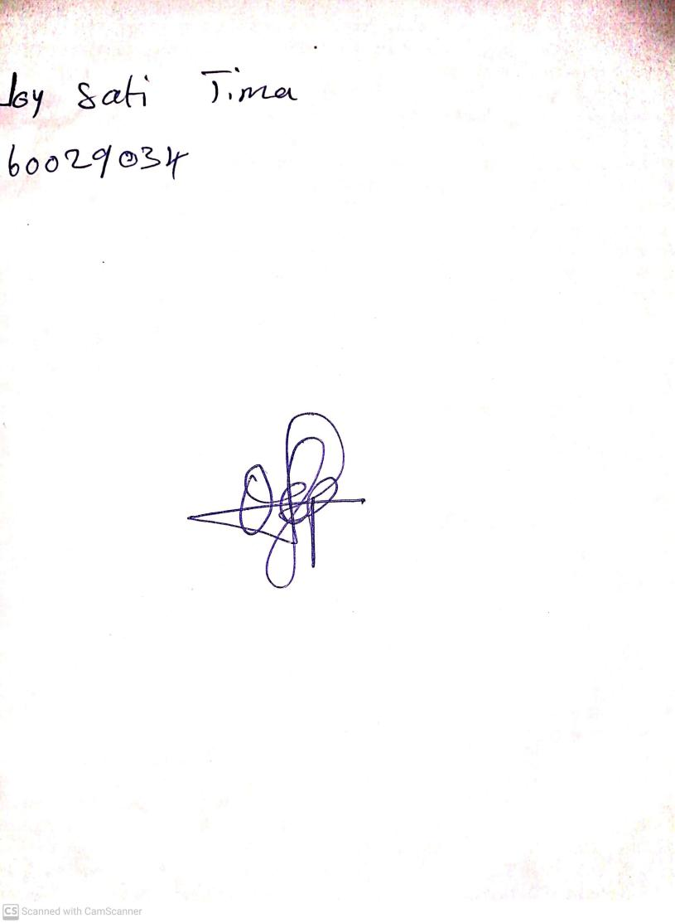

25th October, 2024

Perpetual Ojoma Ocheja

Stream Head Nursery