EMERALD ROYAL INTERNATIONAL SCHOOL

MPAPE, ABUJA.

LESSON PLAN AND NOTE FOR WEEK 6 ENDING 9TH JUNE, 2023

TERM: Third term.

WEEK: 6

SUBJECT: Nature studies.

TOPIC: Weather

SUB-TOPIC: Types weather and activities for each weather.

DATE: 8/6/2023

DURATION: 40 minutes

TIME: 08:50-09:30

PERIOD: 3rd

CLASS: Pre-nursery

NUMBER OF PUPILS: 11

AVERAGE AGE: 2 years

SEX: Mixed

SPECIFIC OBJECTIVES: By the end of the lesson, the pupils should be able to:-

I List the types of weather

2. Activities for each weather.

RATIONALE: For Pupils to know the condition of their place.

PREVIOUS KNOWLEDGE: Pupils have been experiencing raining weather.

INSTRUCTIONAL MATERIALS: chart of a weather types.

REFERENCE: Showers kiddies books Elementary science book nursery 1 by showers kiddies books.

LESSON DEVELOPMENT

|  |  |  |  |
| --- | --- | --- | --- |
| Stages/steps | Teacher's activities | Pupils' activities | Learning points |
| Introduction | Teacher introduces the lesson by singing a nursery rhyme as:-  Rain rain go away  Come again another day  Little children want to play. | Pupils listen to teacher and sing along with the teacher. | To arouse the interest of the pupils. |
| Presentation  Step 1 | Teacher lists the types of weather to the pupils as:   1. Sunny weather. 2. Rainy weather. 3. Windy weather. 4. Cloudy weather.   "Teacher asks the pupils to repeat after the teacher. | Pupils listen to the teacher and repeat after the teacher. | For better understanding of the lesson. |
| Step 2 | Teacher explains to the pupils the differences activities for each weather.  Sunny weather:- The sun is very important. We can see it in the day when the sun is out. The sun keeps us warm and helps our plants grow. Sometimes, when the sun is very hot we wear sunglasses and use an umbrella to shade us from the heat.  Rainy weather:- When clouds can hold no more water, water comes down in the form of rain. On a rainy day, we use umbrellas,rain coats and boots to keep ourselves dry.  Windy weather:- Moving air is called wind. Sometimes when it is windy it is cold and we keep warm. Things we can wear when it is cold and windy are sweaters, scarfs and hat.  Teacher asks the pupils to repeat after the teacher. | Pupils listen to the teacher as she is explaining the activities for each weather. | For proper understanding of the lesson. |
| Summary | Teacher summarizes the lesson by going over the lesson again for more understanding. | Pupils listen attentively to the teacher as she is going over the lesson. | To ensure better understanding. |
| Evaluation | Teacher asks the Pupils to :-   1. State the types of weather. 2. State the different clothes wore in weather. | Pupils answer the teacher's questions correctly. | To ascertain the level of pupils understanding of the lesson. |
| Conclusion | Teacher concludes the lesson by taking the pupils out to experience the sunny weather. | Pupils follow the  Teacher's instruction to experience the sunny weather. | For better understanding of the lesson. |
| Assignment | Teacher asks the pupils to experience how they feel during rainy day orally | Pupils do the assignment at home. | To encourage Learning at home. |

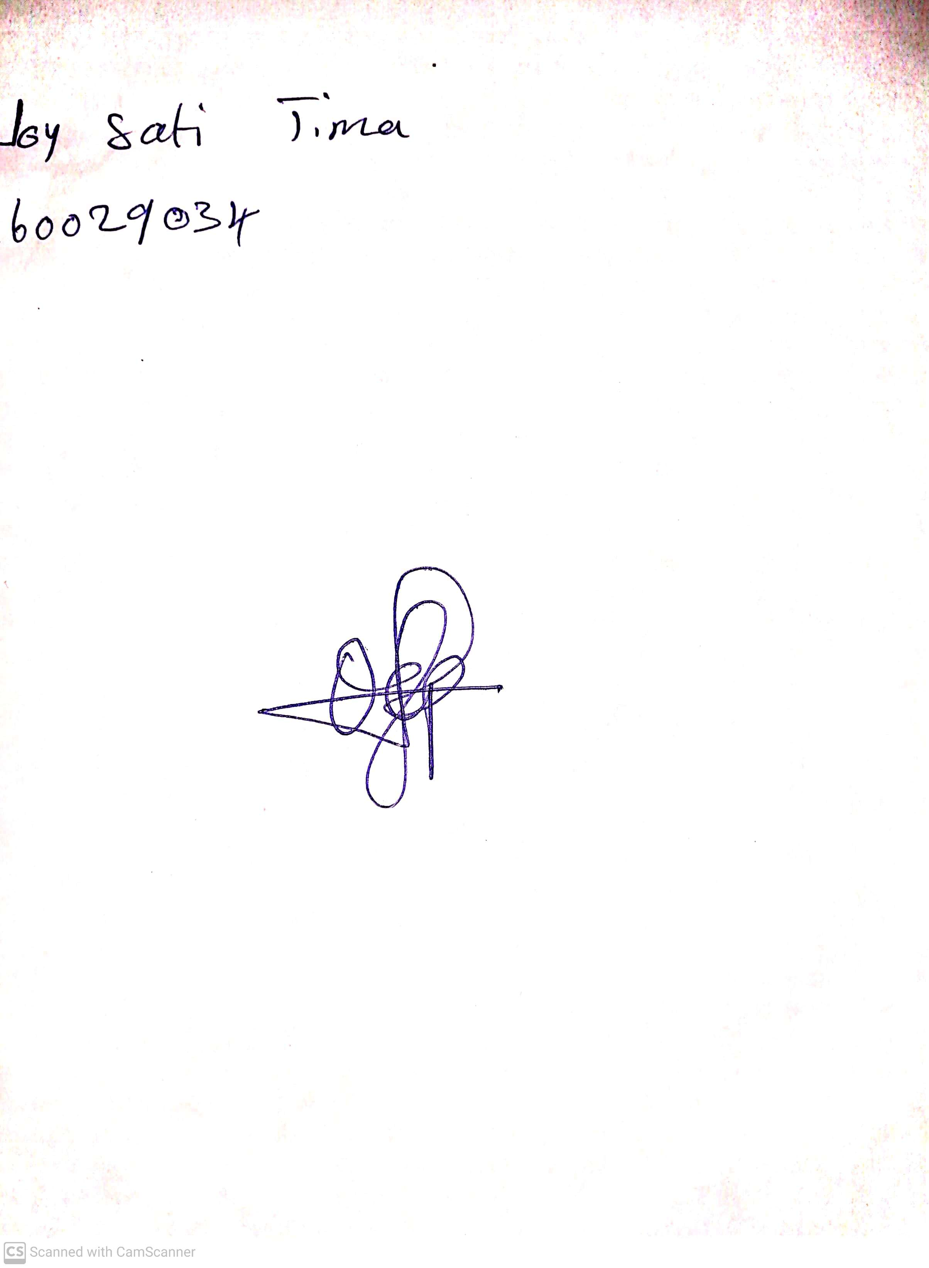

29th April, 2023

Perpetual Ojoma

Stream Head Nursery