**EMERALD ROYAL INTERNATIONAL SCHOOL**

**MPAPE, ABUJA.**

**LESSON PLAN AND NOTE FOR WEEK 3 PERIOD 1 ENDING 19/05/2023**

TERM: THIRD

WEEK: 3RD

DATE: 15/05/2023

CLASS: NURSERY 2

SUBJECT: LETTER WORK

TOPIC: VOWEL DIGRAPHS 2

SUB-TOPIC: WORDS WITH VOWEL DIGRAPHS “AI” AND “AY”

PERIOD: 1ST PERIOD

TIME: 09: 30 - 10:10am

DURATION: 40 MINUTES.

NUMBER IN CLASS: 17

AVERAGE AGE: 5 YEARS.

SEX: MIXED.

SPECIFIC OBJECTIVES: BY THE END OF THE LESSON,THE PUPILS SHOULD BE

ABLE TO:

1. MENTION WORDS WITH VOWEL DIGRAPHS “AI”

2. PRONOUNCE WORDS WITH VOWEL DIGRAPHS “AY”

RATIONALE: FOR PUPILS TO KNOW WORDS WITH. VOWELDIGRAPHS“AI” AND “AY”

PREVIOU KNOWLEDGE: PUPILS HAVE LEARNT THE MEANING OF VOWEL

DIGRAPHS IN PREVIOUS LESSON.

REFERENCE MATERIALS: GOOGLE.COM .

**LESSON DEVELOPMENT**

|  |  |  |  |
| --- | --- | --- | --- |
| STAGES/STEPS | TEACHER’S ACTIVITIES | PUPILS’ ACTIVITIES | LEARNING POINTS |
| INTRODUCTION | Teacher reviews the previous lesson on vowel digraphs to pupils. | Pupil listen attentively to the teacher. | To prepare pupils minds for the lesson ahead. |
| PRESENTATION  STEP 1 | Teacher mentions words with vowel digraphs “ai” to pupils and asks them to repeat after her. | Pupils listen attentively to the teacher and repeat after her. | For proper understanding . |
| STEP 2 | Teacher writes the words with vowel digraph “ay” on the board, spell and pronounce and also asks pupils to identify and repeat after her. | Pupils pay attention to the teacher and repeat after her. | For better understanding of the lesson. |
| BOARD SUMMARY | Teacher writes the whole not of lesson on the board for pupils to copy.ie,  VOWEL DIGRAPH “AI”  “ai” as in rain  “ai” as in train  “ai” as in maid  “ai” as in aim  “ai” as in sail  “ai” as in paid  “ai” as in wait  “ai” as in snail  “ai” as in grain  “ai” as in gain  “ai” as in afraid  “ai” as in nail etc  VOWEL DIGRAPHS “AY”  “ay” as in play  “ay” as in day  “ay” as in say  “ay” as in clay  “ay” as in pay  “ay” as in tray  “ay” as in away  “ay” as in today  “ay” as in relay  “ay” as in spray etc. | Pupils copy the note into their exercise books. | For onward study. |
| EVALUATION | Teacher evaluates the lesson by asking pupils to all,  1. Mention the words with vowel 'ai'  2. Pronounce words with vowel 'ay' | Pupils listen to the teacher and answer the questions asked by the her. | To assess pupils reading skills. |
| CONCLUTION | Teacher concludes the lesson by marking pupils books. | Pupils submit their books for marking. | For endorsement. |
| ASSIGNMENT | Make 10 words with vowel digraphs “ey” | Pupils do their assignment at home. | To encourage learning at home. |

**LESSON PLAN AND NOTE FOR WEEK 3 PERIOD 2 ENDING 19/05/2023**

TERM: THIRD

WEEK: 3RD

DATE: 18/05/2023

CLASS: NURSERY 2

SUBJECT: LETTER WORK

TOPIC: VOWEL DIGRAPHS 2

SUB-TOPIC: WORDS WITH VOWEL DIGRAPHS “EY”

PERIOD: 2ND PERIOD

TIME: 09: 30 - 10:10am

DURATION: 40 MINUTES.

NUMBER IN CLASS: 17

AVERAGE AGE: 5 YEARS.

SEX: MIXED.

SPECIFIC OBJECTIVES: BY THE END OF THE LESSON,THE PUPILS SHOULD BE

ABLE TO:

1. MENTION WORDS WITH VOWEL DIGRAPHS “EY”

2. PRONOUNCE WORDS WITH VOWEL DIGRAPHS “EY”

RATIONALE: FOR PUPILS TO KNOW WORDS WITH VOWEL DIGRAPHS“AI” AND “AY”

PREVIOU KNOWLEDGE: PUPILS HAVE LEARNT THE MEANING OF VOWEL

DIGRAPHS IN PREVIOUS LESSON.

REFERENCE MATERIALS: GOOGLE.COM .

**LESSON DEVELOPMENT**

|  |  |  |  |
| --- | --- | --- | --- |
| STAGES/STEPS | TEACHER’S ACTIVITIES | PUPILS’ ACTIVITIES | LEARNING POINTS |
| INTRODUCTION | Teacher reviews the previous lesson on vowel digraphs to pupils. | Pupil listen attentively to the teacher. | To prepare pupils minds for the lesson ahead. |
| PRESENTATION  STEP 1 | Teacher mentions words with vowel digraphs “ey” to pupils and asks them to repeat after her. | Pupils listen attentively to the teacher and repeat after her. | For proper understanding . |
| STEP 2 | Teacher writes the words with vowel digraph “ey” on the board, spell and pronounce and also asks pupils to identify and repeat after her. | Pupils pay attention to the teacher and repeat after her. | For better understanding of the lesson. |
| BOARD SUMMARY | Teacher writes the whole not of lesson on the board for pupils to copy.ie,  VOWEL DIGRAPH “EY”  “ey” as in key  “ey” as in honey  “ey” as in donkey  “ey” as in monkey  “ey” as in kidney  “ey” as in hockey  “ey” as in they  “ey” as in hey  “ey” as in whey  “ey” as in obey  “ey” as in survey etc | Pupils copy the note into their exercise books. | For onward study. |
| EVALUATION | Teacher evaluates the lesson by asking pupils to all stand and then spell and pronounce the words with vowel "ey" on the board all together. | Pupils listen to the teacher and read the note on the board one after another. | To assess pupils reading skills. |
| CONCLUTION | Teacher concludes the lesson by marking pupils books. | Pupils submit their books for marking. | For endorsement. |
| ASSIGNMENT | Make 10 words with vowel digraphs “aw” | Pupils do their assignment at home. | To encourage learning at home. |

**LESSON PLAN AND NOTE FOR WEEK 3 PERIOD 3 ENDING 19/05/2023**

TERM: THIRD

WEEK: 3RD

DATE: 19/05/2023

CLASS: NURSERY 2

SUBJECT: LETTER WORK

TOPIC: VOWEL DIGRAPHS 2

SUB-TOPIC: WORDS WITH VOWEL DIGRAPHS “AW”

PERIOD: 3RD PERIOD

TIME: 09: 30 - 10:10am

DURATION: 40 MINUTES.

NUMBER IN CLASS: 17

AVERAGE AGE: 5 YEARS.

SEX: MIXED.

SPECIFIC OBJECTIVES: BY THE END OF THE LESSON,THE PUPILS SHOULD BE

ABLE TO:

1. MENTION WORDS WITH VOWEL DIGRAPHS “AW”

2. PRONOUNCE WORDS WITH VOWEL DIGRAPHS “AW”

RATIONALE: FOR PUPILS TO KNOW WORDS WITH VOWEL DIGRAPHS“AW”

PREVIOU KNOWLEDGE: PUPILS HAVE LEARNT THE MEANING OF VOWEL

DIGRAPHS IN PREVIOUS LESSON.

REFERENCE MATERIALS: GOOGLE.COM .

**LESSON DEVELOPMENT**

|  |  |  |  |
| --- | --- | --- | --- |
| STAGES/STEPS | TEACHER’S ACTIVITIES | PUPILS’ ACTIVITIES | LEARNING POINTS |
| INTRODUCTION | Teacher reviews the previous lesson on vowel digraphs to pupils. | Pupil listen attentively to the teacher. | To prepare pupils minds for the lesson ahead. |
| PRESENTATION  STEP 1 | Teacher mentions words with vowel digraphs “aw” to pupils and asks them to repeat after her. | Pupils listen attentively to the teacher and repeat after her. | For proper understanding . |
| STEP 2 | Teacher writes the words with vowel digraph “aw” on the board, spell and pronounce and also asks pupils to identify and repeat after her. | Pupils pay attention to the teacher and repeat after her. | For better understanding of the lesson. |
| BOARD SUMMARY | Teacher writes the whole not of lesson on the board for pupils to copy.ie,  VOWEL DIGRAPH “AW”  “aw” as in claw  “aw” as in crawl  “aw” as in dawn  “aw” as in draw  “aw” as in drawers  “aw” as in fawn  “aw” as in hawk  “aw” as in lawn  “aw” as in paw  “aw” as in prawn  “aw” as in raw  “aw”as in saw  “aw” as in straw  “aw” as in shawl | Pupils copy the note into their exercise books. | For onward study. |
| EVALUATION | Teacher evaluates the lesson by asking pupils to spell and pronounce the words with vowel "aw" on the board one after another. | Pupils listen to the teacher and read the note on the board one after another. | To assess pupils reading skills. |
| CONCLUTION | Teacher concludes the lesson by marking pupils books. | Pupils submit their books for marking. | For endorsement. |
| ASSIGNMENT | 1. Make 10 words with vowel digraphs “ea” 2. Write 10 words with vowel digraphs “ie” | Pupils do their assignment at home. | To encourage learning at home. |

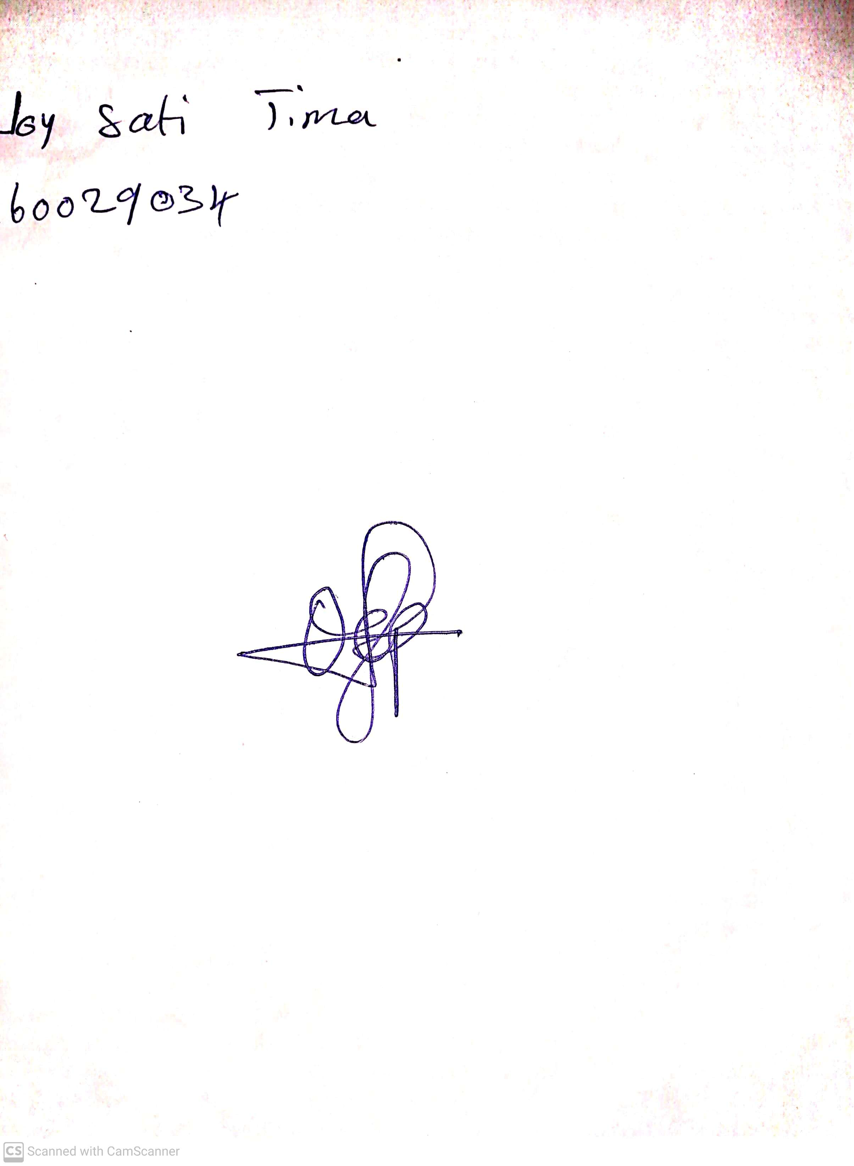

14th May, 2023

Perpetual Ojoma

Stream Head Nursery