**Lesson Plan/Note for Week 4 Ending 03/2/2023.**

**Term:** 2nd.

**Week:** 4

**Date:** 30/1/2023.

**Class:** SS 2

**Subject:** civic Education.

**Topic:** Drug Abuse.

**Sub-Topic:** prevention of Drug Abuse.

**Period:** 6th

**Time:** 11:50-12:30.

**Duration:** 40 minutes.

**Number of Students:** 5 Students.

**Sex:** mixed.

**Average Age:** 14 Years.

**Specific objectives**: By the end of the lesson, the students should be able to:

(1) State the prevention of Drug Abuse.

(11) Explain the prevention of Drug Abuse.

**Rationale:** To be able to highlight the preventive measures against Drug Abuse.

**Previous knowledge**: The students have seen people who Abuse drugs in their area. E.g Alcohol.

**Instructional Material:** A chart showing Drug manufacturers packing their products and security agents.

**Reference material:** Gbenga Babalola (2017) Essential Civic Education for senior Secondary schools.

**LESSON DEVELOPMENT**

|  |  |  |  |
| --- | --- | --- | --- |
| **Stages/Steps** | **Teacher's Activities** | **Students' Activities** | **Learning points.** |
| **Introduction** | Review the previous lesson | Participate actively in the class discussion. | To arouse the students’ interest to learn. |
| **Step 1** | States the prevention of drug abuse as: (1) public symposia (2) fighting against fake and hard drugs (3) the school etc. | Listen carefully to the teacher | For better understanding of the lesson. |
| **Step 11** | Guides the students to explain the prevention of Drug Abuse | Participate actively in the class discussion | To encourage critical thinking. |
| **Board Summary** | Summaries the lesson as:  **Prevention of Drug Abuse**  (1) public symposia: The public should be enlightened on the dangers of drug abuse such as bill board, bulletins, handballs, posters etc. (2) fighting against fake and drugs: Government agencies such as NAFDAC and NDLEA should be used to fight drug abuse. (3) The school: The school subjects like Social Studies, Civic Education, Diplomacy, History, international relation should include drug abuse in their curriculum. (4) The mass media: The mass media such as television, radio, newspaper, magazines internet etc should advertise the danger of drug abuse. (5) The constitution of the state: The constitution should emphasize the danger of drug abuse and the punishment attached it in details. (6) self-example: parents, lecturers, teachers, pastors, leaders in various sectors should avoid and live above drug abuse in order to be able to use themselves as living examples for the children to imitate. (7) Sale of Drug: professional should be engaged in the sale of drug other than unprofessional. (8) The police/ security agents: Sale of hard drugs should be prevented by the security agents. Offenders should be jail or punished as contained in the constitution. (9) Religious Groups: All forms of religion readers should be used and they should use the Holy Books to teach on the dangers of drug abuse. (10) The family: Since the family is the first institution for the children, parents and other members of the family should spend time to teach against drug abuse. | Copy and submit the Note book for marking | For future purpose. |
| **Evaluation** | Evaluates the lesson as:  (1) State 5 prevention of drug abuse.  (2) Explain 4 prevention of drug abuse. | Respond to the questions. | Ascertaining the attainment of the stated objectives. |
| **Conclusion** | Rounds up the lesson by marking and correcting students' work. | Check and do their correction | Consolidation of the lesson. |
| **Assignment** | Gives home work as:  (1) in a tabular form, describe the types of drug and how they can be abused. | Respond by doing the home work at home. | To ensure continuity of learning. |

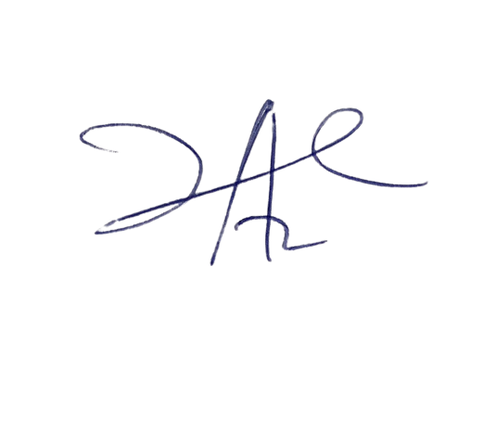

6/3/2023

Principal Head Instructor