EMERALD ROYAL INTERNATIONAL SCHOOL

MPAPE, ABUJA.

LESSON PLAN AND NOTE 1 FOR WEEK 3 ENDING 10TH MAY, 2024.

SUBJECT: Letter work

TOPIC: Matching letter Ff - Jj with picture word and copy letters Cc - Ff.

SUB-TOPIC: identification of letters Ff - Jj.

DATE: 6/5/2024.

DURATION: 40 minutes.

TIME: 08:50--09:30.

PERIOD: 2nd

CLASS: Pre-nursery

NUMBER OF PUPILS: 19

AVERAGE AGE: 2 YEARS

SEX: Mixed.

SPECIFIC OBJECTIVES: By the end of the lesson, the pupils should be able to:-

1. Identify letter Ff-Jj.
2. Match the upper case with the lower case.

RATIONALE: For pupils to know letters and their sounds.

PREVIOUS KNOWLEDGE: Pupils have been learning the lower case.

INSTRUCTIONAL MATERIALS: Flash cards, board, and phonics song.

REFERENCE:Mastering English for nursery schools book 1 by J.M.Omogbai.

LESSON DEVELOPMENT

|  |  |  |  |
| --- | --- | --- | --- |
| STAGES/STEPS | TEACHER’S ACTIVITIES | PUPILS’ ACTIVITIES | LEARNING POINTS |
| INTRODUCTION | Teacher introduces the lesson by singing a jolly phonics song for the pupils. | Pupils sing along with the teacher. | To arouse the interest of the pupils for the lesson. |
| PRESENTATION  STEP 1 | Teacher scattered the flash cards of upper and lower case on the table and asks the pupils the upper case and the lower case of each letters. | Pupils identify the upper and lower case of each letters on the table. | For better understanding of the lesson . |
| STEP2 | Teacher prepares the pupils books for them to match the upper case with lower case.  F j  G i  H g  I h  J f | Pupils match the upper case with the lower case.  F j  G I  H g  I h  J f . | To improve pupils locomotive skills. |
| SUMMARY | Teacher summarizes the lesson by going over the lesson again for more understanding | Pupils listen very attentively to the teacher | For more understanding of the lesson. |
| EVALUATION | Teacher calls out the pupils one after another to identify the upper and the lower case of letter Ff-Jj. | Pupils answer the teacher’s questions. | To assess the level of pupils understanding of the lesson. |
| CONCLUSION | Teacher marks the pupils books and make corrections where necessary. | Pupils submit their books for marking and corrections . | For onwards study. |
| ASSIGNMENT | Read and match upper case and lower case of letter Ff-Jj. | Pupils do their Home work at home. | To ensure learning takes place at home. |

LESSON PLAN AND NOTE 2 FOR WEEK 3 ENDING 10TH MAY, 2024.

SUBJECT: Letter work

TOPIC: Matching letter Ff - Jj with picture word and copy letters Cc - Ff.

SUB-TOPIC: identification of letters Ff - Jj and matching letters with the pictures.

DATE: 8/5/2024.

DURATION: 40 minutes.

TIME: 08:50--09:30.

PERIOD: 2nd

CLASS: Pre-nursery

NUMBER OF PUPILS: 19

AVERAGE AGE: 2 YEARS

SEX: Mixed.

SPECIFIC OBJECTIVES: By the end of the lesson, the pupils should be able to:-

1. Identify letter Ff-Jj.
2. Match the letters with the words

RATIONALE: For pupils to know letters and their sounds.

PREVIOUS KNOWLEDGE: Pupils have been learning the lower case.

INSTRUCTIONAL MATERIALS: Flash cards, board, and phonics song.

REFERENCE:Mastering English for nursery schools book 1 by J.M.Omogbai.

LESSON DEVELOPMENT

|  |  |  |  |
| --- | --- | --- | --- |
| STAGES/STEPS | TEACHER’S ACTIVITIES | PUPILS’ ACTIVITIES | LEARNING POINTS |
| INTRODUCTION | Teacher introduces the lesson by singing a jolly phonics song for the pupils. | Pupils sing along with the teacher. | To arouse the interest of the pupils for the lesson. |
| PRESENTATION  STEP 1 | Teacher scattered the flash cards of upper and lower case on the table and asks the pupils the upper case and the lower case of each letters. | Pupils identify the upper and lower case of each letters on the table. | For better understanding of the lesson . |
| STEP2 | Teacher prepares the pupils books for them to match the upper case with the words.  F as in jug    G as in ink    H as in goat    I as in house    J as in fish | Pupils match the upper case with the words.  .  F as in jug  G as in ink  H as in goat  I as in house  J as in fish | To improve pupil locomotive skills. |
| SUMMARY | Teacher summarizes the lesson by going over the lesson again for more understanding | Pupils listen very attentively to the teacher | For more understanding of the lesson. |
| EVALUATION | Teacher calls out the pupils one after another to:- 1. identify the upper and the lower case of letter Ff-Jj.   1. match the letters with the words.   F as in jug  G as in ink  H as in goat  I as in house  J as in fish | Pupils answer the teacher’s questions. | To assess the level of pupils understanding of the lesson. |
| CONCLUSION | Teacher marks the pupils books and make corrections where necessary. | Pupils submit their books for marking and corrections . | For onwards study. |
| ASSIGNMENT | Read and match upper case with the picture words in the text books. | Pupils do their Home work at home. | To ensure learning takes place at home. |

LESSON PLAN AND NOTE 3 FOR WEEK 3 ENDING 10TH MAY, 2024.

SUBJECT: Letter work

TOPIC: Matching letter Ff - Jj with picture word and copy letters Cc - Ff.

SUB-TOPIC: identification of letters Ff - Jj and matching letters with the pictures.

DATE: 10/5/2024.

DURATION: 40 minutes.

TIME: 08:50--09:30.

PERIOD: 2nd

CLASS: Pre-nursery

NUMBER OF PUPILS: 11

AVERAGE AGE: 2 YEARS

SEX: Mixed.

SPECIFIC OBJECTIVES: By the end of the lesson, the pupils should be able to:-

1. Identify letter Cc - Ff.
2. Copy letter Cc-Ff.

RATIONALE: For pupils to know letters and their sounds.

PREVIOUS KNOWLEDGE: Pupils have been learning the lower case.

INSTRUCTIONAL MATERIALS: Flash cards, board, and phonics song.

REFERENCE:Mastering English for nursery schools book 1 by J.M.Omogbai.

LESSON DEVELOPMENT

|  |  |  |  |
| --- | --- | --- | --- |
| STAGES/STEPS | TEACHER’S ACTIVITIES | PUPILS’ ACTIVITIES | LEARNING POINTS |
| INTRODUCTION | Teacher introduces the lesson by singing a nursery rhyme for the pupils. | Pupils sing along with the teacher. | To arouse the interest of the pupils for the lesson. |
| PRESENTATION  STEP 1 | Teacher writes the upper case and lower case of letter Cc-Ff on the board for pupils to identify.  Cc Dd Ee Ff. | Pupils points at the letters on the chalk board and identify them by reading them one after another. | For proper recognition of letters. |
| STEP2 | Teacher prepares the pupils books for them to re-write letter Cc-Ff.  Cc Dd Ee Ff | Pupils re-write Cc-Ff in the books.  Cc Dd Ee Ff  .  Cc Dd Ee Ff  Cc Dd Ee Ff | To improve pupils locomotive skills. |
| SUMMARY | Teacher summarizes the lesson by asking the pupils to sing the phonics song for letters Cc-Ff with the teacher. | Pupils sing the phonics song for letters Cc-Ff with the teacher. | For more understanding of the lesson. |
| EVALUATION | Teacher calls out the pupils one after another to:-  1. identify the upper and lower case on the flash card.  2.Re-write letter Cc-Ff. | Pupils answer the teacher’s questions. | To assess the level of pupils understanding of the lesson. |
| CONCLUSION | Teacher marks the pupils books and make corrections where necessary. | Pupils submit their books for marking and corrections . | For onwards study. |
| ASSIGNMENT | Read and match upper case with the picture words in the text books. | Pupils do their Home work at home. | To ensure learning takes place at home. |

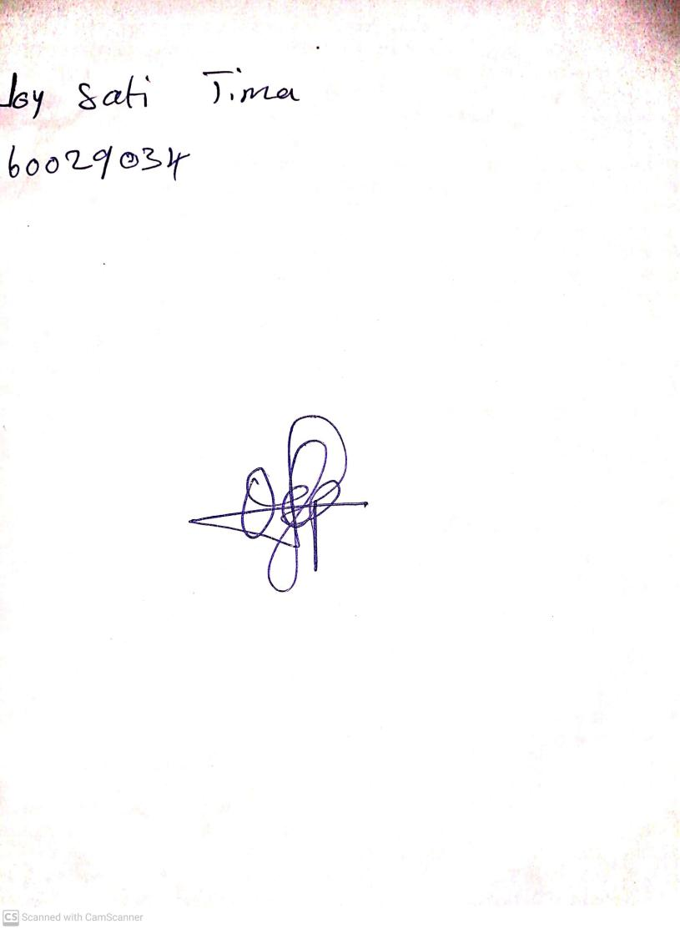

**3rd May, 2024**

**Perpetual Ojoma Ocheja**

**Stream Head Nursery**