**LESSON PLAN AND NOTE FOR WEEK 2 ENDING 20/09/2024**

**Term 1st term**

**Week 2nd week.**

**Date 18th September,2024**

**Class Nursery one**

**Subject Social Norms**

**Topic My self**

**Sub-topic Spell your first name?**

**Period 7th period**

**Time 1:55 pm**

**Duration 35 minutes**

**No in class 15**

**Average Age 3 years**

**Sex Mixed**

**Specific Objectives: By the end of the lesson the pupils should be able to:**

1. **Spell your first name.**
2. **What state are you from?**

**Rationale: To ensure the pupils spell their name & mention their state.**

**Previous Knowledge: The pupils can mention their names and their hobbies.**

**Instructional Resources: Board,marker ,online research.**

**Reference Materials: Smart smart Civic Education by A.M Solu, T.Y Alabi, Nursery 2**

**LESSON PRESENTATION**

|  |  |  |  |
| --- | --- | --- | --- |
| **Steps** | **Teacher’s Activities** | **Pupils’ Activities** | **Learning Points** |
| **Introduction** | **The teacher introduces the lesson by first telling the pupils her names before asking the pupils one after the other to mention their different names.** | **The pupils participate actively in addressing themselves with their names.** | **To arouse the pupils’ interest towards the lesson.** |
| **Step 1** | **The teacher leads and helps the pupils by using herself as example to spell their first name**  **E.g**  **F-a-v-o-u-r.** | **The pupils actively participates in spelling their first name with the help of their teacher.** | **For proper understanding.** |
| **Step 2** | **The teacher leads and helps the pupils to mention their state origin by using herself as example**  **E.g**  **I am from Anambra State.** | **The pupils actively participates in mentioning their state origin with the help of their teacher.** | **For better understanding.** |
| **Summary** | **The teacher summarizes the lesson by asking the pupils each their state origin.** | **The pupils actively mention their state origin.** | **For onward study.** |
| **Evaluation** | **Spell your first name?**  **Which state are you from?** | **The pupils answer the questions accordingly.** | **To ascertain the pupils’ understanding.** |
| **Conclusion** | **The teacher summarizes,reacts,and corrects the pupils.** | **The teacher gives answers to the teacher’s question.** | **To consolidate the lesson.** |
| **Assignment** | **Which state are you from?**  **Spell your first name?** | **The pupils copy and do their home-work at home.** | **To encourage learning while at home.** |

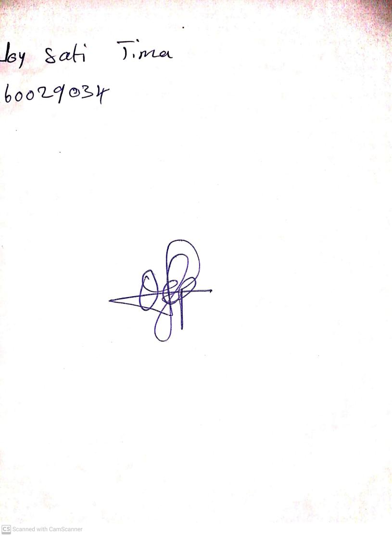

20th September, 2024

Perpetual Ojoma Ocheja

Stream Head Nursery