LESSON PLAN AND NOTE 1 FOR WEEK 5 ENDING 02/06/2023

TERM: 3rd

WEEK: 5th

DATE: 29/05/2023

CLASS: Nursery 2

SUBJECT: Number work

TOPIC: Length

SUB—TOPIC: Simple meaning of length and examples

PERIOD: 1st

TIME: 08:50—09:30 am

DURATION: 40 minutes

NUMBER IN CLASS: 14

AVERAGE AGE: 5 years

SEX: Mixed

LEARNING OBJECTIVES: By the end of the lesson, the Pupils should be able to:

1. Explain the meaning of length

2. Mention some examples of instrument for measuring length

RATIONALE: For Pupils to know measurement

PREVIOUS KNOWLEDGE: Pupils have been seeing long and short things in their daily activities.

INSTRUCTIONAL MATERIALS: long and short pencils, ruler,books, and crayons.

REFERENCE MATERIALS: Mastering Mathematics for Nursery schools book 3 by Henry Z.Idogun

LESSON DEVELOPMENT

|  |  |  |  |
| --- | --- | --- | --- |
| STAGES/ STEPS | TEACHER'S ACTIVITIES | PUPILS' ACTIVITIES | LEARNING POINT |
| Introduction | Teacher reviews the previous lesson. | Pupils listen attentively to the teacher. | To arouse pupils interest for the lesson. |
| Presentation step 1 | Teacher explains the meaning of length to pupils and then asks them to repeat after her. | Pupils listen to the teacher and repeat after her. | For proper understanding. |
| Step 2 | Teacher mentions the examples of instrument for measuring length to pupils and also asks them to repeat after her. | Pupils pay attention to the teacher and repeat after her. | To enhance Pupils participation in class. |
| Board summary | Teacher writes the whole note of lesson on the board for pupils to copy into their books. That is;  Length means how long something is. Some things are long. Some things are short.  The examples of instrument for measuring lengths are:  1.Ruler  2. Meter–rule  3. Tape rule  4. Arms length  5.Hand–span  6. Strides  7. Foot, etc.  The use of arms length, Hand–span ,studies and foot for taking measurement are old methods of measuring lengths. These methods have been replaced by the use of ruler and tape–rule. | Pupils copy the note into their exercise books. | For onward study. |
| Evaluation | Teacher evaluates the lesson by asking pupils the following questions;  1. What is the meaning of length?  2. Mention the instrument for measuring lengths. | Pupils answer the questions ask by the teacher. | To assess pupils level of understanding. |
| Conclusion | Teacher concludes the lesson by marking pupils books. | Pupils submit their books for marking. | For endorsement. |
| Assignment | Answer the following questions:  With the help of the objects in your bag,  1. What color is the longest pencil ?  2. What colour is the shortest pencil?  3. Find two things longer than your pencil and draw them in your book.  4. Which ruler is the shortest?  5. Which ruler is the longest? | Pupils do their assignment at home. | To encourage learning at home. |

LESSON PLAN AND NOTE 2 FOR WEEK 5 ENDING 02/06/2023

TERM: 3rd

WEEK: 5th

DATE: 30/05/2023

CLASS: Nursery 2

SUBJECT: Number work

TOPIC: Length

SUB—TOPIC: Measuring lengths using natural units.

PERIOD: 2nd

TIME: 08:50—09:30 am

DURATION: 40 minutes

NUMBER IN CLASS: 14

AVERAGE AGE: 5 years

SEX: Mixed

LEARNING OBJECTIVES: By the end of the lesson, the Pupils should be able to:

1. Mention the natural units for measuring lengths.

2. Measure some things in the classroom with their hand span, foot

and pencils.

RATIONALE: For Pupils to be able to measure things.

PREVIOUS KNOWLEDGE: Pupils have learnt the meaning of length and some examples.

INSTRUCTIONAL MATERIALS: Table,hand,pencils and foot.

REFERENCE MATERIALS: New General Mathematics for primary schools book 1. By J Aderohunmu etal.

LESSON DEVELOPMENT

|  |  |  |  |
| --- | --- | --- | --- |
| STAGES/ STEPS | TEACHER'S ACTIVITIES | PUPILS' ACTIVITIES | LEARNING POINT |
| Introduction | Teacher reviews the previous lesson. | Pupils listen attentively to the teacher. | To arouse pupils interest for the lesson. |
| Presentation step 1 | Teacher mentions the natural units for measuring lengths to pupils and then asks them to repeat after her. | Pupils listen to the teacher and repeat after her. | For proper understanding. |
| Step 2 | Teacher guides pupils to measure the length of their classroom with their feet one after the other | Pupils measure the length of their classroom with the help of the teacher. | To enhance Pupils participation in class. |
| Board summary | Teacher writes the whole note of lesson on the board for pupils to copy into their books. That is;  Natural Units for measuring lengths:  1. Feet  2. Arms  3. Blocks  4. Sticks.  We use;  Feet to measure the length of our classroom.  Arm's length to measure the width of our classroom.  Pencils to measure the length of the teacher's table. | Pupils copy the note into their exercise books. | For onward study. |
| Evaluation | Teacher evaluates the lesson by asking pupils the following question:  Mention the natural units for measuring lengths. | Pupils answer the question ask by the teacher. | To assess Pupils level of understanding. |
| Conclusion | Teacher concludes the lesson by marking pupils books. | Pupils submit their books for marking. | For endorsement. |
| Assignment | 1. How many of your hand spans is the length of your dinning table?  2. Mrs Vivian walls 14 Strides to visit her friend. How many feet did she walk? One stride is five feet. | Pupils do their assignment at home. | To encourage learning at home. |

LESSON PLAN AND NOTE 3 FOR WEEK 5 ENDING 02/06/2023

TERM: 3rd

WEEK: 5th

DATE: 02/06/2023

CLASS: Nursery 2

SUBJECT: Number work

TOPIC: Place value of numbers

SUB—TOPIC: Comparing and Ordering of length

PERIOD: 3rd

TIME: 08: 10–80 :50am

DURATION: 40 minutes

NUMBER IN CLASS: 14

AVERAGE AGE: 5 years

SEX: Mixed

LEARNING OBJECTIVES: By the end of the lesson, the Pupils should be able to:

1. Identify objects

2. Mention objects that are short, shorter,and shortest.

RATIONALE: For Pupils to know length of objects.

PREVIOUS KNOWLEDGE: Pupils have been seeing things of different length.

INSTRUCTIONAL MATERIALS: keys, pencils and bottes.

REFERENCE MATERIALS: The New Mastering Mathematics for Nursery schools book 3 by Henry Z.Idogun

LESSON DEVELOPMENT

|  |  |  |  |
| --- | --- | --- | --- |
| STAGES/ STEPS | TEACHER'S ACTIVITIES | PUPILS' ACTIVITIES | LEARNING POINT |
| Introduction | Teacher introduces the lesson by showing Pupils her last three fingers and then asks which amongst this there fingers is the shortest? | Pupils listen attentively to the teacher and answer the question. | To arouse pupils interest for the lesson. |
| Presentation step 1 | Teacher draws some objects on the board and then identify them according to their length and then asks Pupils to repeat after her. | Pupils listen to the teacher and repeat after her. | For proper understanding. |
| Step 2 | Teacher guides pupils to mention the object that is short, shorter, shortest.  That is; | Pupils take turns to identify the objects on the board. | To enhance Pupils participation in class. |
| Board summary | Teacher summarizes the lesson by going through the lesson over again.. | Pupils listen attentively to the teacher.. | To create platform for slow learners. |
| Evaluation | Teacher evaluates the lesson by asking pupils the following questions; | Pupils answer the questions ask by the teacher. | To assess Pupils level of understanding. |
| Conclusion | Teacher concludes the lesson by marking pupils books. | Pupils submit their books for marking. | For endorsement. |
| Assignment | Answer the following questions.  1.  2. | Pupils do their assignment at home. | To encourage learning at home. |

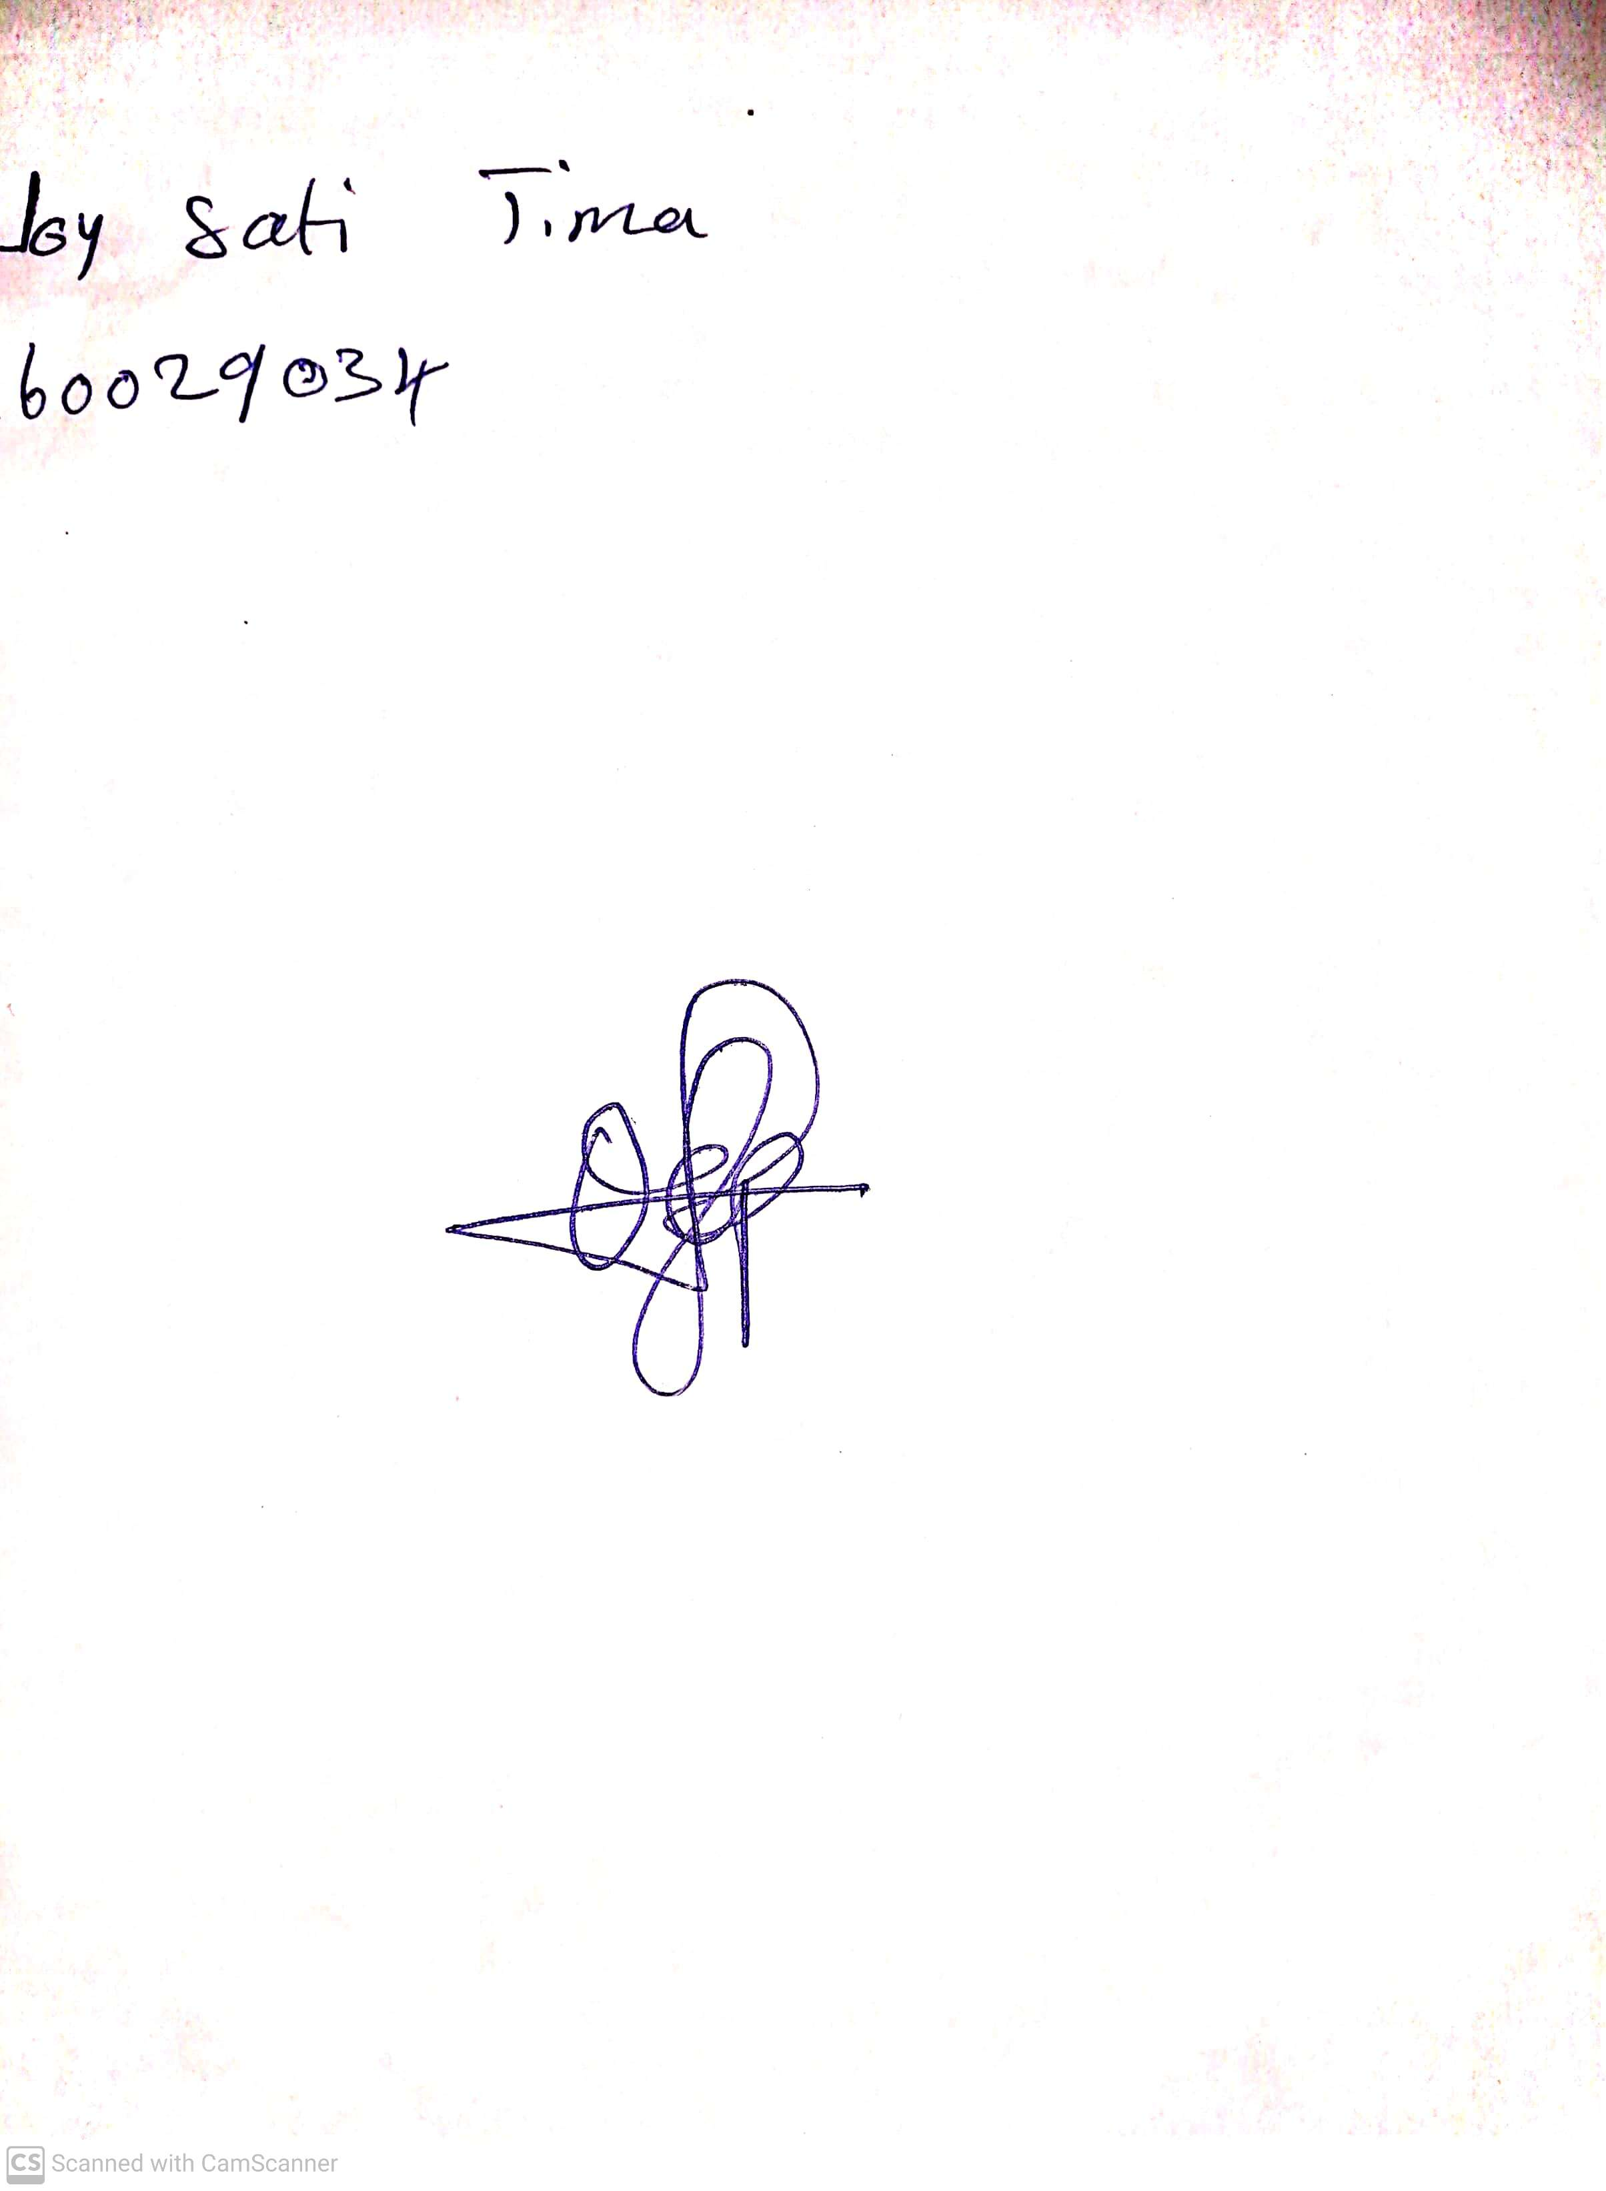

29TH April, 2023

Perpetual Ojoma

Stream Head Nursery