**LESSON PLAN AND NOTE FOR WEEK 7 ENDING 16/6/2023**

**Term 3rd term**

**Week 7th week**

**Date 16th June,2023**

**Class Nursery one**

**Subject Nature studies**

**Topic Animals and their homes.**

**Sub-topic Naming different animals and their homes.**

**Period 2nd period**

**Time 9:05 am**

**Duration 35 minutes**

**No in class 18**

**Average Age 3 years**

**Sex Mixed.**

**Specific Objectives: By the end of the lesson, the pupils should know how to:**

1. **Name different animals and their homes.**
2. **Identify the different animals and their homes.**

**Rationale: To help the pupils know animals & their homes.**

**Previous Knowledge: The pupils have knowledge of Animals and their young ones.**

**Instructional Resources: Online Research.**

**Reference Materials: Online Research, Elementary Science by Showers Kiddies.**

**LESSON PRESENTATION**

|  |  |  |  |
| --- | --- | --- | --- |
| **Steps** | **Teacher’s Activities** | **Pupils’ Activities** | **Learning Points** |
| **Introduction** | **The teacher introduces the topic (Animals and their homes ) by showing the pupils pictures of different kinds of animals and their homes.** | **The pupils participates in seeing animals and their homes.** | **To arouse the interest of the pupils.** |
| **Step 1** | **The teacher starts the lesson by teaching and mentioning for the pupils animals and their homes e.g**   |  |  | | --- | --- | | **Animals** | **Homes** | | **Horse** | **Stable** | | **Lion** | **Den** | | **Dog** | **Kernel** | | **Bird** | **Nest** | | **The pupils listen attentively to the teacher and repeats after the teacher names of animals and their homes.** | **For proper understanding.** |
| **Step 2** | **The teacher leads the pupils to identify animals and their homes.** | **The pupils identify animals and their homes with their teacher.** | **For better understanding.** |
| **Summary** | **The teacher summarizes the lesson by listing animals and their homes.** | **The pupils with fun participates with the teacher in listing animals and their homes.** | **For onward study.** |
| **Evaluation** | **Question:**  **Where does horses stay?**  **Identify the home of a Lion?** | **The pupils answer the question correctly.** | **To ascertain the pupils’ understanding.** |
| **Conclusion** | **The teacher summarizes, reacts, and corrects the pupils.** | **The pupils gives answers to the teacher’s question.** | **To consolidate the lesson.** |
| **Assignment** | **Question:**  **Mention the two animals and their homes?** | **The pupils copy and do their homework at home.** | **To encourage learning while at home.** |

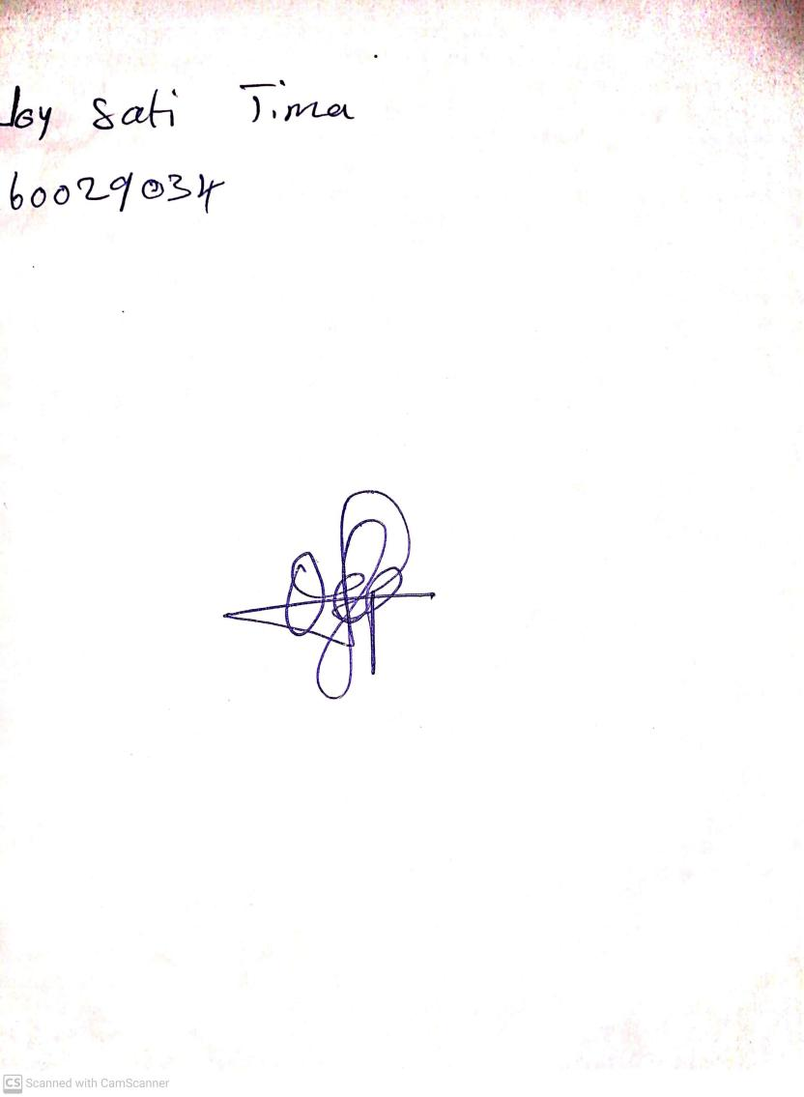

30th April, 2023

Perpetual Ojoma

Stream Head Nursery