**LESSON PLAN AND NOTE FOR WEEK 1 ENDING 26/4/2024**

**Term 3rd term**

**Week 1st week.**

**Date 25th April,2024**

**Class Nursery one**

**Subject Social Norms**

**Topic Objects in the classroom**

**Sub-topic Mention the objects in the classroom**

**Period 2nd period**

**Time 8:50 am**

**Duration 35 minutes**

**No in class 14**

**Average Age 3 years**

**Sex Mixed**

**Specific Objectives: By the end of the lesson the pupils should be able to:**

1. **Identify the objects in the classroom.**
2. **Mention (5) objects found in the classroom.**

**Rationale: To ensure the pupils know and mention the objects in the classroom.**

**Previous Knowledge: The pupils can mention the elements of culture**

**Instructional Resources: Board,marker ,online research.**

**Reference Materials: Smart smart Civic Education by A.M Solu, T.Y Alabi, Nursery 2**

**LESSON PRESENTATION**

|  |  |  |  |
| --- | --- | --- | --- |
| **Steps** | **Teacher’s Activities** | **Pupils’ Activities** | **Learning Points** |
| **Introduction** | **The teacher introduces the topic (Objects in the classroom) by asking the pupils to point whatever objects in their classroom.** | **The pupils participate actively in identifying the objects in their classroom.** | **To arouse the pupils’ interest towards the lesson.** |
| **Step 1** | **The teacher leads the pupils to point and identify the objects in the classroom such as Table etc.** | **The pupils points and identify objects e.g Chair,Pencil,Book,Bags etc along with the teacher.** | **For proper understanding.** |
| **Step 2** | **The teacher guides the pupils to mention the objects in the classroom e.g Books,Bags,Chairs,Lunch pack etc.** | **The pupils mention objects in the classroom together with the teacher.** | **For better understanding.** |
| **Summary** | **The teacher summarizes the lesson by making the pupils understand that objects in the classroom are things found in the classroom.** | **The pupils understands the lesson of identifying objects in the classroom.** | **For onward study.** |
| **Evaluation** | **Question:**  **Can you see a school bag in your class?**  **Mention the things in the classroom?.** | **The pupils answer the questions accordingly.** | **To ascertain the pupils’ understanding.** |
| **Conclusion** | **The teacher summarizes,reacts,and corrects the pupils.** | **The teacher gives answers to the teacher’s question.** | **To consolidate the lesson.** |
| **Assignment** | **Question:**  **Can you see a school bag in your class?**  **Mention the things in the classroom?.** | **The pupils copy and do their home-work at home.** | **To encourage learning while at home.** |

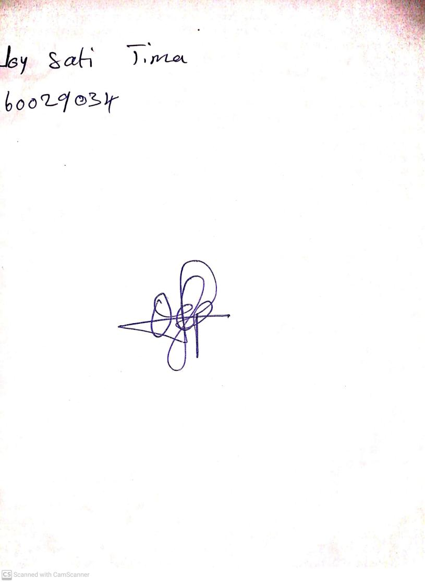

19th April, 2024

Perpetual Ojoma Ocheja

Stream Head Nursery