**LESSON PLAN /NOTE FOR WEEK 5 ENDING 02/06/2023**.

**Term**: 3rd

**Week**: 5

**Date**: 29/05/2023

**Class**: SS 1

**Subject**: Economics

**Topic**: Money

**Sub**-**Topic**: Meaning of money, trade by barter and history of money.

**Period**: First

**Time**: 8:10-8:50

**Duration**: 40 Minutes

**Number** **in** **class**: 8 students

**Average** **Age**: 14 years

**Sex**: mixed

**Specific objectives**: By the end of the lesson, the students should be able to:

(1) Define money

(11) Explain trade by barter

(111) Describe the history of money.

**Rationale**: For the students to be able to differentiate between money and trade by barter.

**Previous knowledge**: The students have been using money to buy goods and pay for services.

**Instructional material:** A chart showing different denomination of money.

**Reference material**: Gbenga Babalola (2017) Metropolitan Economics for senior secondary schools.

**LESSON DEVELOPMENT**

|  |  |  |  |
| --- | --- | --- | --- |
| **Stages/steps** | **Teacher's Activities** | **Students' Activities** | **Learning points** |
| **Introduction** | Review the previous lesson | Participate actively in the class discussion | To arouse the students interest to learn. |
| **Step 1** | Defines money as: money is anything that is generally acceptable as a medium of exchange. | Listen carefully to the teacher | For better understanding of the lesson. |
| **Step 11** | Guides the students to explain trade by barter | Explain trade by barter as the system whereby goods and services are exchange from goods and services. | To encourage critical thinking. |
| **Step 111** | Asks the students to describe the history of money | Respond to the class activity | To enable the students reason logically. |
| **Board summary** | Summarizes the lesson as:  **Meaning of money**  Money can be defined as anything that is generally acceptable as a medium of exchange. money can also be defined as an item that people accept as payment for goods and services. Anything that serve as money must be generally acceptable as a medium of exchange. It is also acceptable for settling financial obligations.  **Trade by barter**  Trade by barter is a system of exchange by which goods or services are directly exchanged for other goods and services without using money.  **Problem of trade by barter**  (1) Double coincidence of wants  (2) lack of division  (3) lack of common measures of value  (4) Lack of store of value.  **History of money**  In the beginning people bartered, barter is the exchange of goods or services for another goods or services. To solve this problem, human developed what is called commodity money. Commodity was used as money which was a problem on it own. Commodity was difficult to store or it was perishable.  **Coins and paper money**  Metal objects were introduced as money around 5000 B.C by 700 BC . The indians became the first in western world to make coins. Paper money was dated back to China, AD 960 onwards.  **Representative money**  Representative money is token or pieces of paper that are not instrinsically valuable themselves, but can be exchanged for a specific commodity such as gold or silver.  **Fiat money**  Fiat money is similar to representative money except it can't be redeemed for a commodity such as gold or silver. Example, federal reserve note.  **US money trivia**  On march 10, 1862, the first united states paper money was issued. The denomination were $5, $10, and $20. They became legal tender by march 17, 1862. The inclusion of "In God we trust" on all currency was required by law in 1955. The national motto first appeared on paper money in 1957 on $1 silver certificate and on all federal reserve notes beginning with series 1963. | Copy and submit the note book for marking | For future reference |
| **Evaluation** | Evaluates the students as:  (1) Define money  (2) explain trade by barter  (3) Describe the history of money. | Respond to the questions | Ascertaining the attainment of the stated objectives. |
| **Conclusion** | Rounds up the lesson by marking and correcting students work | Check and do their correction | Consolidation of the lesson. |
| **Assignment** | Gives home work as:  (1) Explain 5 functions of money | Respond by doing the home work at home. | To ensure continuity of learning. |

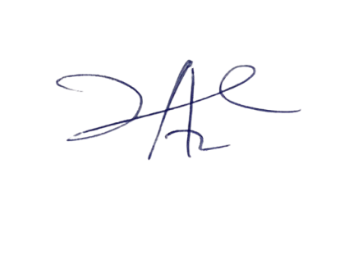

2/6/2023

Principal Head Instuctor