**EMERALD ROYAL INTERNATIONAL SCHOOL, MPAPE ABUJA**

**LESSON PLAN AND NOTE FOR WEEK 5 ENDING FRIDAY, 13TH OCTOBER, 2023**

**TERM:** FIRST TERM

**WEEK:** WEEK 5

**SUBJECT:** SOCIAL STUDIES

**TOPIC:** CULTURE AND SOCIAL VALUES

**SUB-TOPIC:** ASPECTS OF CULTURE

**DATE:** TUESDAY, 10TH ANDWEDNESDAY, 11TH OCTOBER, 2023

**TIME:** 11:50 – 12:30PM AND 01:20 – 02:00PM

**DURATION:** 40 MINUTES

**PERIOD:** 6TH AND 8TH

**CLASS:** NURSERY 3

**NUMBER IN CLASS:** ELEVEN

**AVERAGE AGE:** FIVE

**SEX:** MIXED

**LEARNING OBJECTIVES:** By the end of the lesson, the pupils should be able to:

1. Identify the aspects of culture.
2. Explain the aspect of culture.

**RATIONALE:** for pupils to learn the aspects of culture

**PREVIOUS KNOWLEGDE:** pupils learnt the meaning of culture and the types of culture.

**INSTRUCTIONAL MATERIALS:**

1. Charts.
2. Textbook

**REFERENCE MATERIALS:**

1. Social Studies for primary schools book 1 by Olufemi J. Olugasa, Olusola H. Bamidele, Felix K. Alonge, Julius O. Onwuka

**LESSON DEVELOPMENT**

|  |  |  |  |
| --- | --- | --- | --- |
| **STAGES/STEPS** | **TEACHER’S ACTIVITIES** | **PUPILS’ ACTIVITIES** | **LEARNING POINTS** |
| **INTRODUCTION** | Review previous knowledge | Respond to the teacher | To arouse the pupils’ interest. |
| **PRESENTATION**  **STEP 1** | Teaches and states the aspects of culture.  **Aspects of culture**   1. Beliefs 2. Customs and traditions 3. Dressing 4. Language 5. Food 6. Greeting 7. Respect 8. Religion | Listen attentively and learn. | Types of family. |
| **STEP 2** | Teaches and explain the aspects of culture.  **Beliefs**  This is a strongfellingupheld by a group of people.  **Customs and traditions**  They are accepted way of behaving or doing things in community that are handed over from the past.  **Dressing**  Dressing help people to identify different culture.  **Language**  This is a way of expressing oneself or communicating with others from the same culture for better understanding. It can be in verbal or written form.  **Food**  The different culture has their own kind of food that are peculiar to them. For example, the Hausa eat tuwo with mia kuka, the Yoruba eat amala and ewedu soup while the Igbos eat akpo and ofe oha  **Greeting**  We show good manner by greeting. Every culture has their different ways of greeting.  **Religion**  Religion is the belief on God and ways of worshiping Him. In Nigeria, there basically three types of religion which are: Christianity, Islam and Traditional religion. | Listen attentively and learn. | Qualities of a family |
| **SUMMARY** | Summarises the lesson by emphasising on the main concept and writes note on the board | Listen and copy their notes | For onward study |
| **EVALUATION** | Asks pupils to:   1. State the aspects of culture. 2. Explain any three aspects of culture. | Respond to the teacher’s question. | To test the pupils understanding on the lesson. |
| **CONCLUSION** | Summarizes, corrects and mark pupils’ notebooks | Submit their notebooks for marking. | Clarifying the concept. |
| **HOME WORK** | 1. Write down five (5) aspects of culture. | Cope and return with task. | Extending lesson home. |

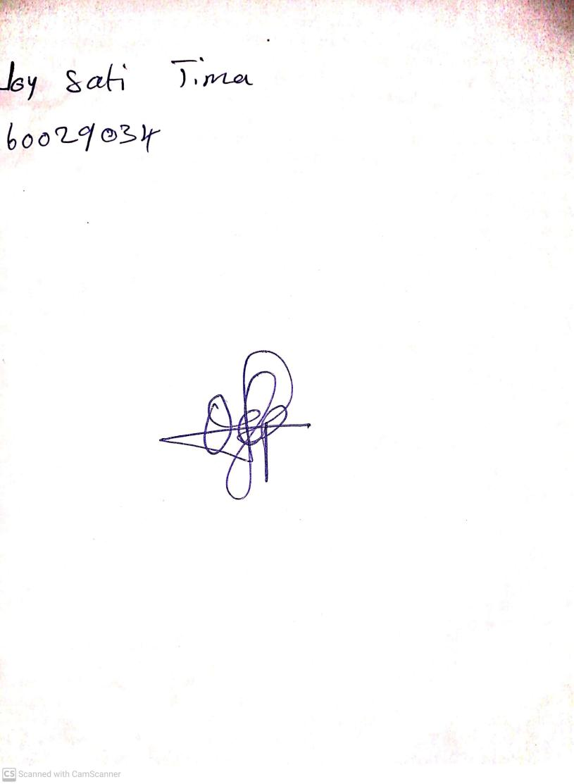

6TH Octoberr, 2023

Perpetual Ojoma Ocheja

Stream Head Nursery