**LESSON PLAN/NOTE FOR WEEK 1 ENDING 05/05/2023**

**Term**: 3rd

**Week**: 1

**Date**: 01/05/2023.

**Class**: ss 2

**Subject**: Economics

**Topic**: Elementary treatment of fiscal policy

**Sub-Topic:** Meaning and objectives of fiscal policy and public finance.

**Period**: second

**Time**: 8:50-9:30

**Duration**: 40 minutes

**Number in class:** 5 students

**Average Age:** 14 years

**Sex**: mixed

**Specific objectives:** By the end of the lesson, the students should be able to:

1. Define fiscal policy
2. State the objectives of fiscal policy
3. Explain public finance

**Rationale**: For the students to be able to identify how government generate revenue and expenditure.

**Previous knowledge:** the students have been seeing their parents making and spending money.

**Instructional material:** A chart showing central bank and commercial banks.

**Reference material:** Gbenga Babalola (2017) metropolitan Economics for senior secondary schools.

**LESSON DEVELOPMENT**

|  |  |  |  |
| --- | --- | --- | --- |
| **Stages/steps** | **Teacher’s Activities** | **Students’ Activities** | **Learning points.** |
| **Introduction** | Review the previous lesson | Participate actively in the class discussion | To arouse the students interest to learn. |
| **Step 1** | Defines fiscal policy as: fiscal policy is the process of shaping government taxation and expenditure to achieve economics objectives. | Listen carefully to the teacher | For better understanding of the lesson. |
| **Step 11** | Guides the students to state the objectives of fiscal policy | Respond to the class activity | To encourage critical thinking. |
| **Step 111** | Asks the students to explain public finance | Explain public finance as: the branch of economics that is concerned with the revenue and expenditure of government. | To enhance their logical reasoning. |
| **Board summary** | Summarizes the lesson as:  **Meaning of fiscal policy**  Fiscal policy can be defined as the process of shaping government taxation and expenditure to achieve desired economic and social objectives. It is the of action of the state pertaining to raising of revenue through taxation and the pattern of expenditure.  **Objectives of fiscal policy**   1. Increase in saving: this is use to increase the rate of saving in the country. 2. To encourage investment: government can provide many incentives like tax holiday in the various sectors of the economy 3. To achieve equal distribution of wealth. 4. To control inflation 5. To reduce regional disparity 6. Stabilization of price level. 7. To increase industrial and agricultural outputs. 8. To attain maximum welfare of the people. 9. To check rapid increase in consumption. 10. To achieve economic stability: this increase the rate of production and employment without inflation.   **Meaning of public finance**  Public finance refers to that branch of economics that is concerned with the revenue,expenditure and debt operation of the government and the impact of these measures.  **functions of public finance**   1. Allocation functions. 2. Stabilization functions 3. Distribution function. | Copy and submit the note book for marking. | For future reference. |
| **Evaluation** | Evaluates the lesson as:   1. define fiscal policy? 2. State 5 objectives of fiscal policy. 3. Explain public finance. | Respond to the questions | Ascertaining the attainment of the stated objectives. |
| **Conclusion** | Rounds up the lesson by marking and correcting students work | Check and their correction | Consolidation of the lesson. |
| **Asssignment** | Gives home work as:   1. Explain the functions of public finance. 2. What is public revenue and public expenditure? | Respond by doing the home work at home. | To ensure continuity of learning. |

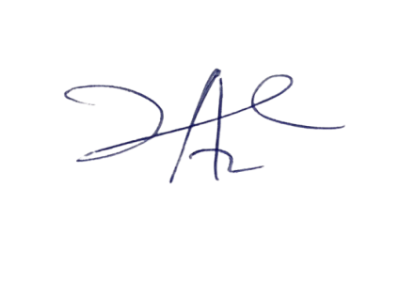

11/5/2023

Principal Head Instuctor