**LESSON PLAN/NOTE FOR WEEK 3 ENDING 19/05/2023**

**Term**: 3rd

**Week**: 3

**Date**: 16/05/2023

**Class**: SS 2

**Subject**: Economics

**Topic**: Budget

**Sub-Topic**: Meaning and types of unbalanced budget

**Period**: 6th

**Time**: 11:50-12:30

**Duration**: 40 minutes

**Number in class**: 4 students

**Average Age:** 14 years

**Sex**: mixed

**Specific objectives**: By the end of the lesson, the students should be able to:

1. Define unbalanced budget
2. Mention the types of unbalanced budget.
3. Explain the types of unbalance budget

**Rationale**: for the students to be able to identify that budget can be surplus or deficit.

**Previous knowledge**: the students have seen in the national assembly during plenary as the legislature pass appropriation bill.

**Instructional material**: A chart showing a surplus and deficit budget.

**Reference material:** Gbenga Babaloa (2017) metropolitan economics for senior secondary schools.

**LESSON DEVELOPMENT**

|  |  |  |  |
| --- | --- | --- | --- |
| **Stages/steps** | **Teacher’s Activities** | **Students Activities** | **Learning points** |
| **Introduction** | Review the previous lesson | Participate actively in the class discussion | To arouse the students interest to learn. |
| **Step 1** | Defines unbalanced budget as: unbalanced budget is when the income and expenditure are not equal to each other. | Listen carefully to the teacher | For better understanding of the lesson. |
| **Step 11** | Asks the students to mention the types of unbalanced budget | Mention the types of unbalanced budget as: (1) surplus and (2) deficit budget | To encourage critical thinking |
| **Step 111** | Gudes the students to explain the types of unbalanced budget. | Respond to the class activity. |  |
| **Board summary** | Summarizes the lesson as:  **Unbalanced Budget**  Unbalanced budget is a situation in which the income and expenditure are not equal to each other.  **Types of unbalanced Budget**   1. Surplus budget: this is when the estimated revenues of the year, are greater than the anticipated expenditure. That is to say, the governments expected revenue is greater than its proposed surplus budget shows the financial soundness of the government. When there is too much inflation, the government can adopt the policy of surplus budget as it will reduce aggregate demand. 2. Deficit budget: this is when the estimated government expenditure is more than the expected revenue. That is to say, the government estimated revenue is less than it’s proposed expenditure. Such deficit amount is covered through public borrowings or withdrawing resources from the accumulated reserve surplus. It is a liability of the government as it creates a burden of debt or it reduces the stock of reserves of the government. | Copy and submit the note book for marking | For future reference |
| **Evaluation** | Evaluates the students as:   1. Define unbalanced budget 2. Mention 2 types of unbalanced budget 3. Explain 2 types of unbalanced budget. | Respond to the questions | Ascertaining the attainment of the stated objectives. |
| **Conclusion** | Rounds up the lesson by marking and correcting students work. | Check and do their correction. | Consolidation of the lesson |
| **Assignment** | Gives home work as:   1. Mention and explain 5 instruments or sources of government borrowing in Nigeria. | Respond by doing the home work at home. | To ensure continuity of learning. |

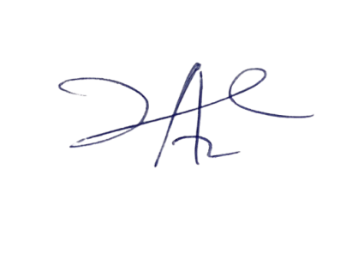

2/6/2023

Principal Head Instuctor