**EMERALD ROYAL INTERNATIONAL SCHOOL**

**MPAPE, ABUJA.**

**LESSON PLAN AND NOTE FOR WEEK 4 PERIOD 1 ENDING 06/10/2023**

TERM: FIRST

WEEK: 4TH

DATE: 02/10/2023

CLASS: NURSERY 2

SUBJECT: LETTER WORK

TOPIC: THREE LETTER WORDS ENDING WITH "IN", "IP",

" IG" AND "IB".

SUB-TOPIC: THREE LETTER WORDS ENDING WITH "IN" , AND

" IP".

PERIOD: 1ST

TIME: O8:50-09:30.

DURATION: 40 MINUTES.

NUMBER IN CLASS: 17

AVERAGE AGE: 5 YEARS.

SEX: MIXED.

SPECIFIC OBJECTIVES: BY THE END OF THE LESSON,THE PUPILS SHOULD BE

ABLE TO:

1. IDENTIFY THREE LETTER WORDS ENDING WITH "IN"

AND " IP".

2. SPELL AND PRONOUNCE THREE LETTER WORDS

ENDING WITH "IN" AND "IP".

RATIONALE: FOR PUPILS TO BE ABLE TO SPELL AND PRONOUNCE

THERE LETTER WORDS ENDING WITH "IN" AND "IP".

PREVIOU KNOWLEDGE: PUPILS HAVE LEARNT THREE LETTER WORDS ENDING WITH "ET" AND " EG" IN PREVIOUS LESSON.

INSTRUCTIONAL MATERIALS: LIP AND PIN.

REFERENCE MATERIALS: MASTERING ENGLISH BOOK 2 BY J. M OMOGBAI

**LESSON DEVELOPMENT**

|  |  |  |  |
| --- | --- | --- | --- |
| STAGES/STEPS | TEACHER’S ACTIVITIES | PUPILS’ ACTIVITIES | LEARNING POINTS |
| INTRODUCTION | Teacher introduces the lesson by reviewing the previous lesson. | Pupil listen to the teacher attentively. | To arouse pupils interest for the lesson ahead. |
| PRESENTATION  STEP 1 | Teacher presents the lesson by writing three letter words ending with "in" and "ip" on the board, identify and then asks pupils to repeat after her. | Pupils pay attention and repeat after the teacher. | For proper understanding of the lesson . |
| STEP 2 | Teacher spells and pronounce the three letter words ending with "in" and "ip" on the board and also asks pupils to repeat after her. | Pupils spelled the three letter words on the board after the teacher. | For better understanding of the lesson. |
| BOARD SUMMARY | Teacher summarizes the lesson by writing the whole note of lesson on the board for pupils to copy into their books.that is,  THREE LETTER WORDS ENDING WITH "IN" AND "IP" ARE:  "in" as in;   1. Pin 2. Bin 3. Fin 4. Sin 5. Gin 6. Tin etc.   "ip" as in;   1. Dip 2. Hip 3. Kip 4. Lip 5. Rip 6. Sip 7. Tip 8. Yip 9. Zip etc. | Pupils copy the note into their exercise books. | For onward study. |
| EVALUATION | Teacher asks pupils to go to the board one after the other and read. | Pupils read the note on the board one after another. | To assess pupils level of understanding of the lesson so far. |
| CONCLUSION | Teacher marks pupils books. | Pupils submit their books for marking. | For endorsement. |
| ASSIGNMENT | Fill in the missing letters and pronounce.   1. G __ n 2. T __ n 3. Si__ 4. Bi__ 5. Zi__ 6. T __ p 7. Di__ 8. Hi__ 9. Li __ 10. R__ p | Pupils do their assignment at home. | To encourage learning at home. |

**LESSON PLAN AND NOTE FOR WEEK 4 PERIOD 2 ENDING 06/10/2023**

TERM: FIRST

WEEK: 4TH

DATE: 03/10/2023

CLASS: NURSERY 2

SUBJECT: LETTER WORK

TOPIC: THREE LETTER WORDS ENDING WITH "IN " ,"IP","IG",

"IB",

SUB-TOPIC: THREE LETTER WORDS ENDING WITH " IG"

PERIOD: 2ND

TIME: O8:50-09:30.

DURATION: 40 MINUTES.

NUMBER IN CLASS: 17

AVERAGE AGE: 5 YEARS.

SEX: MIXED.

SPECIFIC OBJECTIVES: BY THE END OF THE LESSON,THE PUPILS SHOULD BE

ABLE TO:

1. IDENTIFY THREE LETTER WORDS ENDING WITH "IG".

2. SPELL AND PRONOUNCE THREE LETTER WORDS

ENDING WITH "IG"

RATIONALE: FOR PUPILS TO BE ABLE TO READ WORDS THAT ENDS

WITH " IG"

PREVIOU KNOWLEDGE: PUPILS HAVE LEARNT THREE LETTER WORDS ENDING WITH "IN" AND "IP" IN PREVIOUS LESS0N.

INSTRUCTIONAL MATERIALS: A CHART OF THREE LETTER WORDS ENDING

WITH "IG"

REFERENCE MATERIALS: MASTERING ENGLISH 2 BY J. M OMOGBAI.

**LESSON DEVELOPMENT**

|  |  |  |  |
| --- | --- | --- | --- |
| STAGES/STEPS | TEACHER’S ACTIVITIES | PUPILS’ ACTIVITIES | LEARNING POINTS |
| INTRODUCTION | Teacher introduces the lesson by reviewing the previous lesson. | Pupil listen attentively to the teacher. | To arouse pupils interest for the lesson ahead. |
| PRESENTATION  STEP 1 | Teacher presents the lesson by writing three Letter words ending with "ig" on the board, identify and then asks pupils to repeat after. | Pupils listen and repeat after the teacher. | For proper understanding of the lesson . |
| STEP 2 | Teacher spells and pronounce the three letter words ending with "ig" on the board and also asks pupils to repeat after her. | Pupils pay attention and repeat after the teacher. | For better understanding of the lesson. |
| BOARD SUMMARY | Teacher summarizes the lesson by writing the whole note of lesson on the board for pupils to copy into their books.that is;  THREE LETTER WORDS ENDING WITH "IG" ARE:  "ig" as in;   1. Pig 2. Sig 3. Vig 4. Yig 5. Big 6. Rig 7. Tig 8. Wig 9. Zig 10. Dig 11. Gig 12. Mig 13. Fig etc. | Pupils copy the note into their exercise books. | For onward study. |
| EVALUATION | Teacher asks Pupils to read the three Letter words ending with "ig" on the board one after the other. | Pupils read the note on the board one after another. | To assess pupils understanding of the lesson. |
| CONCLUSION | Teacher marks pupils books. | Pupils submit their books for marking. | For endorsement. |
| ASSIGNMENT | Spell, pronounce and rewrite the following three Letter words ending with " ig" .   1. Gig ___ 2. Mig ___ 3. Pig ___ 4. Vig ___ 5. Sig ___ 6. Yig ___ 7. Big ___ 8. Rig ___ 9. Tig ___ 10. Zig ___ | Pupils do their assignment at home. | To encourage learning at home. |

**LESSON PLAN AND NOTE FOR WEEK 4 PERIOD 3 ENDING 06/10/2023**

TERM: FIRST

WEEK: 4TH

DATE: 06/10/2023

CLASS: NURSERY 2

SUBJECT: LETTER WORK

TOPIC: THREE LETTER WORDS ENDING WITH "IN", " IP",

"IG", " IB".

SUB-TOPIC: THREE LETTER WORDS ENDING WITH "IB"

PERIOD: 3RD

TIME: 08:10- 08:50am

DURATION: 40 MINUTES.

NUMBER IN CLASS: 17

AVERAGE AGE: 5 YEARS.

SEX: MIXED.

SPECIFIC OBJECTIVES: BY THE END OF THE LESSON,THE PUPILS SHOULD

BE ABLE TO:

1. IDENTIFY THREE LETTER WORDS ENDING WITH "IB"

2. SPELL AND PRONOUNCE THREE LETTER WORDS

ENDING WITH "IB"

RATIONALE: FOR PUPILS TO KNOW HOW TO PRONOUNCE WORDS

THAT ENDS WITH " IB".

PREVIOU KNOWLEDGE: PUPILS HAVE LEARNT ABOUT THREE LETTER WORDS ENDING WITH "IG" IN PREVIOUS LESS0N.

INSTRUCTIONAL MATERIALS: A CHART OF WORDS ENDING WITH "IB".

REFERENCE MATERIALS: MASTERING ENGLISH BOOK 2 BY J.M OMOGBAI.

**LESSON DEVELOPMENT**

|  |  |  |  |
| --- | --- | --- | --- |
| STAGES/STEPS | TEACHER’S ACTIVITIES | PUPILS’ ACTIVITIES | LEARNING POINTS |
| INTRODUCTION | Teacher introduces the lesson by reviewing the previous lesson. | Pupils pay attention to the teacher. | To arouse pupils interest for the lesson ahead. |
| PRESENTATION  STEP 1 | Teacher presents the lesson by writing three letter words ending with "ib" on the board, identify and then asks pupils to repeat after her. | Pupils listen to the teacher and repeat after her. | For proper understanding of the lesson . |
| STEP 2 | Teacher guides pupils to spell and pronounce the words ending with "ib" on the board. | Pupils spell and pronounced the words on the board. | For better understanding of the lesson. |
| BOARD SUMMARY | Teacher summarizes the lesson by preparing pupils books for them to copy the note on the board.ie,  Three Letter words ending with "ib" are:  "ib" as in;   1. Rib 2. Lib 3. Sib 4. Bib 5. Jib 6. Nib 7. Gib 8. Hib 9. Mib 10. Tib 11. Fib etc. | Pupils copy the note into their exercise books. | For onward study. |
| EVALUATION | Teacher evaluates the lesson by asking pupils to all stand and spell and pronounce three Letter words ending with "ib" on the board all together. | Pupils all stand and spelled and pronounced the words on the board. | To create platform for slow learners. |
| CONCLUSION | Teacher concludes the lesson by marking pupils books. | Pupils submit their books for marking. | For endorsement. |
| ASSIGNMENT | Fill in the missing letters and pronounce.   1. R___ b 2. F ___b 3. Li___ 4. Si___ 5. Ji ___ 6. T___ b 7. Mi___ 8. H___b 9. G ___ b 10. Ni___ | Pupils do their assignment at home. | To encourage learning at home. |

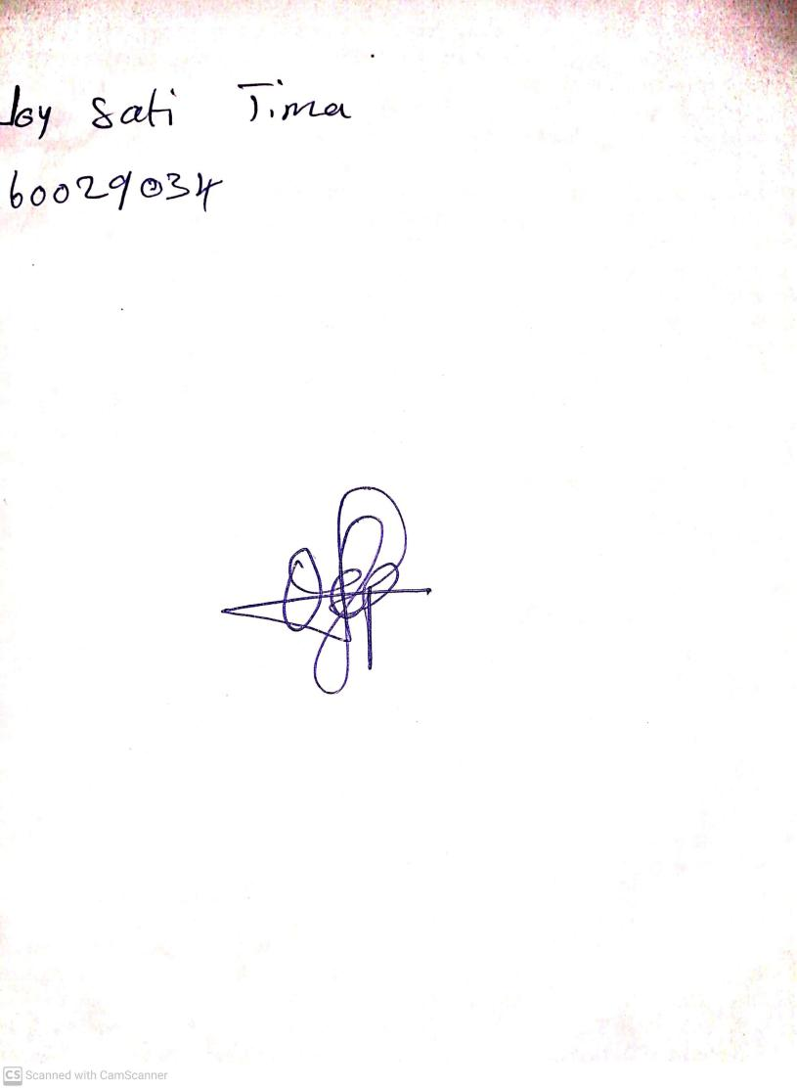

18th September, 2023

Perpetual Ojoma Ocheja

Stream Head Nursery