EMERALD ROYAL INTERNATIONAL SCHOOL

MPAPE, ABUJA.

LESSON PLAN AND NOTE FOR WEEK 3 ENDING 28TH SEPTEMBER,2023

TERM: First term.

WEEK: Three

SUBJECT: Nature studies.

TOPIC: Importance of the parts of the body.

SUB-TOPIC: Functions of the parts of the body.e.g ear and teeth.

DATE: 21/9/2023

DURATION: 40 minutes

TIME: 08:50-09:30

PERIOD: 3rd

CLASS: Pre-nursery

NUMBER OF PUPILS: 8

AVERAGE AGE: 2 years

SEX: Mixed

SPECIFIC OBJECTIVES: By the end of the lesson, the pupils should be able to:-

I Mention the use of ear

2. State the uses of teeth.

RATIONALE: For Pupils to identify their body parts and the uses of the body parts.

PREVIOUS KNOWLEDGE: Pupils have been taught the parts of the body.

INSTRUCTIONAL MATERIALS: Charts video clips.

REFERENCE: Showers kiddies books Elementary science book nursery 1 by Showers kiddies books.

LESSON DEVELOPMENT

|  |  |  |  |
| --- | --- | --- | --- |
| Stages/steps | Teacher's activities | Pupils' activities | Learning points |
| Introduction | Teacher introduces the lesson by singing parts of the body song for the pupils. | Pupils sing the song along with the teacher. | To arouse the interest of the pupils. |
| Presentation  Step 1 | Teacher guides the pupils to touch their ear and say what they use the ear to do. | Pupils touch their ear and say :-  "This is my ear'.  They also say what they use the ear to do as:-  " I hear with my ears." | For better understanding of the use of ear. |
| Step 2 | Teacher leads the pupils to touch their teeth and say what they use their teeth to do. | Pupils touch their teeth and say;  "These are my teeth."  Pupils also say what they uses the teeth to do as:-   1. I cut food with my teeth.   2. I chew food with my teeth | For better understanding of the uses of teeth. |
| Summary | Teacher summarizes the lesson by going over the lesson again for more understanding of the lesson as:-  Uses of ear.   1. I hear with my ear.   Uses of teeth   1. I cut food with my teeth. 2. I chew food with my teeth. | Pupils listen attentively to the teacher as she is going over the lesson again. | To ensure better understanding. |
| Evaluation | Teacher asks the Pupils to :-  I. Say what they use their ear to do.  II. State the uses of teeth. | Pupils answer the teacher's questions correctly. | To ascertain the level of pupils understanding of the lesson. |
| Conclusion | Teacher concludes the lesson by singing nursery rhymes for the pupils. | Pupils sing along with the teacher. | For onwards learning. |
| Assignment | Teacher asks the pupils to answer the these questions at home.   1. I see with my--------------(eyes,legs) 2. I hear with my------------(nose,ear) 3. I cut food with my--------(tongue, teeth) | Pupils do the assignment at home. | To encourage Learning at home. |

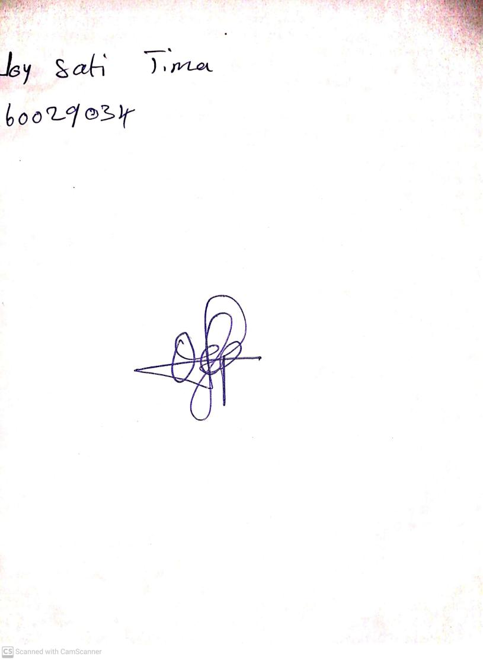

20th August, 2023

Perpetual Ojoma Ocheja

Stream Head Nursery