LESSON PLAN/ NOTE FOR WEEK 8 ENDING 03/03/2023

TERM: 2nd

WEEK: 8th

DATE: 27/02/2023

CLASS: Nursery 2

SUBJECT: Letter work

TOPIC: Consonant Digraph 1

SUB—TOPIC: Meaning and example of digraphs.

PERIOD: 1st

TIME: 09:30—10:10am

DURATION: 40 minutes

NUMBER IN CLASS: 14

AVERAGE AGE: 5 years

SEX: Mixed

LEARNING OBJECTIVES: By the end of the lesson, the Pupils should be able to:

1. Define consonant digraphs.

2. Explain the example of consonant digraphs.

RATIONALE: For Pupils to know what consonant digraphs means and Examples.

PREVIOUS KNOWLEDGE: Pupils have learnt initial and final consonant blends.

INSTRUCTIONAL MATERIALS: Phone.

REFERENCE MATERIALS: Google. com

LESSON DEVELOPMENT

|  |  |  |  |
| --- | --- | --- | --- |
| Steps | Teacher's activities | Pupils' activities | Learning point |
| Introduction | Teacher reviews the previous lesson. | Pupils pay attention to the teacher. | To arouse pupils interest for the lesson ahead. |
| Presentation step 1 | Teacher defines the meaning of consonant digraphs to pupils and ask them to repeat after her. | Pupils listen to the teacher and repeat after her. | For proper understanding. |
| Step 2 | Teacher explains at least one example of consonant digraphs to pupils and also ask them to repeat after her. | Pupils pay attention to the teacher and repeat after her. | For better understanding. |
| Board summary | Teacher writes the whole note of lesson on the board for pupils to copy. As;  CONSONANT DIGRAPHS  Consonant digraphs are two or more consonants that , together represent one sound.  Example: 'p' and 'h' form the grapheme 'ph' that can represent the /f/ sound in words such as “nephew” and “phone”. | Pupils copy the note into their books. | For onward study. |
| Evaluation | Teacher asks Pupils one after the other to define consonant digraphs. | Pupils define consonant digraphs one after another. | To create platform for slow learners. |
| Conclusion | Teacher concludes the lesson by marking pupils books. | Pupils submit their books for marking. | For endorsement. |
| Assignment | 1. Generate words with consonant digraphs 'ck'  2. Consonant digraphs' ph' | Pupils do their assignment at home. | To encourage learning at home |

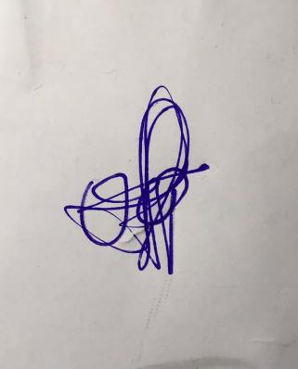

**29th March, 2023**

**Perpetual Ojoma Ocheja**

**Stream Head Nursery**