**EMERALD ROYAL INTERNATIONAL SCHOOL MPAPE, ABUJA. LESSON PLAN AND NOTE FOR WEEK 1 PERIOD 1 ENDING 26/04/2024**

**TERM: 3RD**

**WEEK: 1ST**

**DATE: 22/04/2024**

**CLASS: NURSERY 2**

**SUBJECT: NUMBER WORK**

**TOPIC: REVISION OF NUMBER 1-40 .**

**SUB-TOPIC: COUNTING OF NUMBERS 1-4O**

**PERIOD: 1ST.**

**TIME: O8:50-09:30.**

**DURATION: 40 MINUTES.**

**NUMBER IN CLASS: 13**

**AVERAGE AGE: 5 YEARS.**

**SEX: MIXED.**

**SPECIFIC OBJECTIVES: BY THE END OF THE LESSON,THE PUPILS SHOULD BE**

**ABLE TO:**

1. **COUNT NUMBER 1-15.**
2. **WRITE NUMBER 1-15.**

**RATIONALE: FOR PUPILS TO BE ABLE TO RECALL NUMBERS 1-15.**

**PREVIOU KNOWLEDGE: PUPILS HAVE LEARNT COUNTING OF NUMBERS IN**

**PREVIOUS TERM.**

**INSTRUCTIONAL MATERIALS: NUMBER CHART FROM 1-15.**

**REFERENCE MATERIALS: THE NEW MASTERING MATHEMATICS FOR NURSERY SCHOOLS BOOK 3 BY HENRY.Z.IDOGUN.**

**LESSON DEVELOPMENT**

|  |  |  |  |
| --- | --- | --- | --- |
| **STAGES/STEPS** | **TEACHER’S ACTIVITIES** | **PUPILS’ ACTIVITIES** | **LEARNING POINTS** |
| **INTRODUCTION** | **Teacher introduces the lesson by singing a number rhyme for the pupils.** | **Pupils sing the rhyme along with the teacher.** | **To arouse pupils interest in the lesson.** |
| **PRESENTATION**  **STEP 1** | **Teacher writes numbers 1-15 on the board, counts and then asks pupils to repeat after her. I.e, 1 2 3 4 5 6 7 8 9 10 11 12 13 14 15** | **Pupils count numbers 1- 15 after the teacher.** | **For proper understanding of the lesson .** |
| **STEP 2** | **Teacher prepares pupils books for them to count and copy the numbers on the board into their exercise books.** | **Pupils count and copy the numbers into their exercise books. I.e,**  **1 2 3 4 5 6 7 8 9 10 11 12 13 14 15.** | **For better understanding of the lesson.** |
| **BOARD SUMMARY** | **Teacher summarizes the lesson by going through the lesson on the board over and over again.** | **Pupils pay attention to the teacher.** | **For more understanding of the lesson.** |
| **EVALUATION** | **Teacher asks Pupils to count numbers 1 - 15 on the board one after the other.** | **Pupils count numbers 1 - 15 on the board one after another.** | **To assess pupils understanding of the lesson.** |
| **CONCLUSION** | **Teacher marks pupils books.** | **Pupils submit their books for marking.** | **For endorsement.** |
| **ASSIGNMENT (HOME WORK)** | **Identify, count and write numbers 1 -30** | **Pupils do their assignment at home.** | **To encourage learning at home.** |

**LESSON PLAN AND NOTE FOR WEEK 1 PERIOD 2 ENDING 26/04/2024**

**TERM: 3RD**

**WEEK: 1ST**

**DATE: 23/04/2024**

**CLASS: NURSERY 2**

**SUBJECT: NUMBER WORK**

**TOPIC: REVISION OF NUMBER 1-40 .**

**SUB-TOPIC: COUNTING OF NUMBERS 16- 30**

**PERIOD: 2ND.**

**TIME: O8:50-09:30.**

**DURATION: 40 MINUTES.**

**NUMBER IN CLASS: 13**

**AVERAGE AGE: 5 YEARS.**

**SEX: MIXED.**

**SPECIFIC OBJECTIVES: BY THE END OF THE LESSON,THE PUPILS SHOULD BE**

**ABLE TO:**

1. **COUNT NUMBER 16- 30**
2. **WRITE NUMBER 16- 30**

**RATIONALE: FOR PUPILS TO BE ABLE TO RECALL NUMBERS 16- 30.**

**PREVIOU KNOWLEDGE: PUPILS HAVE LEARNT COUNTING OF NUMBERS IN**

**PREVIOUS TERM.**

**INSTRUCTIONAL MATERIALS: NUMBER CHART FROM 16- 30.**

**REFERENCE MATERIALS: THE NEW MASTERING MATHEMATICS FOR NURSERY SCHOOLSBOOK 3 BY HENRY.Z.IDOGUN.**

**LESSON DEVELOPMENT**

|  |  |  |  |
| --- | --- | --- | --- |
| **STAGES/STEPS** | **TEACHER’S ACTIVITIES** | **PUPILS’ ACTIVITIES** | **LEARNING POINTS** |
| **INTRODUCTION** | **Teacher introduces the lesson by reviewing the previous lesson.** | **Pupil listen to the teacher.** | **To arouse pupils interest for the lesson ahead.** |
| **PRESENTATION**  **STEP 1** | **Teacher writes numbers 16- 30 on the board, counts and then asks pupils to repeat after her. I.e, 16 17 18 19 20 21 22 23 24 25 26 27 28 29 30.** | **Pupils count numbers 16- 3o after the teacher.** | **For proper understanding of the lesson .** |
| **STEP 2** | **Teacher prepares pupils books for them to count and copy the numbers on the board into their exercise books.** | **Pupils count and copy the numbers into their exercise books. I.e,**  **16 17 18 19 20 21 22 23 24 25 26 27 28 29 30.** | **For better understanding of the lesson.** |
| **BOARD SUMMARY** | **Teacher summarizes the lesson by going through the lesson on the board over and over again.** | **Pupils pay attention to the teacher.** | **For more understanding of the lesson.** |
| **EVALUATION** | **Teacher asks Pupils to count numbers 16 - 30 on the board one after the other.** | **Pupils count numbers 16 - 30 on the board one after another.** | **To assess pupils understanding of the lesson.** |
| **CONCLUSION** | **Teacher marks pupils books.** | **Pupils submit their books for marking.** | **For endorsement.** |
| **ASSIGNMENT** | **Identify, count and write numbers 1- 40.** | **Pupils do their assignment at home.** | **To encourage learning at home.** |

**LESSON PLAN AND NOTE FOR WEEK 1 PERIOD 3 ENDING 26/04/2024**

**TERM: 3RD**

**WEEK: 1ST**

**DATE: 26/04/2024**

**CLASS: NURSERY 2**

**SUBJECT: NUMBER WORK**

**TOPIC: REVISION OF NUMBER 1-40 .**

**SUB-TOPIC: COUNTING OF NUMBERS 31- 40**

**PERIOD: 3RD.**

**TIME: O8:1O- 08:50.**

**DURATION: 40 MINUTES.**

**NUMBER IN CLASS: 13**

**AVERAGE AGE: 5 YEARS.**

**SEX: MIXED.**

**SPECIFIC OBJECTIVES: BY THE END OF THE LESSON,THE PUPILS SHOULD BE**

**ABLE TO:**

1. **COUNT NUMBER 31 - 40**
2. **WRITE NUMBER 31 - 40**

**RATIONALE: FOR PUPILS TO BE ABLE TO RECALL NUMBERS 31 - 40.**

**PREVIOU KNOWLEDGE: PUPILS HAVE LEARNT COUNTING OF NUMBERS IN**

**PREVIOUS TERM.**

**INSTRUCTIONAL MATERIALS: NUMBER CHART FROM 31 - 40.**

**REFERENCE MATERIALS: THE NEW MASTERING MATHEMATICS FOR NURSERY SCHOOLSBOOK 3 BY HENRY.Z.IDOGUN.**

**LESSON DEVELOPMENT**

|  |  |  |  |
| --- | --- | --- | --- |
| **STAGES/STEPS** | **TEACHER’S ACTIVITIES** | **PUPILS’ ACTIVITIES** | **LEARNING POINTS** |
| **INTRODUCTION** | **Teacher introduces the lesson by reviewing the previous lesson.** | **Pupil listen to the teacher.** | **To arouse pupils interest for the lesson ahead.** |
| **PRESENTATION**  **STEP 1** | **Teacher writes numbers 31 - 40 on the board, counts and then asks pupils to repeat after her. I.e, 31 32 33 34 35 36 37 38 39 40.** | **Pupils count numbers 31 - 40 after the teacher.** | **For proper understanding of the lesson .** |
| **STEP 2** | **Teacher prepares pupils books for them to count and copy the numbers on the board into their exercise books.** | **Pupils count and copy the numbers into their exercise books. I.e,**  **31 32 33 34 35 36 37 38 39 40.** | **For better understanding of the lesson.** |
| **BOARD SUMMARY** | **Teacher summarizes the lesson by going through the lesson on the board over and over again.** | **Pupils pay attention to the teacher.** | **For more understanding of the lesson.** |
| **EVALUATION** | **Teacher asks Pupils to count numbers 31 - 40 on the board one after the other.** | **Pupils count numbers 31- 40 on the board one after another.** | **To assess pupils understanding of the lesson.** |
| **CONCLUSION** | **Teacher marks pupils books.** | **Pupils submit their books for marking.** | **For endorsement.** |
| **ASSIGNMENT** | **Identify, count and write numbers 1- 50.** | **Pupils do their assignment at home.** | **To encourage learning at home.** |

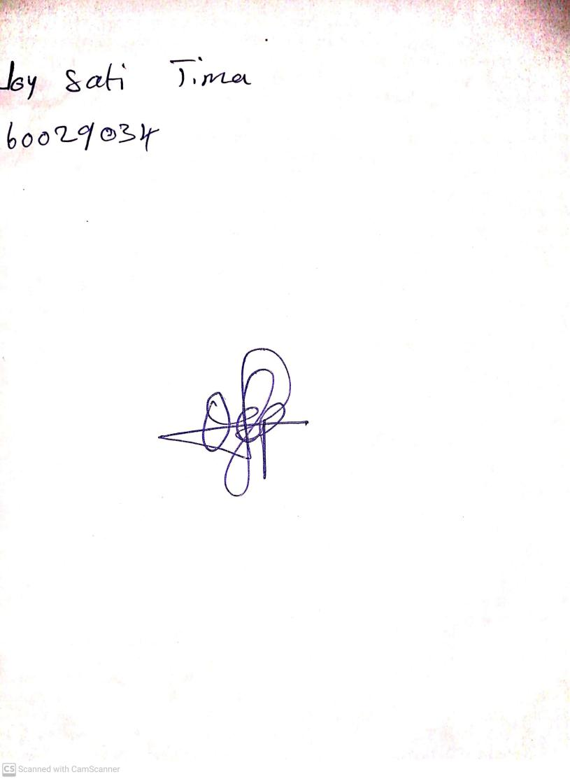

**19th April, 2024**

**Perpetual Ojoma Ocheja**

**Stream Head Nursery**