LESSON PLAN FOR WEEK 3 ENDING 27th JANUARY,2023

|  |  |
| --- | --- |
| TERM | 2ND |
| WEEK | 3 |
| DATE | 23rd -27th January, 2023 |
| CLASS | SS 2 |
| SUBJECT | Government |
| TOPIC | Colonialism |
| SUB-TOPIC | Indirect Rule |
| PERIOD | 3rd |
| TIME | 9:30-9:50 |
| DURATION | 40 Minutes |
| NO IN CLASS | 2 |
| AVERAGE AGE | 14-15 years |
| SEX | Mixed |
| SPECIFIC OBJECTIVES | By the end of the lesson, scholars should be able to:  i.Explain the meaning of Indirect Rule System.  ii.State the reasons for the adoption of the Indirect Rule System. |
| RATIONALE | To familiarize scholars with the meaning and reasons for the adoption of Indirect Rule system. |
| PREVIOUS KNOWLEDGE | The scholars can explain the historical background of colonialism. |
| INSTRUCTIONAL RESOURCES | Charts from textbook explaining the topic. |
| REFERENCE MATERIAL | Essential Government for Senior Secondary Schools.  Debie Chris(2017) |

LESSON DEVELOPMENT

|  |  |  |  |
| --- | --- | --- | --- |
| STEPS | TEACHER’S ACTIVITIES | SCHOLARS’ ACTIVITIES | LEARNING POINTS |
| Introduction | The teacher introduces the lesson by asking the scholars to who was regarded as the Father of Indirect Rule system. | The scholars mention them the person as Sir Friederick Lord Lugard. | To arouse the scholars’ interest towards the topic. |
| Step 1 | The teacher explains the meaning of Indirect Rule system. | The scholars pay attention. | To ensure proper understanding of the topic. |
| Step 2 | The teacher states the reasons for the adoption of Indirect Rule system. | The scholars ask relevant questions on the topic. | To make room for logical reasoning on the topic. |
| Board summary | The teacher summerises the lesson thus:  **Meaning of Indirect Rule System**  Indirect rule is a system of administration in which the British colonial government adopted as it’s colonial policy in dealing with the people by using the traditional rulers, the traditional political institutions, administrative, cultural and judicial structures as intermediaries while the British officials mainly advised and when necessary, enforced colonial rule.  **Native Authority**  The native authority was an institution of local administration of indirect rule system in British West African colonies.  **Main Features of Indirect Rule**  1.Traditional Rulers: The colonialists ruled indirectly be engaging the traditional rulers and the chiefs to govern the people.  2.The traditional system of government: The traditional politics of government in place was utilized.  3.Customs and Traditions: The customs and traditions of the people played significant role in the administration.  4.Respect for the culture: The cultural values of the people were respected by the British officials.  5.British Officials: They were to guide and where need be, enforce colonial regulations. For instance, Resident and District officers.  6.Respect for the Traditional Rulers: They were respected and given exalted positions in the administration which made it easy for the colonialists to operate and rule.  7.The police and prisons: Native police and prisons were untilized in the system.  **Reasons for the Adoption of Indirect Rule System**:  1.Lack of British Personnel: The system had few Europeans to control effectively areas under their control.  2.Insufficient funds: There was no sufficient funds from the British government to engage the British officials for direct administration.  3.Poor climate: Poor climatic conditions made the situation worse. Many British officials refused coming down to be involved in the administration due to poor climate and the presence of mosquitoes.  4.To satisfy their economic needs: The colonialists wanted to create markets for their goods and to encourage West Africans to produce such materials.  5.Large expanse of land: Areas administered by Britain were so large that indirect administration was a better option.  6.Language barrier: English language used by the British was quite different from languages of most of her colonies, for example; Nigeria. | The scholars copy notes into their notebooks. | For reference purposes. |
| Evaluation | The teacher evaluates the scholars thus:  i.Define Native Authority.  ii.Mention three reasons for the adoption of Indirect Rule system in Nigeria. | The scholars attempt the questions. | To ascertain scholars understanding of the topic. |
| Conclusion | The teacher check scholars notes and make corrections. | The scholars take corrections made by the teacher. | For consolidation of the topic. |
| Assignment | The teacher gives the scholars assignment:  -Enumerate seven importance of the Indirect Rule system in West Africa. | The scholars copy their assignment to do it at home. | To encourage continuity of learning. |

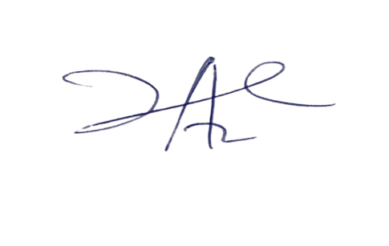

**21/3/2023**

**Principal Head Instructor**