LESSON PLAN FOR WEEK 2 ENDING 13th JANUARY, 2023

|  |  |
| --- | --- |
| TERM | 2ND |
| WEEK | 2 |
| DATE | 9TH -13TH , January, 2023 |
| CLASS | SS1 |
| SUBJECT | Government |
| TOPIC | Constitution |
| SUB-TOPIC | Differences Between Written and Unwritten Constitution |
| PERIOD | 5th |
| TIME | 11:10- 11:15 |
| DURATION | 35 Minutes |
| NO IN CLASS | 7 |
| AVERAGE AGE | 13-15 years |
| SEX | Mixed |
| LEARNING OBJECTIVES | By the end of the lesson, scholars should be able to:  i.State the differences between written and unwritten constitution.  ii.List the differences between rigid and flexible constitution. |
| RATIONALE | To acquaint scholars with the differences between written and unwritten, rigid and flexible constitution. |
| PREVIOUS KNOWLEDGE | The scholars know the types of constitutions. |
| INSTRUCTIONAL RESOURCES | Charts from textbook explaining the topic. |
| REFERENCE MATERIAL | Essential Government for Senior Secondary Schools.  Debie.C.Chris (2017). |

LESSON DEVELOPMENT

|  |  |  |  |
| --- | --- | --- | --- |
| STEPS | TEACHER’S ACTIVITIES | SCHOLARS' ACTIVITIES | LEARNING POINTS |
| Introduction | The teacher introduces the lesson by asking the scholars to mention two types of constitution. | The scholars mention two types of constitution as:  i.Rigid Constitution  ii.Flexible Constitution | To arouse scholars’ interest towards the topic. |
| Step 1 | The teacher states the differences between written and unwritten constitution. | The scholars pay attention. | To enhance proper understanding of the topic. |
| Step 2 | The teacher lists the differences between rigid and flexible constitutions. | The scholars listen and ask relevant questions on the topic. | To make room for critical thinking on the topic. |
| Board Summary | The teacher summarises the lesson thus:  **Differences Between Written and Unwritten constitution**   |  |  | | --- | --- | | Written | Unwritten | | 1.It is written and documented. | It is not written and documented | | 2.It is rigid and difficult to amend. | It is flexible and easy to amend. | | 3.It is available in a single document and can easily be obtained and read. | It cannot be easily documented or studied. | | 4.A written constitution can easily be referred to. For example, in law courts. | An unwritten constitution cannot be easily referred to because it is not written. | | 5.The rights of individuals are entrenched in the constitution. | Individual rights are not stated. | | 6.Written constitutions are not useful in emergencies. | Unwritten constitutions are suitable in times of emergency. |   **Difference Between Rigid and Flexible Constitutions**.   |  |  | | --- | --- | | Rigid | Flexible | | 1.It is difficult to amend. | They are very easy to amend. | | 2.The process of amendment is a complicated one. | The amendment can easily be done by a single majority in the legislature. | | 3.Most written constitutions are rigid. | A flexible constitution may be written or unwritten. | | 4.Rigid constitutions are resistant to change and innovations. | Changes and innovations can easily be brought in. | | 5.The rights of individuals are enhanced and not subject to arbitrary rule. | Fundamental rights of citizens may be infringed upon and this may increase the fears of the of the majority. | | The scholars copy notes into their notebooks. | For reference purposes. |
| Evaluation | The teacher evaluates the scholars thus:  i.Mention two differences between written and unwritten constitutions.  ii.List two differences between rigid and flexible constitutions. | The scholars attempt the questions. | To ascertain their level of understanding of the lesson. |
| Conclusion | The teacher checks scholars notes and make corrections. | The scholars take corrections made by the teacher. | For consolidation of the topic. |
| Assignment | The teacher gives the scholars home work:  i.Mention three examples of countries that operate rigid and flexible constitutions. | The scholars copy their home work to do it at home. | To encourage continuity of learning. |

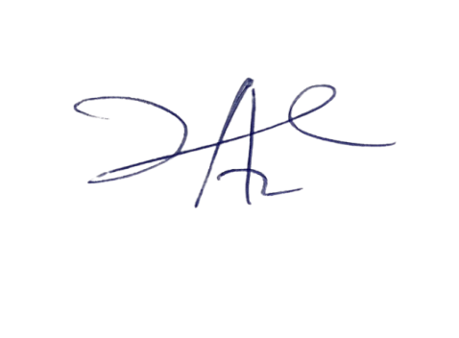

3/3/2023

Head Insrtuctor