**EMERALD ROYAL INTERNATIONAL SCHOOL**

**MPAPE, ABUJA.**

**LESSON AND PLAN AND NOTE FOR WEEK 9 ENDING 30/06/2023**

TERM: THIRD

WEEK: 9TH

DATE: 26/06/2023

CLASS: NURSERY 2

SUBJECT: NATURE STUDY

TOPIC: COLOURS .

SUB-TOPIC: MEANING OF COLOUR AND TYPES OF COLOURS

PERIOD: 1ST PERIOD AFTER LONG BREAK

TIME: 10: 40- 11: 20am

DURATION: 40 MINUTES.

NUMBER IN CLASS: 17

AVERAGE AGE: 5 YEARS.

SEX: MIXED.

SPECIFIC OBJECTIVES: BY THE END OF THE LESSON,THE PUPILS SHOULD BE

ABEL TO:

1. EXPLAIN THE MEANING OF COLOURS.
2. MENTION THE TYPES OF COLOURS.
3. IDENTIFY COLOURS.

RATIONALE: FOR PUPILS TO KNOW COLOURS.

PREVIOU KNOWLEDGE: PUPILS HAVE BEEN SEEING THINGS WITH DIFFERENT

COLOURS.

INSTRUCTIONAL MATERIALS: DIFFERED COLOURS OF CHAIRS AND TABLES IN THE

CLASSROOM

REFERENCE MATERIALS: BASIC SCIENCE AND TECHNOLOGY NURSERY SCHOOLS

BOOK 3 BY OPEMIPO DADA.

**LESSON DEVELOPMENT**

|  |  |  |  |
| --- | --- | --- | --- |
| STAGES/STEPS | TEACHER’S ACTIVITIES | PUPILS’ ACTIVITIES | LEARNING POINTS |
| INTRODUCTION | Teacher introduces the lesson by asking the pupils the following question; what colour of chair are you sitting on? | Pupils pay attention to the teacher and answer the question ask by the teacher. | To prepare pupils minds for the lesson ahead.. |
| PRESENTATION  STEP 1 | Teacher explains the meaning of colour to pupils and then asks them to repeat after her. | Pupils listen attentively to the teacher and repeat after her. | For proper understanding . |
| STEP 2 | Teacher mentions the types of colours to pupils and also asks them to repeat after her. | Pupils pay attention to the teacher and repeat after her. | For better understanding of the lesson. |
| STEP 3 | Teacher guides pupils to identify different colours in the school environment. | Pupils listen to the teacher and identify the colours . | To enhance pupils participation in class. |
| BOARD SUMMARY | Teacher summarizes the lesson by writing the whole note of lesson on the board for pupils to copy into their books. Ie COLOURS  Colour is the appearance of objects or light sources.  TYPES OF COLOURS   1. Primary colours 2. Secondary colours   The primary colours are;  Red,blue,yellow. While, The secondary colours are;  Orange,green,violet. | Pupils copy the note into their exercise books. | For onward study. |
| EVALUATION | Teacher evaluates the lesson by asking the following questions;   1. What is colour? 2. Mention the types of colours. 3. The primary colours are made up of ? 4. The secondary colours are made up of? | Pupils answer the questions ask by the teacher. | To assess pupils level of understanding. |
| CONCLUTION | Teacher concludes the lesson by marking pupils books. | Pupils submit their books for marking. | For endorsement. |
| ASSIGNMENT | 1. What is colours? 2. Mention the two types of colours 3. What are the primary colours? 4. List the secondary colours. | Pupils do their assignment at home. | To encourage learning at home. |

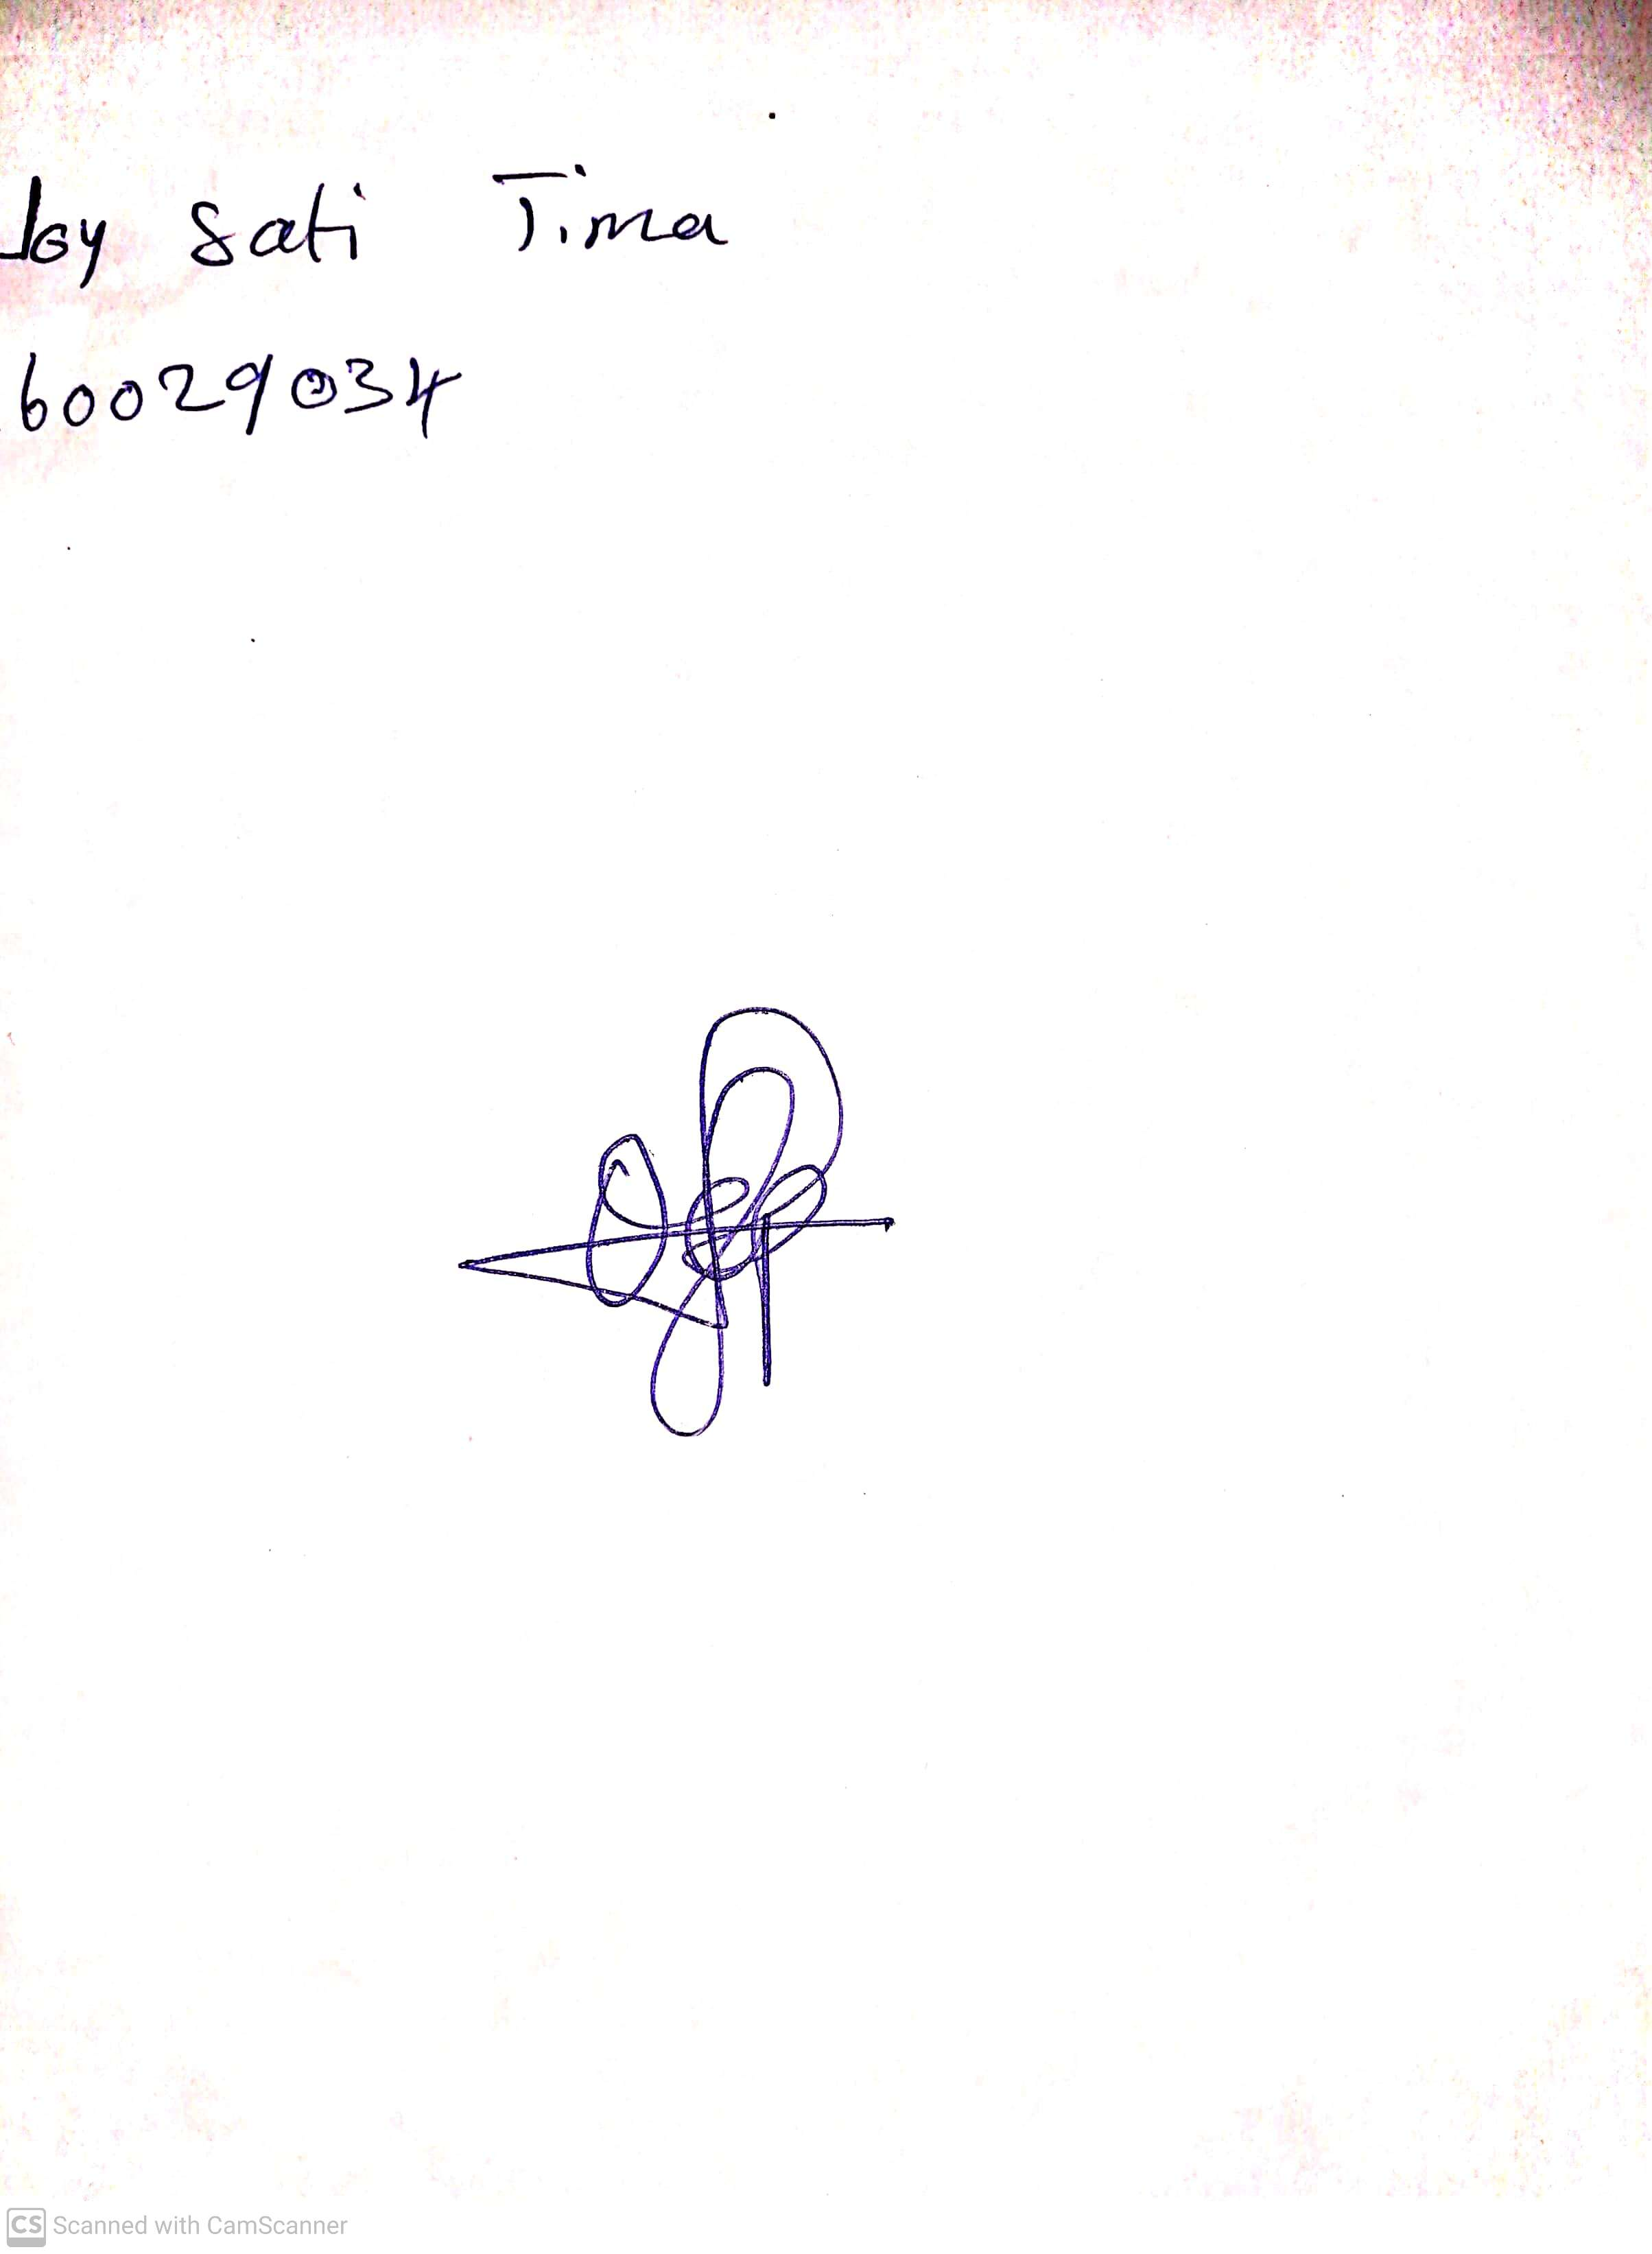

14th May, 2023

Perpetual Ojoma

Stream Head Nursery