**LESSON PLAN AND NOTE 1 FOR WEEK 7 ENDING 16/6/2023**

**Term 3rd Term**

**Week 7th week**

**Date 16th June, 2023**

**Class Nursery One**

**Subject Letter Work**

**Topic Consonants.**

**Sub-topic Meaning of consonant.**

**Period 2nd Period**

**Time 9:05 am**

**Duration 35 minutes**

**No in class 18**

**Average Age 3 years**

**Sex Mixed.**

**Specific Objectives: By the end of the lesson, the pupils should be able to:**

1. **Define consonants**
2. **Words that starts with consonant /b/,/c/,/d/,/f/,/g/,/h/,/j/,/k/.**

**Rationale: To make the pupils define and mention words with**

**consonants /b/,/c/,/d/,/f/,/g/,/h/,/j/,/k/.**

**Previous Knowledge: The pupils can mention words that start with vowel /o/,/u/.**

**Instructional Resources: Chart, board, marker.**

**Reference Material: Online research, chart.**

**LESSON PRESENTATION**

|  |  |  |  |
| --- | --- | --- | --- |
| **Steps** | **Teacher’s Activities** | **Pupils’ Activities** | **Learning Points** |
| **Introduction** | **The teacher introduces the topic (Consonants) to the pupils.** | **The pupils listen to the teacher attentively.** | **To arouse the interest of the pupils.** |
| **Step 1** | **The teacher starts by defining consonant as ‘the letter sound of English alphabet that is not a vowel’ to the pupils.** | **The pupils repeat after the teacher the meaning of consonants.** | **For proper understanding.** |
| **Step 2** | **The teacher mentions words that start with consonant /b/,/c/,/d/,/f/,/g/,/h/,/j/,/k/**  **/b/ = boy, ball**  **/c/ = cat, car**  **/d/ = dog, dot**  **/f/ = fan, fun**  **/g/ = gun, goat**  **/h/ = hat, hen**  **/j/ = jet, jam**  **/k/ = key, king** | **The pupils listens to the teacher attentively.** | **For better understanding.** |
| **Summary** | **The teacher summarizes the lesson by defining consonants.** | **The pupils understands the lesson.** | **For onward study’.** |
| **Evaluation** | **Question:**  **Mention the 21 consonant sounds?**  **Mention the words that’s start with consonant /b/,/c/.** | **The pupils answer the question correctly.** | **To ascertain the pupils’ understanding of the lesson.** |
| **Conclusion** | **The teacher reacts, summarizes the lesson to the pupils.** | **The pupils gives answers to the teacher.** | **To consolidate the lesson.** |
| **Assignment** | **Mention words that starts with consonant /d/,/g/,/f/.** | **The pupils copy ad do their home-work at home.** | **To encourage learning while at home.** |

**LESSON PLAN AND NOTE 2 FOR WEEK 7 ENDING 16/6/2023**

**Term 3rd Term**

**Week 7th week**

**Date 16th June, 2023**

**Class Nursery One**

**Subject Letter Work**

**Topic Consonants.**

**Sub-topic Identification of consonant.**

**Period 2nd Period**

**Time 9:05 am**

**Duration 35 minutes**

**No in class 18**

**Average Age 3 years**

**Sex Mixed.**

**Specific Objectives: By the end of the lesson, the pupils should be able to:**

1. **Identify consonants /l/,/m/,/n/,/p/,/q/,/r/,/s/.**
2. **Words that starts with consonant /l/,/m/,/n/,/p/,/q/,/r/,/s/.**

**Rationale: To make the pupils define and mention words with**

**consonants /l/,/m/,/n/,/p/,/q/,/r/,/s/.**

**Previous Knowledge: The pupils can define consonants.**

**Instructional Resources: Chart, board, marker.**

**Reference Material: Online research, chart.**

**LESSON PRESENTATION**

|  |  |  |  |
| --- | --- | --- | --- |
| **Steps** | **Teacher’s Activities** | **Pupils’ Activities** | **Learning Points** |
| **Introduction** | **The teacher introduces the topic (Consonants) to the pupils.** | **The pupils listen to the teacher attentively.** | **To arouse the interest of the pupils.** |
| **Step 1** | **The teacher leads the pupils to identify consonant /l/,/m/,/n/,/p/,/q/,/r/,/s/.** | **The pupils identify with the teacher the consonants /l/,/m/,/n/,/p/,/q/,/r/,/s/.** | **For proper understanding.** |
| **Step 2** | **The teacher mentions words that start with consonant /l/,/m/,/n/,/p/,/q/,/r/,/s/.**  **/l/ = lion, lamp**  **/m/ = mat, mop**  **/n/ = net**  **/p/ = pan, pat**  **/q/ = queen**  **/r/ = rat, ram**  **/s/ = sun, set.** | **The pupils listens to the teacher attentively.** | **For better understanding.** |
| **Summary** | **The teacher summarizes the lesson by identifying consonants /l/,/m/,/n/,/p/,/q/,/r/,/s/.** | **The pupils understands the lesson.** | **For onward study’.** |
| **Evaluation** | **Question:**  **Mention the words that’s start with consonant /l/, /p/, /s/.**  **Identify the consonant sounds below**  **/q/,/r/,/s/** | **The pupils answer the question correctly.** | **To ascertain the pupils’ understanding of the lesson.** |
| **Conclusion** | **The teacher reacts, summarizes the lesson to the pupils.** | **The pupils gives answers to the teacher.** | **To consolidate the lesson.** |
| **Assignment** | **Mention words that starts with consonant /m/,/n/,/r/.** | **The pupils copy ad do their home-work at home.** | **To encourage learning while at home.** |

**LESSON PLAN AND NOTE 3 FOR WEEK 7 ENDING 16/6/2023**

**Term 3rd Term**

**Week 7th week**

**Date 16th June, 2023**

**Class Nursery One**

**Subject Letter Work**

**Topic Consonants.**

**Sub-topic Identification of consonant.**

**Period 2nd Period**

**Time 9:05 am**

**Duration 35 minutes**

**No in class 18**

**Average Age 3 years**

**Sex Mixed.**

**Specific Objectives: By the end of the lesson, the pupils should be able to:**

1. **Identify consonants /t/,/v/,/w/,/x/,/y/,/z/.**
2. **Words that starts with consonant /t/,/v/,/w/,/x/,/y/,/z/.**

**Rationale: To make the pupils define and mention words with**

**Consonants /t/,/v/,/w/,/x/,/y/,/z/.**

**Previous Knowledge: The pupils can mention words that start with consonants.**

**Instructional Resources: Chart, board, marker.**

**Reference Material: Online research, chart.**

**LESSON PRESENTATION**

|  |  |  |  |
| --- | --- | --- | --- |
| **Steps** | **Teacher’s Activities** | **Pupils’ Activities** | **Learning Points** |
| **Introduction** | **The teacher introduces the topic (Consonants) to the pupils.** | **The pupils listen to the teacher attentively.** | **To arouse the interest of the pupils.** |
| **Step 1** | **The teacher leads the pupils to identify consonant /t/,/v/,/w/,/x/,/y/,/z/.** | **The pupils identify with the teacher the consonants /t/,/v/,/w/,/x/,/y/,/z/.** | **For proper understanding.** |
| **Step 2** | **The teacher mentions words that start with consonant /t/,/v/,/w/,/x/,/y/,/z/.**  **/t/ = tap, tip**  **/v/ = van, vet**  **/w/ = win**  **/x/ = x-ray**  **/y/ = yam**  **/z/ = zip, zebra.** | **The pupils listens to the teacher attentively.** | **For better understanding.** |
| **Summary** | **The teacher summarizes the lesson by identifying consonants /t/,/v/,/w/,/x/,/y/,/z/.** | **The pupils understands the lesson.** | **For onward study’.** |
| **Evaluation** | **Question:**  **Mention the words that’s start with consonant /t/, /y/, /z/.**  **Identify consonant /y/,/z/.** | **The pupils answer the question correctly.** | **To ascertain the pupils’ understanding of the lesson.** |
| **Conclusion** | **The teacher reacts, summarizes the lesson to the pupils.** | **The pupils gives answers to the teacher.** | **To consolidate the lesson.** |
| **Assignment** | **Mention words that starts with consonant /v/,/w/,/z/.** | **The pupils copy ad do their home-work at home.** | **To encourage learning while at home.** |

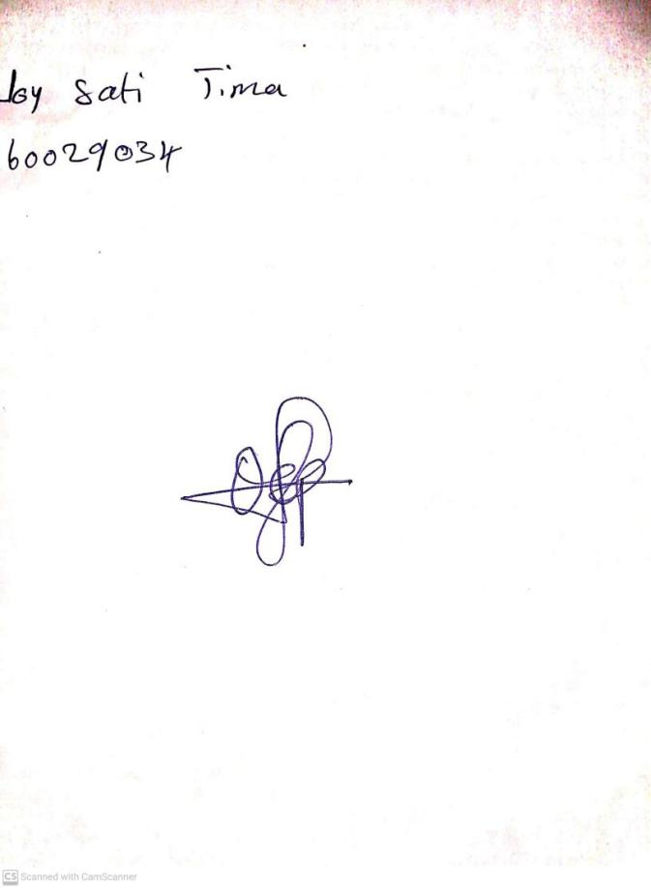

10th May, 2023

Perpetual Ojoma

Stream Head Nursery