**EMERALD ROYAL INTERNATIONAL SCHOOL MPAPE, ABUJA**

**LESSON PLAN AND NOTE FOR WEEK 9 PERIOD 1 ENDING 08/11/2024**

**TERM: FIRST**

**WEEK: 9TH**

**DATE: 04/11/2024**

**CLASS: NURSERY 2**

**SUBJECT: LITERACY**

**TOPIC: THREE LETTER WORDS ACROSS THE FIVE VOWELS**

**SUB-TOPIC: THREE LETTER WORDS WITH VOWEL “a” AND “e”**

**PERIOD: 3RD**

**TIME: 09: 30-10: 10 am**

**DURATION: 40 MINUTES**

**NUMBER IN CLASS: 16**

**AVERAGE AGE: 4**

**SEX: MIXED**

**SPECIFIC OBJECTIVES: BY THE END OF THE LESSON, THE PUPILS SHOULD BE ABLE**

**TO:**

**1.IDENTIFY THREE LETTER WORDS WITH VOWEL “a” AND “e”**

**2.SPELL AND PRONOUNCE THREE LETTER WORDS WITH**

**VOWEL “a” AND “e”**

**RATIONALE: FOR PUPILS TO BE ABLE TO SPELL AND PRONOUNCE WORDS WITH VOWERL “a” AND “e”**

**PREVIOUS KNOWLEDGE: PUPILS HAVE LEARNT THREE LETTER WORDS ENDING “ub” IN PREVIOUS LESSON.**

**INSTRUCTIONAL MATERIALS: A CHART OF THREE LETTER WORDS WITH VOWEL “a” AND “e”.**

**REFERENCE MATERIALS: TOP STAR MY CHOICE OF ENGLISH LANGUAGE STAGE 3 BY J.F OMOTAYO.**

**LESSON DEVELOPMENT**

|  |  |  |  |
| --- | --- | --- | --- |
| **STAGES/STEPS** | **TEACHER’S ACTIVITIES** | **PUPILS’ ACTIVITIES** | **LEARNING POINT** |
| **INTODUCTION** | **Teacher introduces the lesson by reviewing the previous lesson.** | **Pupils listen attentively to the teacher.** | **To arouse pupils interest for the lesson ahead.** |
| **PRESENTATION STEP 1** | **Teacher writes the three letter words with vowel “a” and “e” on the board and identify, and then asks them to repeat after her.** | **Pupils pay attention to the teacher and repeat after her.** | **For proper understanding.** |
| **STEP 2** | **Teacher spells and pronounce the three letter words with vowel “a” and “e” on the board to pupils and also asks them to repeat after her.** | **Pupils listen very attentively to the teacher and repeat after her.** | **For better understanding of the lesson.** |
| **BOARD SUMMARY** | **Teacher summarizes the lesson by writing the whole note of lesson on the board for pupils to copy into their books. That is;**  **Three letter words with vowel “a” and “e”are:**     |  |  |  | | --- | --- | --- | | **S/N** | **“a” as in;** | **“e” as in;** | | **1** | **cat** | **leg** | | **2** | **fat** | **pen** | | **3** | **pat** | **egg** | | **4** | **map** | **get** | | **5** | **bad** | **met** | | **6** | **dad** | **ten** | | **7** | **rat** | **peg** | | **8** | **tag** | **net** | | **9** | **cap** | **men** | | **10** | **hat** | **beg** | | **11** | **sat** | **hen** | | **12** | **bat** | **bed** | | **13** | **fan** | **set** | | **14** | **mat** | **end** | | **15** | **Bag etc.** | **Fed etc.** | | **Pupils copy the note on the board into their exercise books.** | **For onward study.** |
| **EVALUATION** | **Teacher evaluates the lesson by asking the following questions:**   1. **identify three letter words with vowel “a” and “e” on the board.** 2. **Spell and pronounce the three letter words with vowel “a”.** 3. **Spell and pronounce the three letter words with vowel “e”.** | **Pupils answer the questions asked by the teacher.** | **To asses pupils level of understanding of the lesson.** |
| **CONCLUSION** | **Teacher concludes the lesson by marking pupils books.** | **Pupils submit their books for marking.** | **For endorsement.** |
| **ASSIGNMENT** | **Sound and write 10 three letter words with vowel “I” and 10 three letter words with vowel “o”.** | **Pupils do their assignment at home.** | **To encourage learning at home.** |

**LESSON PLAN AND NOTE FOR WEEK 9 PERIOD 2 ENDING 08/11/2024**

**TERM: FIRST**

**WEEK: 9TH**

**DATE: 05/11/2024**

**CLASS: NURSERY 2**

**SUBJECT: LITERACY**

**TOPIC: THREE LETTER WORDS ACROSS THE FIVE VOWELS.**

**SUB-TOPIC: THREE LETTER WORDS ACROSS VOWEL “i” AND “o” .**

**PERIOD: 2ND**

**TIME: 08: 50-09: 30 am**

**DURATION: 40 MINUTES**

**NUMBER IN CLASS: 16**

**AVERAGE AGE: 4**

**SEX: MIXED**

**SPECIFIC OBJECTIVES: BY THE END OF THE LESSON, THE PUPILS SHOULD BE ABLE**

**TO:**

1. **IDENTIFY THREE LETTER WORDS ACROSS VOWEL “i” AND “0”.**
2. **SPELL AND PRONOUNCE THREE LETTER WORDS**

**ACROSS VOWEL “i” AND “o”.**

**RATIONALE: FOR PUPILS TO BE ABLE TO SPELL AND PRONOUNCE WORDS**

**WITH VOWEL “i” AND “o”.**

**PREVIOUS KNOWLEDGE: PUPILS HAVE LEARNT THREE LETTER WORDS WITH VOWEL “a”AND “e” IN PREVIOUS LESSON.**

**INSTRUCTIONAL MATERIALS: A CHART OF THREE LETTER WORDS WITH VOWEL “i” AND “o”.**

**REFERENCE MATERIALS: TOP STAR MY CHOICE OF ENGLISH LANGUAGE STAGE 3 BY J.F OMOTAYO.**

**LESSON DEVELOPMENT**

|  |  |  |  |
| --- | --- | --- | --- |
| **STAGES/STEPS** | **TEACHER’S ACTIVITIES** | **PUPILS’ ACTIVITIES** | **LEARNING POINT** |
| **INTODUCTION** | **Teacher introduces the lesson by reviewing the previous lesson.** | **Pupils listen attentively to the teacher.** | **To arouse pupils interest for the lesson ahead.** |
| **PRESENTATION STEP 1** | **Teacher writes three letter words across vowel “i” and “o” on the board, identify and then asks pupils to repeat after her.** | **Pupils pay attention to the teacher and repeat after her.** | **For proper understanding.** |
| **STEP 2** | **Teacher spells and pronounce the three letter words with vowel “i” and “o” to pupils and also asks them to repeat after her.** | **Pupils listen very attentively to the teacher and repeat after her.** | **For better understanding of the lesson.** |
| **BOARD SUMMARY** | **Teacher summarizes the lesson by writing the whole note of lesson on the board for pupils to copy into their books. That is;**  **Three letter words across vowel “i” and “o” are:**   |  |  |  | | --- | --- | --- | | **S/N1** | **“i” as in;** | **“o” as in;** | | **1** | **fin** | **not** | | **2** | **big** | **pot** | | **3** | **lip** | **dog** | | **4** | **ink** | **top** | | **5** | **pig** | **hop** | | **6** | **lid** | **cot** | | **7** | **rib** | **god** | | **8** | **pin** | **toy** | | **9** | **sit** | **rod** | | **10** | **bin** | **got** | | **11** | **nib** | **pop** | | **12** | **bib** | **rob** | | **13** | **dig** | **lot** | | **14** | **him** | **boy** | | **15** | **Hit etc.** | **joy** | | **Pupils copy the note into their exercise books.** | **For onward study.** |
| **EVALUATION** | **Teacher evaluates the lesson by asking the following questions:**   1. **Identify three letter words across vowel “i” and “o” on the board.** 2. **Spell and pronounce the three letter words across vowel “i” and “o” on the board one after the other.** | **Pupils answer the questions asked by the teacher.** | **To asses pupils level of understanding of the lesson.** |
| **CONCLUSION** | **Teacher concludes the lesson by marking pupils books.** | **Pupils submit their books for marking.** | **For endorsement.** |
| **ASSIGNMENT** | **Identify, write and pronounce the following three letter words across vowel “i” and “o”.**   1. **i - n - k =** 2. **L- i - p =** 3. **R - i - b =** 4. **P - i - n =** 5. **S - i - t =** 6. **B - o - y =** 7. **T - o - y =** 8. **T - o - p =** 9. **G - o - d =** 10. **P - o - t =** | **Pupils do their assignment at home.** | **To encourage learning at home.** |

**LESSON PLAN AND NOTE FOR WEEK 9 PERIOD 3 ENDING 08/11/2024**

**TERM: FIRST**

**WEEK: 9TH**

**DATE: 08/11/2024**

**CLASS: NURSERY 2**

**SUBJECT: LITERACY**

**TOPIC: THREE LETTER WORDS ACROSS THE FIVE VOWELS .**

**SUB-TOPIC: THREE LETTER WORDS WITH VOWEL “u”.**

**PERIOD: 3RD**

**TIME: 09: 30-10: 10 am**

**DURATION: 40 MINUTES**

**NUMBER IN CLASS: 16**

**AVERAGE AGE: 4**

**SEX: MIXED**

**SPECIFIC OBJECTIVES: BY THE END OF THE LESSON, THE PUPILS SHOULD BE ABLE**

**TO:**

**1.STATE THREE LETTER WORDS WITH VOWEL “u”**

**2.SPELL AND PRONOUNCE THREE LETTER WORDS ACROSS**

**VOWEL “u”.**

**RATIONALE: FOR PUPILS TO BE ABLE TO SPELL AND PRONOUNCE WORDS WITH VOWEL “u”.**

**PREVIOUS KNOWLEDGE: PUPILS HAVE LEARNT THREE LETTER WORDS ACROSS VOWEL “i” AND “o” IN PREVIOUS LESSON.**

**INSTRUCTIONAL MATERIALS: A CHART OF THREE LETTER WORDS WITH VOWEL “u” .**

**REFERENCE MATERIALS: TOP STAR MY CHOICE OF ENGLISH LANGUAGE STAGE 3 BY J.F OMOTAYO.**

**LESSON DEVELOPMENT**

|  |  |  |  |
| --- | --- | --- | --- |
| **STAGES/STEPS** | **TEACHER’S ACTIVITIES** | **PUPILS’ ACTIVITIES** | **LEARNING POINT** |
| **INTODUCTION** | **Teacher introduces the lesson by reviewing the previous lesson.** | **Pupils listen attentively to the teacher.** | **To arouse pupils interest for the lesson ahead.** |
| **PRESENTATION STEP 1** | **Teacher states the three letter words with vowel “u” to pupils and then asks them to repeat after her.** | **Pupils pay attention to the teacher and repeat after her.** | **For proper understanding.** |
| **STEP 2** | **Teacher spells and pronounce the three letter words with vowel “u” to pupils and also asks them to repeat after her.** | **Pupils listen very attentively to the teacher and repeat after her.** | **For better understanding of the lesson.** |
| **BOARD SUMMARY** | **Teacher summarizes the lesson by writing the whole note of lesson on the board for pupils to copy into their books. That is;**  **Three letter words across vowel “u” are:**  **“u” as in;**   1. **Rub** 2. **Nub** 3. **Sub** 4. **Cub** 5. **Hub** 6. **Tub** 7. **Bub** 8. **Dub** 9. **Fub** 10. **Gub** 11. **Pub** 12. **Bus** 13. **Hut** 14. **Cup** 15. **Jug** 16. **Sun** 17. **Run** 18. **Hug** 19. **Mug** 20. **But etc.** | **Pupils copy the note on the board into their exercise books.** | **For onward study.** |
| **EVALUATION** | **Teacher evaluates the lesson by asking the following questions:**   1. **State the three letter words with vowel “u”.**   **2.Spell and pronounce the three letter words with vowel “u”.** | **Pupils answer the questions asked by the teacher.** | **To asses pupils level of understanding of the lesson.** |
| **CONCLUSION** | **Teacher concludes the lesson by marking pupils books.** | **Pupils submit their books for marking.** | **For endorsement.** |
| **ASSIGNMENT** | **Answer the following words:**   1. **What are rhyming words?** 2. **List 5 examples of rhyming words .** | **Pupils do their assignment at home.** | **To encourage learning at home.** |

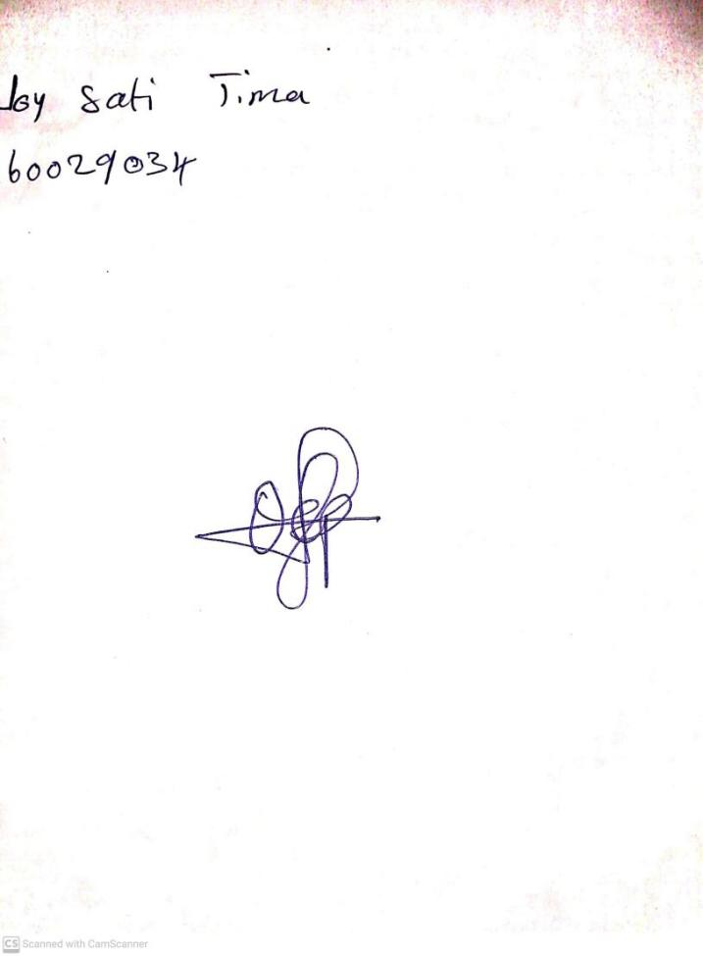

**1st November, 2024**

**Perpetual Ojoma Ocheja**

**Stream Head Nursery**