**EMERALD ROYAL INTERNATIONAL SCHOOL**

**MPAPE, ABUJA.**

**LESSON PLAN AND NOTE FOR WEEK 1 PERIOD 1 ENDING 05/05/2023**

TERM: 3RD

WEEK: 1ST

DATE: 01/05/2023

CLASS: NURSERY 2

SUBJECT: NUMBER WORK

TOPIC: REVISION OF NUMBER 1-40 .

SUB-TOPIC: COUNTING OF NUMBERS 1-4O

PERIOD: 1ST.

TIME: O8:50-09:30.

DURATION: 40 MINUTES.

NUMBER IN CLASS: 17

AVERAGE AGE: 5 YEARS.

SEX: MIXED.

SPECIFIC OBJECTIVES: BY THE END OF THE LESSON,THE PUPILS SHOULD BE

ABLE TO:

1. COUNT NUMBER 1-15.
2. WRITE NUMBER 1-15.

RATIONALE: FOR PUPILS TO BE ABLE TO RECALL NUMBERS 1-15.

PREVIOU KNOWLEDGE: PUPILS HAVE LEARNT COUNTING OF NUMBERS IN

PREVIOUS TERM.

INSTRUCTIONAL MATERIALS: NUMBER CHART FROM 1-15.

REFERENCE MATERIALS: THE NEW MASTERING MATHEMATICS FOR NURSERY SCHOOLS BOOK 3 BY HENRY.Z.IDOGUN.

**LESSON DEVELOPMENT**

|  |  |  |  |
| --- | --- | --- | --- |
| STAGES/STEPS | TEACHER’S ACTIVITIES | PUPILS’ ACTIVITIES | LEARNING POINTS |
| INTRODUCTION | Teacher introduces the lesson by singing a number rhyme for the pupils. | Pupils sing the rhyme along with the teacher. | To arouse pupils interest in the lesson. |
| PRESENTATION  STEP 1 | Teacher writes numbers 1-15 on the board, counts and then asks pupils to repeat after her. I.e, 1 2 3 4 5 6 7 8 9 10 11 12 13 14 15 | Pupils count numbers 1- 15 after the teacher. | For proper understanding of the lesson . |
| STEP 2 | Teacher prepares pupils books for them to count and copy the numbers on the board into their exercise books. | Pupils count and copy the numbers into their exercise books. I.e,  1 2 3 4 5 6 7 8 9 10 11 12 13 14 15. | For better understanding of the lesson. |
| BOARD SUMMARY | Teacher summarizes the lesson by going through the lesson on the board over and over again. | Pupils pay attention to the teacher. | For more understanding of the lesson. |
| EVALUATION | Teacher asks Pupils to count numbers 1 - 15 on the board one after the other. | Pupils count numbers 1 - 15 on the board one after another. | To assess pupils understanding of the lesson. |
| CONCLUSION | Teacher marks pupils books. | Pupils submit their books for marking. | For endorsement. |
| ASSIGNMENT (HOME WORK) | Identify, count and write numbers 1 -30 | Pupils do their assignment at home. | To encourage learning at home. |

**LESSON PLAN AND NOTE FOR WEEK 1 PERIOD 2 ENDING 05/05/2023**

TERM: 3RD

WEEK: 1ST

DATE: 02/05/2023

CLASS: NURSERY 2

SUBJECT: NUMBER WORK

TOPIC: REVISION OF NUMBER 1-40 .

SUB-TOPIC: COUNTING OF NUMBERS 16- 30

PERIOD: 2ND.

TIME: O8:50-09:30.

DURATION: 40 MINUTES.

NUMBER IN CLASS: 17

AVERAGE AGE: 5 YEARS.

SEX: MIXED.

SPECIFIC OBJECTIVES: BY THE END OF THE LESSON,THE PUPILS SHOULD BE

ABLE TO:

1. COUNT NUMBER 16- 30
2. WRITE NUMBER 16- 30

RATIONALE: FOR PUPILS TO BE ABLE TO RECALL NUMBERS 16- 30.

PREVIOU KNOWLEDGE: PUPILS HAVE LEARNT COUNTING OF NUMBERS IN

PREVIOUS TERM.

INSTRUCTIONAL MATERIALS: NUMBER CHART FROM 16- 30.

REFERENCE MATERIALS: THE NEW MASTERING MATHEMATICS FOR NURSERY SCHOOLSBOOK 3 BY HENRY.Z.IDOGUN.

**LESSON DEVELOPMENT**

|  |  |  |  |
| --- | --- | --- | --- |
| STAGES/STEPS | TEACHER’S ACTIVITIES | PUPILS’ ACTIVITIES | LEARNING POINTS |
| INTRODUCTION | Teacher introduces the lesson by reviewing the previous lesson. | Pupil listen to the teacher. | To arouse pupils interest for the lesson ahead. |
| PRESENTATION  STEP 1 | Teacher writes numbers 16- 30 on the board, counts and then asks pupils to repeat after her. I.e, 16 17 18 19 20 21 22 23 24 25 26 27 28 29 30. | Pupils count numbers 16- 3o after the teacher. | For proper understanding of the lesson . |
| STEP 2 | Teacher prepares pupils books for them to count and copy the numbers on the board into their exercise books. | Pupils count and copy the numbers into their exercise books. I.e,  16 17 18 19 20 21 22 23 24 25 26 27 28 29 30. | For better understanding of the lesson. |
| BOARD SUMMARY | Teacher summarizes the lesson by going through the lesson on the board over and over again. | Pupils pay attention to the teacher. | For more understanding of the lesson. |
| EVALUATION | Teacher asks Pupils to count numbers 16 - 30 on the board one after the other. | Pupils count numbers 16 - 30 on the board one after another. | To assess pupils understanding of the lesson. |
| CONCLUSION | Teacher marks pupils books. | Pupils submit their books for marking. | For endorsement. |
| ASSIGNMENT | Identify, count and write numbers 1- 40. | Pupils do their assignment at home. | To encourage learning at home. |

**LESSON PLAN AND NOTE FOR WEEK 1 PERIOD 3 ENDING 05/05/2023**

TERM: 3RD

WEEK: 1ST

DATE: 03/05/2023

CLASS: NURSERY 2

SUBJECT: NUMBER WORK

TOPIC: REVISION OF NUMBER 1-40 .

SUB-TOPIC: COUNTING OF NUMBERS 31- 40

PERIOD: 3RD.

TIME: O8:1O- 08:50.

DURATION: 40 MINUTES.

NUMBER IN CLASS: 17

AVERAGE AGE: 5 YEARS.

SEX: MIXED.

SPECIFIC OBJECTIVES: BY THE END OF THE LESSON,THE PUPILS SHOULD BE

ABLE TO:

1. COUNT NUMBER 31 - 40
2. WRITE NUMBER 31 - 40

RATIONALE: FOR PUPILS TO BE ABLE TO RECALL NUMBERS 31 - 40.

PREVIOU KNOWLEDGE: PUPILS HAVE LEARNT COUNTING OF NUMBERS IN

PREVIOUS TERM.

INSTRUCTIONAL MATERIALS: NUMBER CHART FROM 31 - 40.

REFERENCE MATERIALS: THE NEW MASTERING MATHEMATICS FOR NURSERY SCHOOLSBOOK 3 BY HENRY.Z.IDOGUN.

**LESSON DEVELOPMENT**

|  |  |  |  |
| --- | --- | --- | --- |
| STAGES/STEPS | TEACHER’S ACTIVITIES | PUPILS’ ACTIVITIES | LEARNING POINTS |
| INTRODUCTION | Teacher introduces the lesson by reviewing the previous lesson. | Pupil listen to the teacher. | To arouse pupils interest for the lesson ahead. |
| PRESENTATION  STEP 1 | Teacher writes numbers 31 - 40 on the board, counts and then asks pupils to repeat after her. I.e, 31 32 33 34 35 36 37 38 39 40. | Pupils count numbers 31 - 40 after the teacher. | For proper understanding of the lesson . |
| STEP 2 | Teacher prepares pupils books for them to count and copy the numbers on the board into their exercise books. | Pupils count and copy the numbers into their exercise books. I.e,  31 32 33 34 35 36 37 38 39 40. | For better understanding of the lesson. |
| BOARD SUMMARY | Teacher summarizes the lesson by going through the lesson on the board over and over again. | Pupils pay attention to the teacher. | For more understanding of the lesson. |
| EVALUATION | Teacher asks Pupils to count numbers 31 - 40 on the board one after the other. | Pupils count numbers 31- 40 on the board one after another. | To assess pupils understanding of the lesson. |
| CONCLUSION | Teacher marks pupils books. | Pupils submit their books for marking. | For endorsement. |
| ASSIGNMENT | Identify, count and write numbers 1- 50. | Pupils do their assignment at home. | To encourage learning at home. |

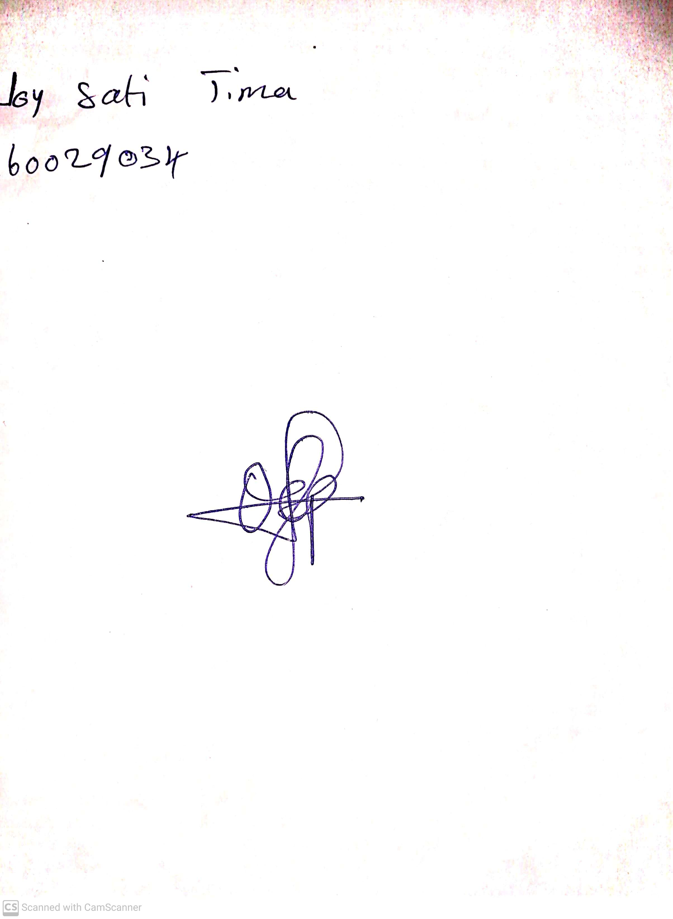

14th May, 2023

Perpetual Ojoma

Stream Head Nursery