**EMERALD ROYAL INTERNATIONAL SCHOOL MPAPE, ABUJA.**

**LESSON PLAN AND NOTE FOR WEEK 4 ENDING 17/05/2024**

**TERM: THIRD**

**WEEK: 4TH**

**DATE: 13/05/2024**

**CLASS: NURSERY 2**

**SUBJECT: SOCIAL NORMS**

**TOPIC: VIOLENCE (MENTAL) .**

**SUB-TOPIC: DEFINITION OF VIOLENCE, HARMFUL EFFECT AND**

**EXAMPLES.**

**PERIOD: 2ND PERIOD AFTER LONG BREAK**

**TIME: 11: 20- 12: 00PM**

**DURATION: 40 MINUTES.**

**NUMBER IN CLASS: 13**

**AVERAGE AGE: 5 YEARS.**

**SEX: MIXED.**

**SPECIFIC OBJECTIVES: BY THE END OF THE LESSON,THE PUPILS SHOULD BE**

**ABLE TO:**

1. **DEFINE MENTAL VIOLENCE**
2. **STATE THE HARMFUL EFFECT OF MENTAL VIOLENCE**
3. **MENTION EXAMPLES OF MENTAL VIOLENCE.**

**RATIONALE: FOR PUPILS TO KNOW WHAT MENTAL VIOLENCE IS ALL**

**ABOUT.**

**PREVIOU KNOWLEDGE: PUPILS HAVE LEARNT ABOUT PHYSICAL VIOLENCE**

**INSTRUCTIONAL MATERIALS: BELT AND STICK.**

**REFERENCE MATERIALS: GOOGLE.COM**

**LESSON DEVELOPMENT**

|  |  |  |  |
| --- | --- | --- | --- |
| **STAGES/STEPS** | **TEACHER’S ACTIVITIES** | **PUPILS’ ACTIVITIES** | **LEARNING POINTS** |
| **INTRODUCTION** | **Teacher reviews the previous lesson to pupils.** | **Pupils pay attention to the teacher.** | **To arouse pupils interest for the lesson ahead.** |
| **PRESENTATION**  **STEP 1** | **Teacher defines the meaning of mental violence to pupils and then asks them to repeat after her.** | **Pupils listen attentively to the teacher and repeat after her.** | **For proper understanding .** |
| **STEP 2** | **Teacher states the harmful effect of mental violence to pupils and also asks them to repeat after her.** | **Pupils pay attention to the teacher and repeat after her.** | **For better understanding of the lesson.** |
| **STEP 3** | **Teacher mentions the examples of mental violence to pupils and also asks them to repeat after her.** | **Pupils listen to the teacher and repeat after her.** | **To enhance pupils participation in class.** |
| **BOARD SUMMARY** | **Teacher summarizes the lesson by writing the whole note of lesson on the board for pupils to copy into their books. Ie,**  **MENTAL VIOLENCE**  **Mental violence is when a child is repeatedly made to feel worthless, unloved, alone or scared.**  **HARMFUL EFFECT OF MENTAL VIOLENCE**   1. **Depression** 2. **Anxiety** 3. **Poor self-esteem** 4. **Heart disease etc.**   **EXAMPLES OF MENTAL VIOLENCE**   1. **Yelling** 2. **Bullying** 3. **Blaming and scapegoat** 4. **Making the child the subject of jokes** 5. **Threatening,shouting at a child or calling them names** 6. **Humiliating or constantly criticizing a child etc.** | **Pupils copy the note into their exercise books.** | **For onward study.** |
| **EVALUATION** | **Teacher evaluates the lesson by asking the following questions;**   1. **What is mental violence?** 2. **State the harmful effect of mental violence .** 3. **Mention the examples of mental violence.** | **Pupils answer the questions ask by the teacher.** | **To assess pupils level of understanding.** |
| **CONCLUTION** | **Teacher concludes the lesson by marking pupils books.** | **Pupils submit their books for marking.** | **For endorsement.** |
| **ASSIGNMENT** | 1. **Explain the meaning of children with special needs** 2. **Mention 3 ways we can care for children with special needs.** | **Pupils do their assignment at home.** | **To encourage learning at home.** |

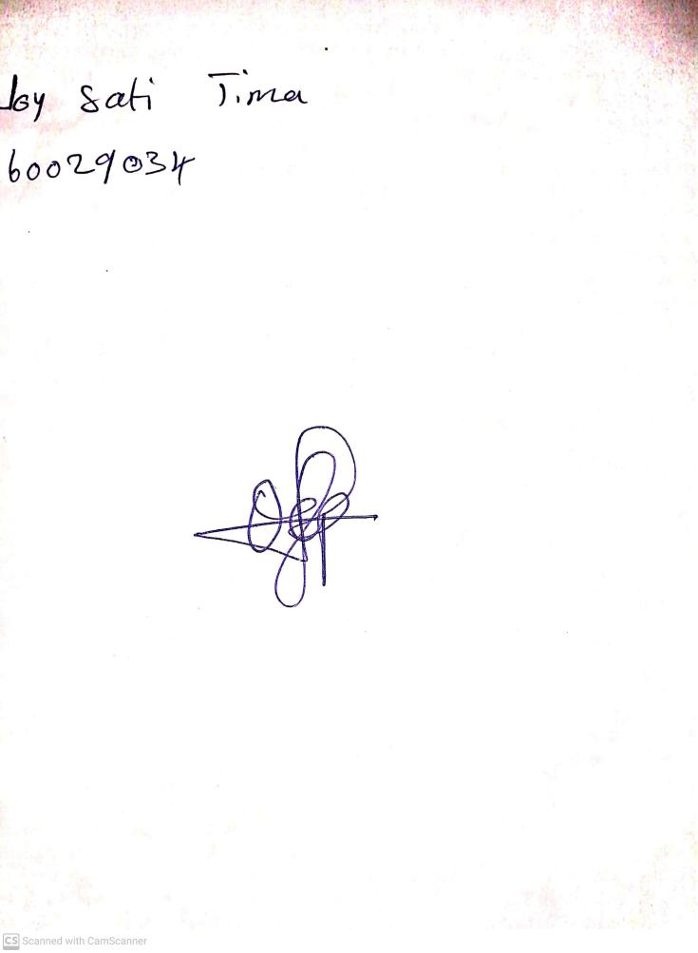

**10th May, 2024**

**Perpetual Ojoma Ocheja**

**Stream Head Nursery**